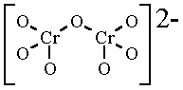
Polyatomic Ionic Compounds (Text pgs. 91–92)
Some ions are just single atoms. Others are large molecules with several different atoms covalently bonded together. These larger ions are called polyatomic ions.
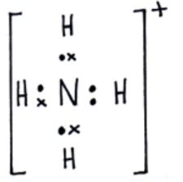
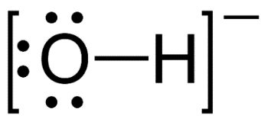
Eg. OH⁻ (hydroxide), CH₃COO⁻ (acetate), NH₄⁺ (ammonium), Cr₂O₇²⁻ (dichromate)
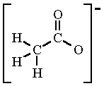

Ionic compounds that contain polyatomic ions are called polyatomic ionic compounds.
- NAMING COMPOUNDS WITH POLYATOMIC IONS (*LOOK UP ION NAMES)

Metal Non-metal{use the polyatomic ion name}
See Table 3.10 pg. 92 IN TEXTBOOK or the back side of your periodic table for polyatomic ion names
Number of Atoms List ions and determine chemical names!
Sn(OH)₂

(NH₄)₂Cr₂O₇

Sr(NO₃)₂

Ca₃(PO₄)₂

- WRITING CHEMICAL FORMULAS FOR COMPOUNDS CONTAINING POLYATOMIC IONS

We write formulas as before, but you MUST use parentheses if there is more than one polyatomic ion required in the formula. The brackets are needed around the polyatomic ion if the subscript >1.

Write Formula # of Atoms
sodium permanganate
List Ions:

Balance charge:

iron(III) sulfate
List Ions:

Balance charge:

barium carbonate
List Ions:

Balance charge:

magnesium bisulphite or magnesium hydrogen sulphite
List Ions:

Balance charge:

DO pg. 91 Practice Problems
Section 3.2 Comprehension
Worksheet “BLM 1-38”

