Name: Date: Block: #
Experiment Design and Analysis
Discuss the following experiment with a partner and answer the related questions.
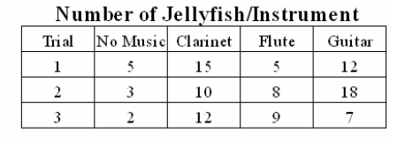
- Squidward loves playing the clarinet and believes it attracts more jellyfish than any other instrument he has played. To test his hypothesis, Squidword played a song on his clarinet for a total of 5 minutes and counted the number of jellyfish he saw in his front yard. He played the song a total of 3 times on his clarinet, and then repeated the experiment using a flute and a guitar. He also recorded the number of jellyfish he observed when he was not playing an instrument. The results are shown in the chart.

For analysis determine averages
in each category!

- What is Squidward’s hypothesis?

2. Describe/identify the:
a. Independent Variable:
b. Dependent Variable:
c. Control Group:
3. Based on the results and analysis of this experiment, write a conclusion.

4. Are the results of this experiment reliable? Why or why not? Discuss sources of error/controlled variables.

Independently! Read the following experiments and answer the related questions!
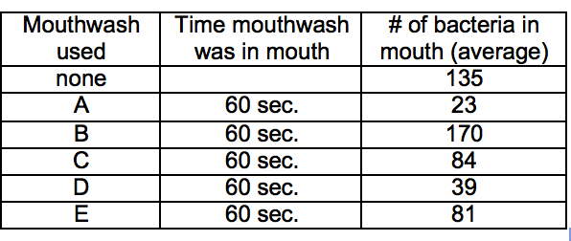
B. The makers of brand A Mouthwash want to prove that their mouthwash kills more bacteria than the other 4 leading brands of mouthwash. They organized 60 test subjects into 6 groups of 10 test subjects.
The data for the experiment is shown below. # of bacteria values refer to remaining living bacteria in the mouth!

- What is the independent variable?

- What is the Dependent variable?
- What was the control group in this experiment?

- List 3 variables that should be held constant in this experiment to ensure results are reliable.
a) b) c)
C. Smithers thinks that a special juice will increase the productivity of workers. He creates two groups of 50 workers each and assigns each group the same task (in this case, they're supposed to staple stacks of papers together). Group A is given the special juice to drink while they work. Group B is not given the special juice. After an hour, Smithers counts how many stacks of papers each group has made. Group A made 1,587 stacks Group B made 2,113 stacks.
- What is Smither’s Hypothesis?

- Identify/describe the:
- Independent Variable:
- Dependent Variable:
- Control Group:
- Based on the results of the experiment, describe Smithers' conclusion?

- How could this experiment be improved to make results more reliable?

Emerging | Developing | Proficient | Extending
Hypothesis incorrect. Most variables incorrectly identified, and control group not described correctly. | Hypothesis partially correct.  Variables incorrectly identified or control group incorrect | Hypothesis,  Variables and control group correctly identified but more clarity needed | Hypothesis is correct in “If… then….format  Independent, dependent, and constant variables are clearly and correctly stated
Competencies 1- I can design portions of an experiment to test a hypothesis.

Competencies 3- I can process, analyze, and evaluate results to write a conclusion and critique results/experiment design.
Weak attempt made to state conclusions and/or respond to analysis questions | Some conclusions are correct.  Attempted analysis of experiment/results. | Most conclusions correctly stated, and reliability of results/experiment design discussed. | All conclusions stated correctly with explanation and clear and reasonable critique of reliability of results/experiment design.

Complete the Scientific Method Crossword Puzzle to Review Terminology

