Assignment 2: Domain and Range, Functions and Relation Terminology Name:___________________________________

Give the domain and range for each in indicated forms (number lines, set notation and/or interval notation). ( /26)
D: D:
1) 2)
Set notation: Set notation:
Interval notation:
R:
R:
Set notation:
Set notation:
Interval notation:
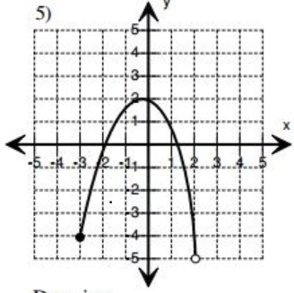
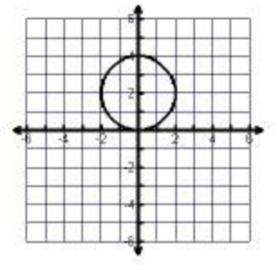
3) D: 4) D:

Set notation: Interval notation:

R: R:

Set notation: Interval notation:

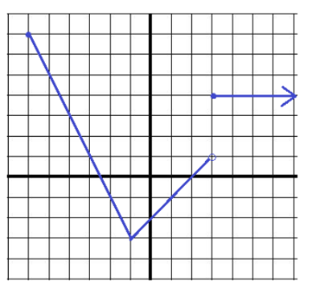
D: D:
(-1, 3)
5) 6)
Interval notation: Set notation:

R: R:
Interval notation: Set notation:

Write the domain and range of each. Tell if the relation is a function or not! /6

{(5, 2), (–3, 1), (5, –4), (0, 11)} | {(–6, –8), (5, 1), (9, –4), (7, 1), (15, 0)}
Domain:  Range: | Domain:  Range:
Function: yes or No (circle one) | Function: yes or No (circle one)

Graph 1 /8 | - For Graph 1 check all descriptions that apply to the graph. /4
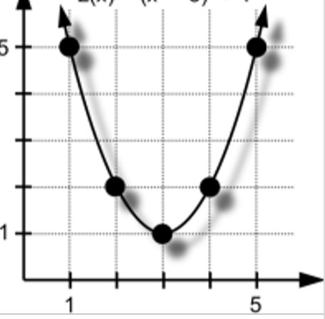  Z  1 5 X  - Use the graph to find f(4). Show work on graph to find value!  f(4) = /2 | 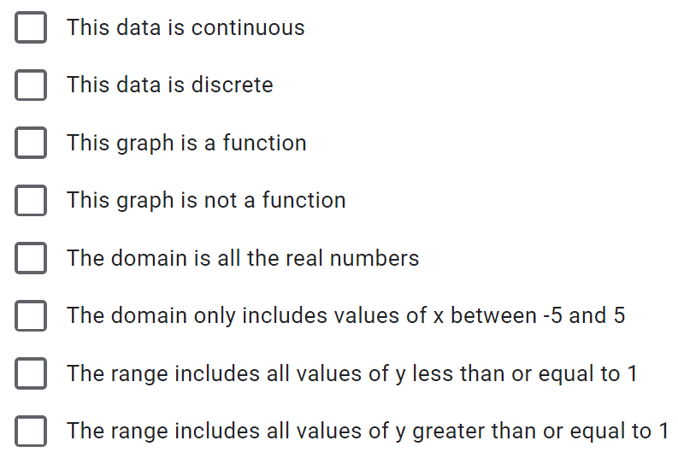  - If f(x) = 5, use the graph to find the value(s) of x. Show work on the graph!  x = /2
Graph 2 /5  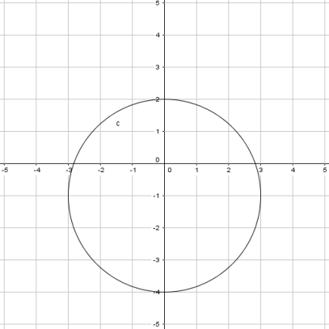  3. Check all that apply to graph 2. /3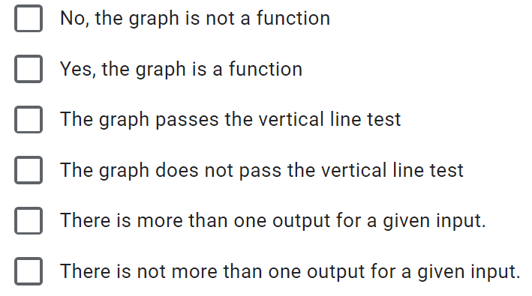 | 1. Which inequality correctly shows the range of  Graph 2? ____________  - $2≤y≥-4$  - $-4≥y≥2$  - $-4≤y≤2$  - $2≥y≤-4$  /1  2. Which interval notation best describes the domain of Graph 2? ____________  - $\left[-3, 3\right]$  - $\left(-3, 3\right)$  - $\left[-4, 3\right]$  - $\left(-4, 3\right)$  /1

Graph 3: /7  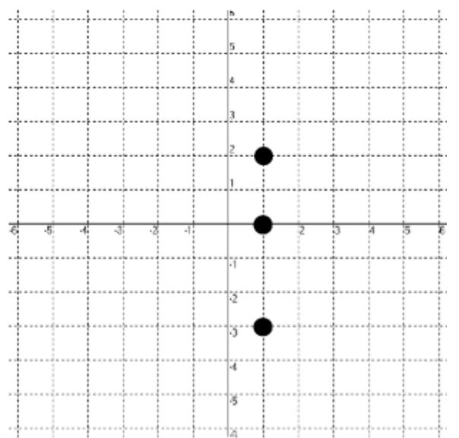  - Label each point shown on the graph. i.e. (-1, 2)  ( /3)  - Complete the number line to represent the domain of this relation. | - The range of this graph is correctly written as ? Choose one response:  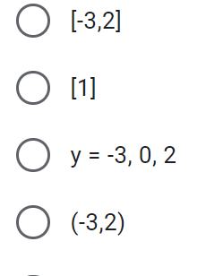  - Is this data continuous or discrete? Explain how you know? ( /2)

Graph 4: Show work on graph for #3, 4.  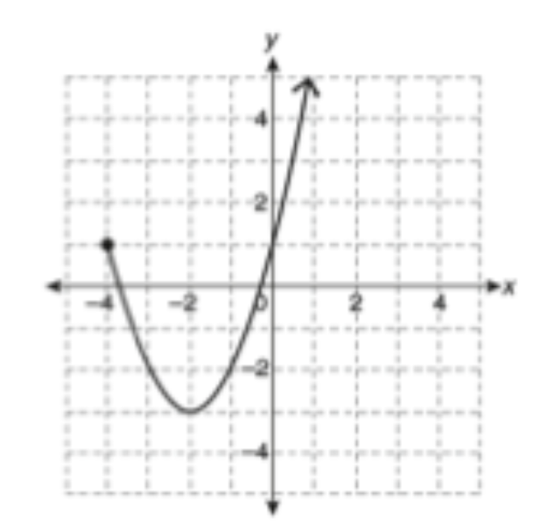 /8 | - What is the domain and range in interval notation? /2  - What is the domain and range in set notation? /2  - What is f (-2) = ? /2  - What is x if f(x) = 0 ? /2

Total: /60 marks ________%

