Math 10 Polynomials & Factoring Assignment Total: /28 = %
Name:___________________
- Use algebra tiles to multiply the following. /2
- $(x-4)(2x+3)$

- Use the distributive property to expand and simplify the following. /8 2 marks each
- $\left(x-4\right)\left(2x+3\right)=$ | - $\left(2x+5\right)\left(3x-2\right)=$
- $\left(3x+2\right)\left(x^{2}-2x+5\right)=$ | - ${\left(x-2\right)}^{2}+3x\left(x-2\right)=$
- A circle is inset into a square with a side length of $6x+4$, as shown. Write an expression to represent the area of the circle. Then multiply and simplify. $A =πr^{2}$ /2
6x +4
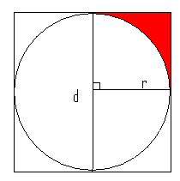
- What is the greatest common factor for each set of terms /2
- ${8x}^{2}y^{2} and 24 x^{3}y^{3}$  _______________ | - $14p^{4}q^{5}, -24p^{5}q^{3}and 7p^{3}q^{4}$  __________________

D. Draw in the factors as tiles for the following algebra tile models and label with expression above. /2
9.  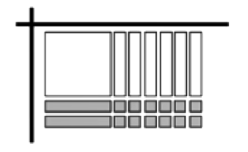 | 10.  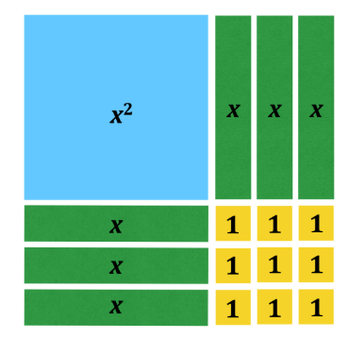
- Completely Factor the Following. Remove GCF first! /10
11. $8x+24y=$ | 12. $4x^{3}-8x^{2}+12x=$
13. $4x\left(x+3\right)-5\left(x+3\right)=$ | 14. $8x^{2}+12xy-6x-9y=$
15. $12a^{2}-25a+2=$ | 16. $16x^{2}+36x+20$=
17. $36m^{2}-196n^{4}=$ | 18. $16m^{3}n^{2}+24mn^{4}-8mn^{2}=$
19. $9k^{2}+3k+\frac{1}{4}=$ | 20. $3a^{2}+39a-90=$
21. For what integer values of k can the following trinomial be factored? /2

$$4x^{2}+kx-5$$

