Cell Structure and Types: https://www.youtube.com/watch?v=URUJD5NEXC8
There are two broad categories of cells. Prokaryotic and Eukaryotic
All cells have three things in common:
- _________________________ 2. _________________________ 3._______________________
_____________________ cells are found in multi-cellular, complex organisms. These cells contain membrane bound organelles which have specific roles in the cells.
_____________________ cells are found in unicellular, simple organisms like _________________. These cells do not contain membrane bound organelles or a nucleus. But the cells do contain _______________________.
Eukaryotic cells are found in Plant and Animals. Not all organelles are found in both plant and animal cells.
Organelle | Role or Function of in the Cell | Location: In plant or animal cells or Both
- Separates inside of cell from the outside environment
- Controls what enters or leaves a cell
Cytoplasm | - Jelly like fluid that suspends the cell’s organelles and carries life-supporting materials such as water and sugar
- Control centre of the cell
- Contains the genetic material (DNA) as
________________ or ___________________
-dictates what particular cell does and how it does it
Nuceolus |  | In both – located in the  ___________________
 | - Synthesize or make proteins | - In both - Either attached to the Endoplasmic Reticulum or free floating in the ______________________ of the cell
Rough Endoplasmic - contains  _____________ and  Smooth Endoplasmic Reticulum (ER) does not contain  _______________ | - A membrane enclosed passageway for transporting materials made in the cell
- Receives vesicles from the ER
- Proteins are repackaged (customized into forms the cell can use for cell processes)
Central ______________ | - Large sac like structure  - that store different materials such as water
Lysosomes | - Garbage ________________  - Filled with enzymes that ________________ cellular debris | Found in only _____________
- Powerhouse
- Make ATP molecules that provide energy for all cell activities
Chloroplast |  | Found in only _____________
 | -a tough, rigid structure that surrounds the cell membrane  -provides support and box like shape to cells  -extra protective layer | Found in only _____________
Flagella | -tail like structure helps cell move or swim | - in humans a ______________  Cell has this structure

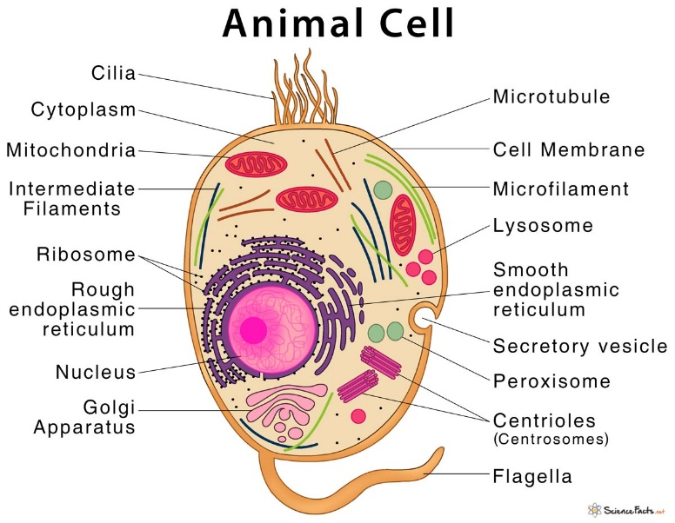 | Plant Cell  