Unit 4

Systems of Equations

Chapter 8 – Solving Systems of Linear Equations Graphically
Chapter 9 – Solving Systems of Linear Equations Algebraically

In this unit you will learn:
- The point of intersection of a system of linear equations
- The number of solutions to a linear system
- Strategies for solving systems of linear equations graphically and algebraically

CHAPTERS 8 & 9– Solving Systems of Linear Equations Graphically and Algebraically

Lesson 1

Systems of Linear Equations and Graphs

The equation of a straight line __________ is also called a _________ _________.
A pair of linear equations is called a _______________ ______________.
A solution to a linear system is the coordinates of the _______________ where the pair of lines intersects.

How to find the solution to a linear system graphically?
- Graph one line on a grid (y = mx + b).
- Graph the second line on the same grid (y = mx + b).
- The point where the two lines intersect is the answer! Write the answer as a coordinate (x, y). Note: Write no solution if no such point exists.

Example 1: Solve the linear system graphically.
x – y = -2
4x + 2y = 16

How can you check if your answer is correct?

Example 2: Solve the linear system graphically.

3x + y = 11
x – 2y = 6

Example 3: David earns $40 plus $10 per hour. Ranjit earns $50 plus $8 per hour.
- Represent the linear system relating the earnings numerically (table of values) and graphically.
- Identify the solution to the linear system and explain what it represents.

x | y

Example 4: For the system of linear equations, verify whether the given point (-3,-2) is a solution. Explain what the results would show on a graph.

2x + 3y = -12
4x – 3y = -6

Homework: Worksheet “What were the Headlines…” + Pg. 427-431 #3-11, 15, 19 & 20

Warm-up

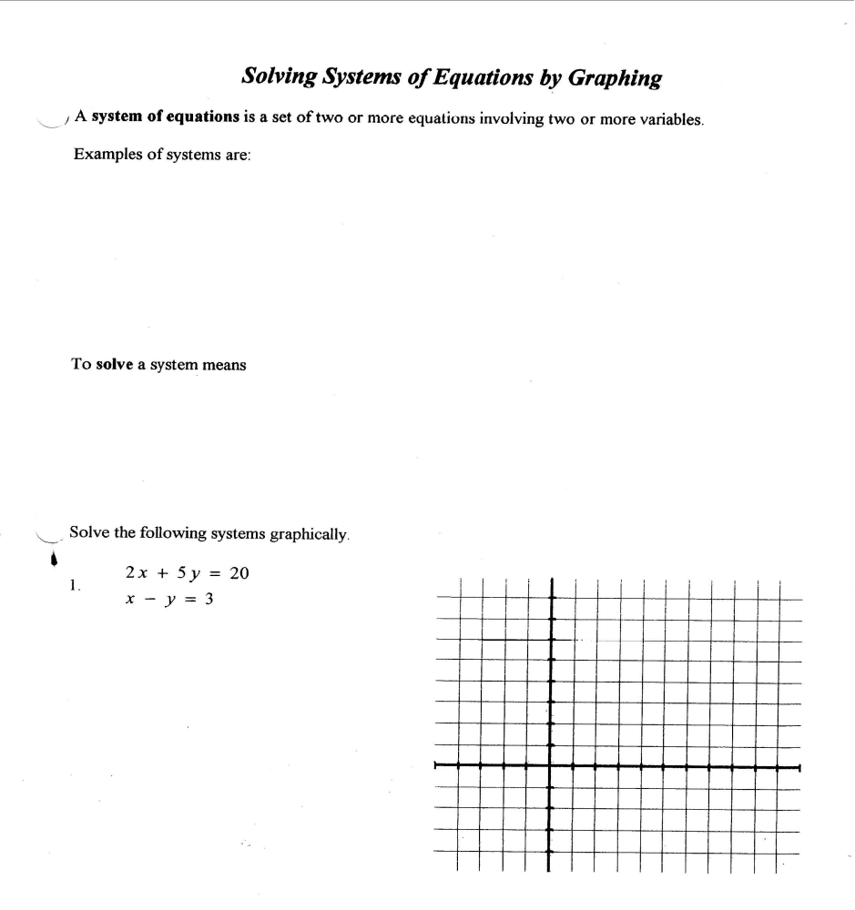

Lesson 2

Modeling and Solving Linear Systems

Example 1: People can rent ski and snowboard equipment from two places at Winterland Resort. Option A charges a one-time $30 fee and then $8 per hour.
Option B charges $14 per hour.
- Create a system of linear equations to model the rental charges.
- Solve the linear system graphically. What does the solution represent?

Example 2: Two pools start draining at the same time. The larger pool contains 54 675 L of water and drains at a rate of 25 L/min. The smaller pool contains 35 400 L of water and drains at a rate of 10 L/min.
- Model the draining of the pools algebraically using a system of linear equations.
- Represent the linear system graphically. Describe how the information shown in the graph relates to the pools.

Assignment: Pg. 440-445 #1-6, 8, 14-19, 22

Lesson 3

Solving Systems of Linear Equations by Elimination

This method is called the Elimination Method or Linear Combination.
- Line up the two linear equations and eliminate one of the variables with the same coefficient by adding or subtracting the two equations.
- Once one of the variables is removed, solve for the remaining variable.
- Solve for the variable that was removed by plugging in your solution from part 2 into one of the original equations.
- Write your answer as an ordered pair (x, y).

Example 1: Solve: x – y = 2
How can you check your answer to see if it is correct?
3x + y = -14

Example 2: Solve: 5x – 3y = 9
5x + 4y = 23

Example 3: Solve: x – 2y = 7 (Problem! No coefficients are alike.)
3x + 4y = 1 What shall we do?

Example 4: Solve: 2x + 3y = 8
5x – 4y = -6

Example 5: Solve: 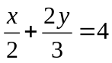 (Oh no, fractions!!!)
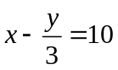 What shall we do?

Example 6: Is (2, -1) a solution for the following systems?

How will you know? _________________________________________

- x + y = 1 (b) 3x + y = 5
3x – y = 4 6x – 11y = 23

Assignment: Pg. 488-490 #1-2, 4-6 Quiz on Lessons 1-3 on ____________________

Lesson 4

Number of Solutions of a Linear System

There are _____ possibilities when determining the number of solutions of a linear system:

1. Intersecting Lines

Number of Solutions: _____

This system is called ____________________.

Example: 5x + 6y = 1
6x + 2y = -3

Put each equation in y = mx + b form:

2. Parallel Lines

Number if Solutions: __________

This system is called ____________________.

Example: 2x + y = 4 or 2x + y = 4
2x + y = 8 4x + 2y = 3

Put each equation in y = mx + b form:

3. Coincident Lines

Number of solutions: ____________________.

This system is ____________________.

Example: 2x + y = 4
4x + 2y = 8

Put each equation in y = mx + b form:

Example 1: Given x – 2y = 8. Write a second equation to form a linear system with:

(a) infinitely many solutions (b) no solution (c) only one solution

Solution:
(a) x – 2y = 8 (b) x – 2y = 8 (c) x – 2y = 8

Example 2: Is (1, -2) a solution of the following system?

3x – y = 1
x + y = 3

- Check to see if the system is consistent, otherwise if inconsistent the system is a pair of parallel lines, and there is no solution.

- This system is: INCONSISTENT / CONSISTENT

Assignment: Pg. 455 #1-6, 12

Lesson 5

Solving Systems of Linear Equations by Substitution

THE IDEA: John wants to sell his car in a newspaper ad. The ad only allows up to 95 characters including spaces. Here is John’s ad:

Vehicle on sale! 2001 black Honda prelude in mint condition for $12000. Call John at 604-512-3456.

John’s ad has 98 characters including spaces. Therefore, we can substitute the word _______________ for _______________.

How to solve linear equations algebraically with the substitution method?
  - Isolate one of the variables from one of the given equations.
  - Plug in the results from step 1 into the remaining equation.
  - Now simplify and solve for the remaining variable.
  - Use the results in step 3 to find the solution of the variable that was isolated. (Don’t forget to write your final answer as an ordered pair).

Examples:

2x + y = 7 3x + y = 3 4x + 5y = 26
x – 3y = 14 7x – 2y = 20 3x = y – 9

How can you check your answer to see if it is correct?

Assignment: Pg. 474-477 #1-5, 7, 8

Warm – up

- What are the three methods you have learned to solve systems of equations?

- Solve the following systems by adding or subtracting.

  - x + 4y = 42 (b) 2x – 7y = 6
x – 6y = 12 -3x + 4y = 4

3. Solve the following system by substitution: x – 2y = 7 3x + 4y = 1

Lesson 6

Solving Problems Using Systems of Linear Equations

Example 1: A play-off football game drew 36 500 fans. Depending on seat location the ticket prices were $35 and $20. The total revenue from the ticket sales was $940 000. How many $35 tickets and how many $20 tickets were sold?

 | $20 tickets | $35 tickets | Total
Variable

Number of tickets

Cost

Example 2: A person invested $2000, part at 8% per annum and the rest at 10% per annum. After one year, the total interest earned was $190. How much was invested at each rate?

 | 8% interest | 10% interest | Total
Variable
Earnings

Example 3: A golf club charges an initiation fee and a monthly fee. After 3 months, one member has paid $1450, while at the end of 10 months they have paid $2500. What is the initiation fee?

Example 4: From his paper route, Andy collected $5.55 in nickels and dimes. The number of nickels was 6 more than the dimes. How many of each coin does Andy have?

Example 5: John and Ted’s ages total 38. John’s age is 13 years less than twice Ted’s age. Find their ages.

Homework: Pg. 498-499 #2-8

Warm-up

- Samuel invests $8000, part at 7% and the rest at 9%. After one year, the total interest is $620. How much did he invest at each rate?

- Tickets to a concert are $25 in advance, or $30 if bought at the door. If 2000 people attended the concert, and the total gate receipts were $51 600, how many people bought tickets at the door?

Assignment: 5.1-5.4 Review sheet
Practice Test on ________________________
Test on _______________________________

