- Which of the following, when connected in an electric circuit, is not considered to be an electric load?
  - Light bulb
  - Motor
  - Buzzer
  - Switch

- When electrons pass through a load device
  - the electrons gain energy.
  - the electrical energy they carry is turned into different forms of energy.
  - electrical energy is created.
  - the electrons are converted into energy.

3. The following circuit contains three different components labeled A, B, and C.
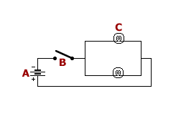
Which of the labeled components represents a closed switch?
  - None of the components represents a closed switch
  - Component C
  - Component A
  - Component B

4. A student sketches a small part of circuit with two components.
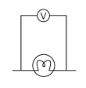
What circuit components are part of the student sketch?
  - Voltmeter and bulb
  - Voltmeter and battery
  - Battery and bulb
  - Voltmeter and buzzer

- As part of an assignment to connect several circuit components together, Abe draws the following circuit diagram:
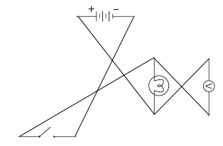
Which of the following best describes what is wrong with Abe's circuit diagram?
  - Not all the components in the circuit are connected
  - Conducting wires should not cross over one another
  - There are too many components in the circuit for the size of battery used
  - For a circuit such as this, two switches are necessary

