Science 9: Understanding the Earth System Activity Name: _______________
Earth- I can communicate an understanding of interactions between Earth’s spheres and the interconnectedness of everything within the Earth System.
Total: /28 Marks Emg Dev Prf Ext
<15.5 15.5 -20.5 21-24.5 25-28
Watch the following Prezi in Chrome. Use the arrow keys on computer to move through the slides.
https://prezi.com/h3zdz920040c/chapter-7-lesson-1-interactions-among-earths-spheres/
Respond to the following questions as you read through the Prezi Presentation –
Interaction’s Among Earth’s Spheres By Autumn Chadwick
- What is the objective of this activity? /1

- What does “Earth as a System Mean”? /1

- Describe each of Earth's spheres. List a few examples of features in each sphere. /5
Geosphere

Hydrosphere

- Cryosphere (part of hydrosphere)

Biosphere

Atmosphere

- After looking at the slide with the house and mountains in the background, list several examples of features found in each of the four main spheres above. /4

- Do you think clouds should be classified as part of the atmosphere, part of the hydrosphere or both? Explain why. /1

- Define the term sphere interactions and give your own example of a sphere interaction. /2

- After looking at the picture with the tornado. Describe at least 2 sphere interactions. /2

- Look at the slide with the farmer on the tractor. Read and think about Sphere interactions on Earth. /4
- Human’s (part of biosphere) impact the Earth System. What are 2 ways that humans change or impact the atmosphere, hydrosphere and/or geosphere?

- What are some Earth Sphere Interactions that result from your daily activities?

- Using both images, look for evidence of materials and energy moving between the spheres.
Volcanic Eruption near Tonga, Jan. 15, 2022
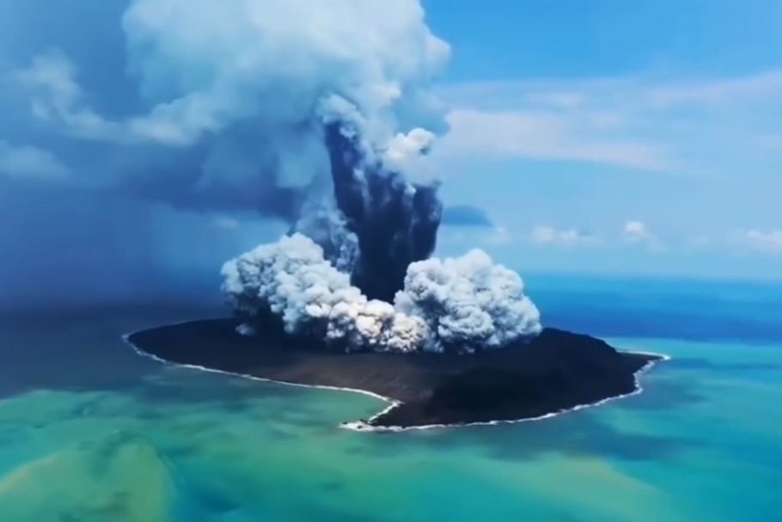
- List the major features in these
two graphics and tell which sphere each one represents. /4
Feature Sphere

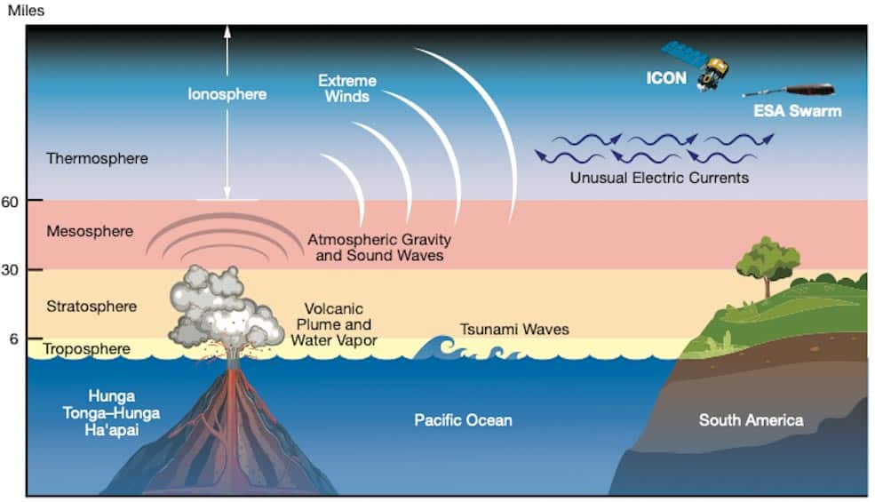
Utube Video Link: https://www.youtube.com/watch?v=KAYu3iYIU1c

https://cosmosmagazine.com/earth/impact-2022-tonga-eruption/
- Describe sphere interactions that occurred in all four spheres of the Earth System following this volcanic eruption. /4

W.C. Bennett Dam Impact:
Video Link: http://acip.sd79.bc.ca/video/quicktime/socials/fort_ware/fort_ware.mp4
- How did the flooding caused by the Bennett Dam hydro electric facility impact the indigenous communities living in the vicinity of the Dam?

- How has the creation of this dam affected the biosphere and geosphere?

Earth – I can understand how indigenous people lived in harmony with the environment and are being impacted by global resource use Emg Dev Prf Ext

 |  | 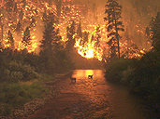
James McVey, NOAA |  | John McColgan, BLM
A. Tropical Island, Palau Islands |  | B.Forest fire, Montana, U.S.A.
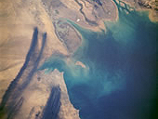 |  | 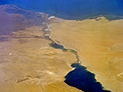
NASA |  | NASA
C. Oil wells burning, Kuwait  and the Persian Gulf |  | D. Suez Canal-Man-made waterway between  Mediterranean Sea and Gulf of Suez , in Egypt
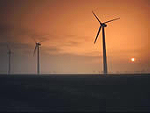 |  | 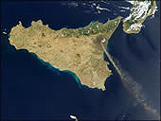
EPOD/USRA |  | Earth Observatory, NASA GSFC
E. Wind farm, Norfolk County, England |  | F. Mount Etna, a volcano on an Island in Italy

