Math 10
Trig assignment: Finding heights

- Using a protractor, string. washers and a straw, make a sextant like the one below.
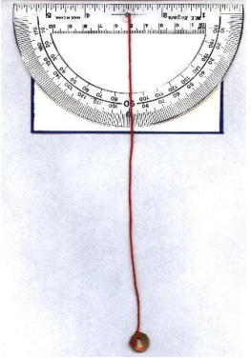
- Use your sextant to find the height of three (3) objects around the school. For each object you must have
  - A labeled diagram like the one below including the angle of inclination (found using your sextant), horizontal distance to the object (measured using measuring tape) and the eye height (measured using measuring tape).

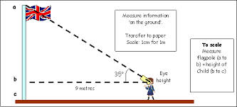
  - Calculations showing how you found the height of the object. Make sure you box your final height and that your work is neat.
You will be put into groups, but you must hand in your own work.

Math 10
Trig assignment: Finding heights
Name:________________________
Group members:__________________________________
Teacher led example:__________________
Diagram:

Horizontal distance to object:______________
Eye Height:_______________________
Angle measured with sextant:______________
Angle of inclination:____________________

Calculations

Height of object:________________________
______________________________________________________________________________
Object 1:__________________
Diagram:

Horizontal distance to object:______________
Eye Height:_______________________
Angle measured with sextant:______________
Angle of inclination:____________________

Calculations

Height of object:________________________
Object 2:__________________
Diagram:

Horizontal distance to object:______________
Eye Height:_______________________
Angle measured with sextant:______________
Angle of inclination:____________________

Calculations

Height of object:________________________
______________________________________________________________________________
Object 3:__________________
Diagram:

Horizontal distance to object:______________
Eye Height:_______________________
Angle measured with sextant:______________
Angle of inclination:____________________

Calculations

Height of object:________________________

