NOTES: Elements

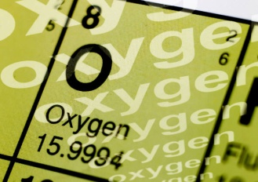
Pure Substances

Chemical Symbols
There are at least 118 elements. Of these, around 92 occur naturally. The symbols for most elements are derived from Latin or Greek words. (See Table 2.1, p. 44 in Text)

Rules For Writing Chemical Symbols
Learning Target: I can interpret chemical formulas

- Symbols for all elements have only one or two letters.
- First letter is ALWAYS
- Second letter is ALWAYS
- The symbols are derived from the Latin or Greek words
i.e. Tin in Latin is Stannum – its symbol is _________
Hydrogen’s symbol is H – derived from _______ genes = water forming
Calcium’s symbol is ____–Calx = latin for limestone
- Ions are created from the atoms of an element when electrons are lost or gained.
Calcium as an atom is written _______ but as an ion it is written ______
Chlorine as an atom is written _______ but as an ion it is written______
Ion charges are listed on the periodic table of elements! Page 54.
Classes of Elements
Learning Target: I can explain how atoms bond to form compounds and molecules
Refer to the tables on pages 22, 54 & 55 to list the properties of metals, non-metals and metalloids.
a) Metals -List the physical properties terms that match the descriptions below
(i) (describe appearance)
(ii) (can be stretched into wires)
(iii) (can be beaten into sheets)
(iv) ( ability to transfer heat / electricity)
(v) Exist as _______________________ (state: solid/liquid/gas at room temperature)
Examples of metals ______________,___________________ Metals are located on the ____________side of the periodic table. They form only ___________________ ions.
b) Non-metals (if given a choice, circle the correct response)
(i) (describe appearance)
(ii) Are or Are not Malleable and ductile (circle one)
(iii) Good or poor Conductivity (circle one)
(iv) Exist as__________________________ (State: solid/liquid/gas at room temperature)
Examples of non-metals________________,___________________ Non-metals are located on the ____________side of the periodic table. They form only ________________ions.
c) Metalloids possess properties of both and Examples of metalloids: _________________, _________________
Pair up and select 5 elements to observe from the elements tray. Return when complete.
Element Name | Symbol | State  (solid/liquid/gas) | Colour | Shiny or Dull?  (shiny/dull) | Malleable?  (Y/N) | Ductile?  (Y/N) | Metal or Non-metal?  (m/nm)
Platinum | Pt | solid | silver | shiny | Y | Y | m

To Do: Complete text questions p. 51, # 2-10

