Watch the video. Then cut and paste in the steps in the scientific method into the boxes. Fill in important terms from the following list!
“What are the steps of the scientific method with Mr. Harris” https://www.youtube.com/watch?v=qoepMxUIDfQ
Terms: dependent, control group, controlled variables, graph, table, charts, model, materials, independent, procedure
MUST BE TESTABLE!
1.
Find new information
7. Communicate/share this
information.

The Scientific Method

2.
6.

Was your hypothesis supported or refuted?
What did you learn?

WHAT YOU THINK WILL HAPPEN!
How are Results/Data presented?
____________
____________
____________
____________

3.
Educated Guess/prediction – response to question/solution to problem

5.

4.
HOW WILL TEST YOUR PROPOSED
EXPLANATION?

OBSERVATION TYPES
QUALITATIVE VS QUANTITATIVE

______________________ steps followed to test hypothesis. Instructions to perform experiment.

______________________list of equipment/tools required to complete experiment.
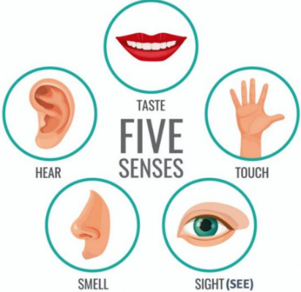
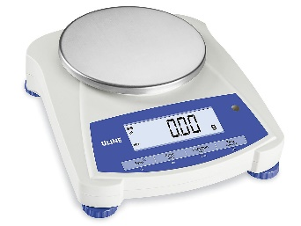
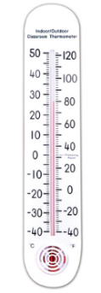

Variables:
_____________________________________
What you change in the experiment to observe what happens
____________________________________
What you measure or observe because of the change

________________________________ (constants)
What you keep the same to reduce sources of error!

_______________________________ No change made

Slide Show Responses:
For the examples: Identify the variables in these investigations – Independent Variable; Dependent Variable(s); Controlled Variables (constants)
Examples | Independent Variable | Dependent Variable | Controlled Variables
1.

2.

3.

Cut out the steps of the scientific method and paste in appropriate boxes in the graphic organizer
DESIGN & DO AN  EXPERIMENT | HYPOTHESIS  IF ……. THEN…. STATEMENT | ASK A QUESTION BASED ON INITIAL OBSERVATIONS | CONDUCT FURTHER  RESEARCH
COMMUNICATE RESULTS | ANALYZE THE DATA | WRITE A CONCLUSION

Cut out the steps of the scientific method and paste in appropriate boxes in the graphic organizer
DESIGN & DO AN  EXPERIMENT | HYPOTHESIS  IF ……. THEN…. STATEMENT | ASK A QUESTION BASED ON INITIAL OBSERVATIONS | CONDUCT FURTHER  RESEARCH
COMMUNICATE RESULTS | ANALYZE THE DATA | WRITE A CONCLUSION

Cut out the steps of the scientific method and paste in appropriate boxes in the graphic organizer!
DESIGN & DO AN  EXPERIMENT | HYPOTHESIS  IF ……. THEN…. STATEMENT | ASK A QUESTION BASED ON INITIAL OBSERVATIONS | CONDUCT FURTHER  RESEARCH
COMMUNICATE RESULTS | ANALYZE THE DATA | WRITE A CONCLUSION

Cut out the steps of the scientific method and paste in appropriate boxes in the graphic organizer
DESIGN & DO AN  EXPERIMENT | HYPOTHESIS  IF ……. THEN…. STATEMENT | ASK A QUESTION BASED ON INITIAL OBSERVATIONS | CONDUCT FURTHER  RESEARCH
COMMUNICATE RESULTS | ANALYZE THE DATA | WRITE A CONCLUSION

Cut out the steps of the scientific method and paste in appropriate boxes in the graphic organizer
DESIGN & DO AN  EXPERIMENT | HYPOTHESIS  IF ……. THEN…. STATEMENT | ASK A QUESTION BASED ON INITIAL OBSERVATIONS | CONDUCT FURTHER  RESEARCH
COMMUNICATE RESULTS | ANALYZE THE DATA | WRITE A CONCLUSION

Cut out the steps of the scientific method and paste in appropriate boxes in the graphic organizer
DESIGN & DO AN  EXPERIMENT | HYPOTHESIS  IF ……. THEN…. STATEMENT | ASK A QUESTION BASED ON INITIAL OBSERVATIONS | CONDUCT FURTHER  RESEARCH
COMMUNICATE RESULTS | ANALYZE THE DATA | WRITE A CONCLUSION

