Name: Science 9 - Investigating Circuits- Hands on! Block: #___

Questions to think about:
How do you measure voltage? How does voltage behave in a simple series circuit? What does a circuit need for electrical current to flow? What makes the circuit successful?

Materials:
- 2 dry cell holders | - 2 light bulbs | - 1 switch
- 2 dry cells | - Peg board | - 1 voltmeter
- 6 alligator clips
Note: Keep switch open or disconnect wires from the dry cell(s) when they’re not in use to extend the life of the dry cell and light bulbs. If you do not connect dry cells facing the same way when combining components in circuit, the circuit will not work.

Part I: Making a series circuit is simple. The peg board is used to secure components. Alligator clips can be connected to circuit by clipping to the metal posts on the switch and cell holders and to light bulb wires.

- Create the following circuit using a switch, three alligator clips and a dry cell in a holder.
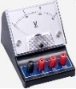  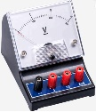  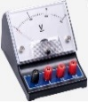  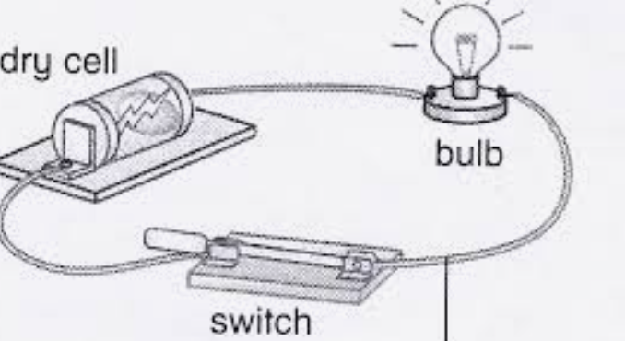 | a. This is a simple series circuit. It includes a source, conductive wires, a switch, and a bulb. Current flows through one pathway from the __________ terminal of the dry cell to the _________terminal of the dry cell.  b. When you lift the lever on the switch does the bulb light up? Yes or No. Why?  c. Draw the electron flow through the circuit to the left! Use arrows to show direction.
- Draw a schematic diagram that represents the circuit pictured above. Include voltmeters.

Note: Voltmeters are connected in parallel around devices in a circuit. The resistance in the voltmeter is very high so no current flows through allowing the device to measure voltage drop across the device (change in potential energy).

- Close the switch and measure the voltage drops across the dry cell, the bulb, and the switch by connecting the meter in parallel around each device separately with two other alligator clips.

Voltage Measurements: dry cell:_______ light bulb:______ Switch:________

The voltage should be _________ around the closed switch because the switch does not use energy as current passes through it. There is no difference in potential energy like in a dry cell or around a bulb.

Part II: Is the circuit complete or not? Does the circuit work? Why or why not?

Hypothesis: IF we create a complete closed circuit containing essential components connected correctly, THEN current will flow through the circuit and the bulbs will light up.

1. Draw the schematic diagram
2. Predict whether the bulbs will light up. Remember there must be a complete path (circuit) for bulbs to light and wires must connect the positive terminal to the negative terminal to complete the circuit. Explain why?
3. Make the circuit to test your prediction. Did the circuit work?

- Predict will the bulb light? Yes or No. Why?  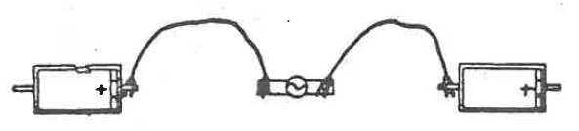 | Schematic Diagram:  Did circuit work?______________
- Predict will the bulb light? Yes or No. Why?  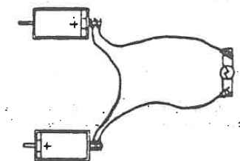 | Schematic Diagram:  Did circuit work?______________

- Predict will the bulb light? Yes or No. Why?  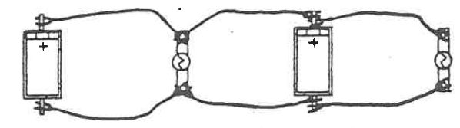 | Schematic Diagram  Did circuit work?______________
Q: What does a circuit need for electrical current to flow? What do successful circuits have in common?

Elect2 - I can compare current with voltage and explain factors influencing electron flow through components in a circuit. Emg Dev Prf Ext
Name: Science 9 - Investigating Circuits- Phet! Block: #___
Using the Phet Simulation you will investigate how voltage and current behave when components are connected in series vs in parallel. You will also draw schematic diagrams of the circuits you create and
show how electrons flow through the circuit.
Questions to think about:

How does the arrangement of cells and/or bulbs in the circuit impact voltage and brightness of bulbs?
How does the arrangement of cells and/or bulbs in a circuit impact current?
How do you draw schematic diagrams of circuits containing cells and/or bulbs connected in series and parallel?
How do you show the flow of electrons and direction through a series vs a parallel circuit?

Part I: Investigating circuits – Using the Phet Simulations Lab
- Draw schematic diagrams as required and use arrows to show electron flow throughout the circuit.
- Set up the circuit using the Phet simulation for DC circuits lab. https://phet.colorado.edu/en/simulation/circuit-construction-kit-dc
- Perform measurements using the voltmeter and movable ammeter provided in the simulation.
- Respond to questions that follow. Then reset the simulation before making the next circuit.
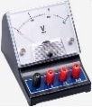
- Draw the following circuit and show electron flow through the different components. Include the voltmeter placement to measure voltage around both cells and each bulb.
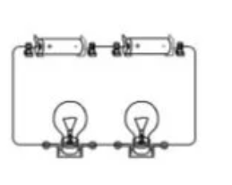  Circuit A:  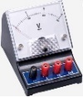  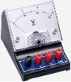 | Draw Schematic Diagram and show electron flow
Q1: Are components in circuit A in series or parallel? ___________________How do you know?

Use the voltmeter to measure the total voltage drop around both cells.
The total voltage drop is __________________. Measure the voltage drop around each bulb.
Voltage Drop around Bulb 1 ______V Voltage Drop around Bulb 2______V
Q2: What do you notice about the total voltage supplied by the cells compared to the voltage drops across each bulb?

- Draw a schematic diagram for circuit B. Include voltmeters to measure voltage around both cells and one bulb in diagram and show electron flow using arrows through this circuit.
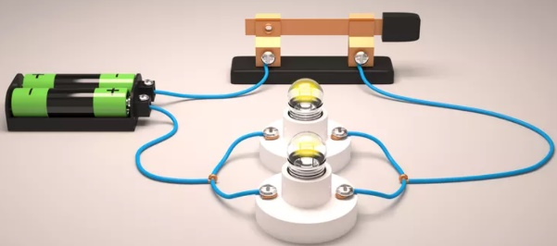  Circuit B: | Schematic Diagram. Show electron flow!

Q3: The cells are connected in series. Are the bulbs connected in series or in parallel._________________
Q4: Will the bulbs light when the switch lever is up or down?__________ Why?

Use the voltmeter to measure the voltage drop around both cells. The voltage measured is __________.

Measure the voltage drops across each bulb. Bulb 1 _______V Bulb 2 _______V

Q5: What do you notice about the total voltage supplied by the cells compared to the voltage drops across each bulb?

- For circuits C and D dry cells are either connected in parallel or in series.
- Draw schematic diagrams of each of these circuits and indicate if the cells are arranged in parallel or in series.
- Create each circuit using the simulation to see how the different arrangement of cells impacts the brightness of the bulbs. Do iii and iv before resetting circuit to make next circuit.
- Use a voltmeter to measure the voltage drop around the bulb in each circuit and cells as described below pictures of circuits. Record measurements as indicated.
- Use the ammeter to measure current as indicated.

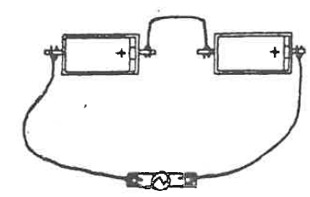  Circuit C: Cells arranged in __________________  Measurements:  Current to bulb: _______A  Voltage drop around bulb: _______ V  Voltage drop around both cells: _______ V  Draw Schematic Diagram and include an ammeter between the negative terminal and the bulb and a voltmeter to measure voltage drop around the bulb and around both cells. | Circuit D: Cells arranged in ___________________  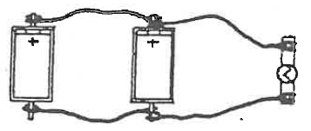  Measurements:  Current to bulb: _______A  Voltage drop around bulb: _______ V  Voltage drops across each cell:  ______ V (cell 1) _______V (cell 2)  Draw a Schematic Diagram and include a voltmeter around the bulb and each cell and an ammeter to measure current flow through the from the negative terminal of cell 2 to the bulb.
Q1: Which circuit, C or D, has a brighter bulb?_________________ Why? _____________________________ _________________________________________________________________________________________
Q2: What do you notice about the voltage supplied by the source (cells) compared to the voltage drop across the single bulb in each circuit? _________________________________________________________________
_________________________________________________________________________________________
Q3: Based on your observations in the lab so far, If you connected three 1.5 V cells in series what do you predict will be the voltage drop across all three cells ______V.
What would the voltage drop provided by the source be if these three cells are arranged in parallel? ______V.

Name:_____________________ Block: ______ #_____
Analysis/Conclusion:

1) Refer to lab observations for circuit A and B. What do you notice about your voltage drops across bulbs that are connected in series compared to bulbs connected in parallel? How do these measurements compare to the total voltage provided from the source (the two cells connected in series)? (Elec 2)

2) Refer to lab observations for circuits C and D. What did you learn about voltages provided by cells connected in series vs voltages provided by cells connected in parallel? How does the arrangement of cells impact brightness of bulbs? Which arrangement of cells makes the bulb brighter? Explain Why? (Elec 2)

- a) Draw a schematic diagram below of three 2V cells connected in parallel to a closed switch connected
in series to two bulbs in series. Include a voltmeter across each bulb and one across the parallel cells! Three voltmeters total! Show electron flow through all components in the circuit. (Elec 3)

b) Predict, based on lab results, the voltage drop across each of the bulbs in this circuit given that each
cell has a voltage of 2 V and the cells are arranged in parallel while the bulbs are in series to each other.
Bulb 1 _______V Bulb 2 _______V.

c) If the cells in the circuit in “a” were arranged in series instead of parallel. Would the bulbs be dimmer or brighter explain.

Lab Rubric
Criteria | Emerging | Developing | Competent | Extending
Schematic Diagrams  Elec 3 – I can describe different types of circuits and draw schematic diagrams showing components and electron flow | -Many schematic diagrams are incorrectly drawn.  -Several required components are missing such as meters or switches  -An understanding of how to draw circuit components in series vs in parallel has not been shown or is inconsistent and meters not correctly integrated into diagrams.  -Electron flow in circuit drawn incorrectly or unclear. | -More than half the schematic diagrams are correct, but more care is needed to correctly draw circuit and components  -Most required components included  -Some understanding of how to draw circuit components in parallel vs in series has been shown but some difficulty including meters in diagrams  -Some confusion with showing electron flow | -Most Schematic Diagrams are correct, but some minor errors. Most dry cell terminals are labelled correctly.  -All required components included  -Can draw circuit components in parallel vs in series most of the time as well as correctly including meters in diagrams  -Electron flow drawn correctly | -Schematic Diagrams are neat and correct. Lines representing wires are straight, 90 degree turns, components upright and not on corners. Dry cell terminals consistently labelled.  -All required components included  -Consistently able to correctly draw circuit components in parallel vs in series as well as correctly including meters in diagrams  -Electron flow drawn correctly and clearly through all circuit parts
Conclusions/  Analysis  Competencies 3 – I can process, analyze, and evaluate results to write a conclusion and critique results/ experiment design.  Elect2 - I can compare current with voltage and explain factors influencing electron flow through components in a circuit. | -Responses to conclusion and analysis questions are incomplete, left blank and/or unclear.  -Explanations to why questions throughout lab not provided or make no sense  -A weak understanding of concepts covered in the lab has been demonstrated. | -Responses provided for all questions but some answers are incomplete and/or unclear/incorrect.  -Attempted to respond to why questions sometimes using lab results  -A satisfactory understanding of concepts covered in the lab has been demonstrated. | -Responses provided for all questions with minor omissions. Most answers make sense.  - Most explanations provided for why questions are logical and based on lab results  - A good understanding of concepts covered in the lab is demonstrated. | -Responses to Conclusion/Analysis questions are all complete and make sense.  - All explanations provided for why questions are logical/clear and based on lab results  - A strong understanding of concepts covered in the lab is demonstrated.

