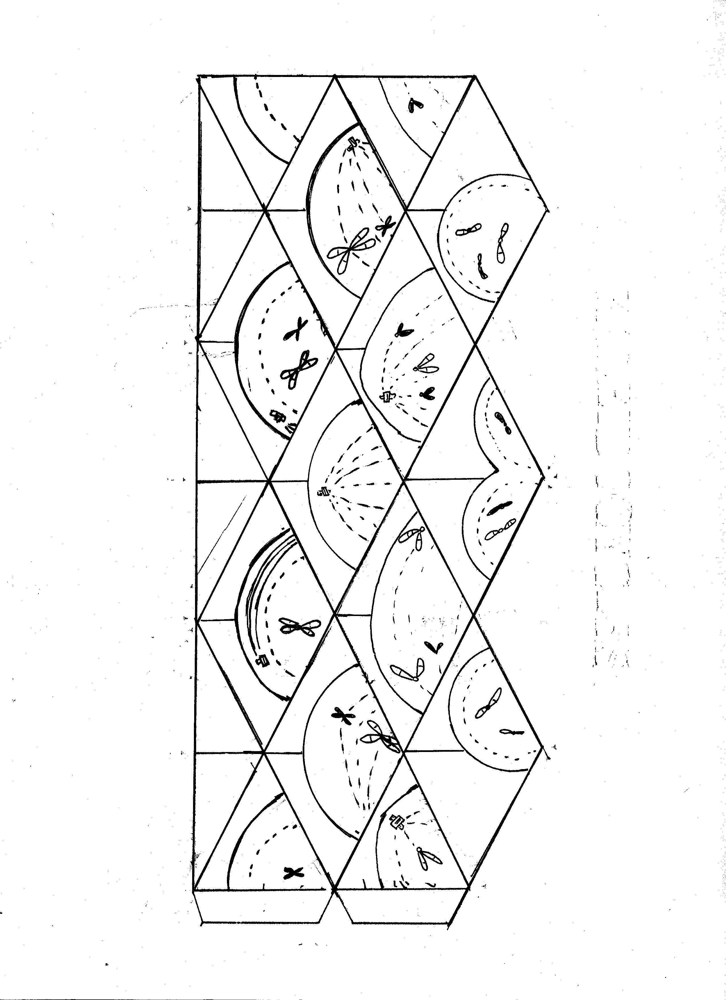

1. Cut out the shape on the left, being careful to snip the small triangular notch at the end to create two tabs.

2. You may find it useful to score all the indicated lines with a blunt probe or similar object

3. Crease all vertical lines forward (print-side to print-side)

4. Crease all diagonal lines away (back-side to back-side)

5. The Kaleidocycle will start to take shape. All top diamonds show by arrows are glued to the non-printed isosceles triangles at the base. The tabs are inserted and taped into the opposied end of the kaleidocycle.

6. It is actually easier to color the shape beore folding as long as you know what parts will line up.

Have Fun!!!