Bio 2 – I can explain and recognize main stages of the cell cycle.

Notes The Cell Cycle and Mitosis
Cells Divide to Make Identical Copies
Why?
a) Repair/_____________________ of BODY tissue/cells
b) ____________________of organism
c) Reproduction by some asexual organisms
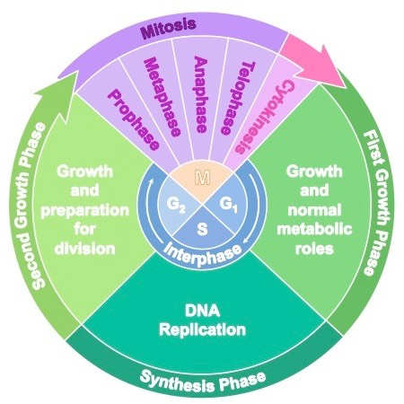
Overview of the Cell Cycle
The cell cycle includes:
1)_____________________
2)______________________
3)_______________________
1) INTERPHASE
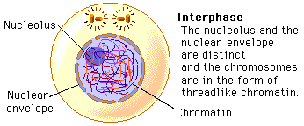
Longest phase of the cell cycle where cell carries out
regular cell functions, grows and prepares for cell division
- Cell increases in ____________
- Organelles are duplicated
- DNA is _____________________ and exists as chromatin
-loosely coiled strands of DNA

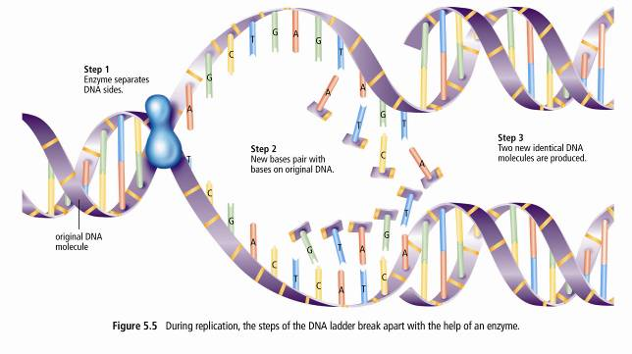
DNA is COPIED!
STEPS:
1. Enzyme separates _________________
2. New bases __________ with bases on original DNA
3. Two _______ ______________ DNA molecules are produced

2) MITOSIS – Nuclear Division
Stages of Mitosis: P M A T (________phase, ________phase, _______phase, _______phase)
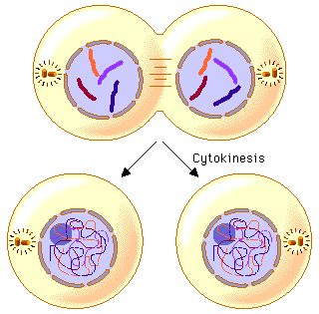
3) CYTOKINESIS – Cell division
- Cytokinesis is the splitting of ___________________
- In animals the cell membrane pinches in middle dividing the cell into two.
- In plants a cell plate grows across the middle of cell, resulting in the formation of cell walls between two daughter cells.
The RESULT OF CELL DIVISION: Two _________________daughter cells that have the same number and type of chromosomes as the parent cell!

In the diagram below label the cell life cycle stages and the phases of mitosis!
Terms to use: cytokinesis, prophase, anaphase, telophase, metaphase, interphase
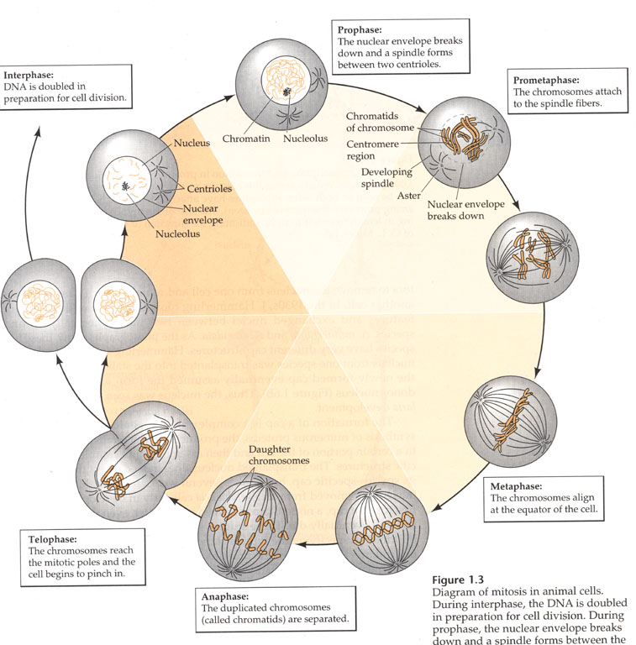
Mitosis Begins
Early ______________________

______________________
Late ______________________

______________________
(cell Division)

______________________

______________________
______________________

1) Complete the blanks below using the following terms and textbook: Some terms could be used more than once!
straight, pole(s), reform, chromatin, centrioles, sister, centromere, disappear, contraction of spindle fibres, chromatids, separate, opposite, X-shaped, nucleus, middle, cytokinesis, anaphase, telophase, middle, prophase, break down, chromosomes, spindle, two, nuclear
2) Sketch 2 chromosomes at each stage and label the important cell structures involved in that stage of MITOSIS.
Colour each X shaped chromosome a different colour! Illustrate what the cell looks like at each stage (in boxes).
Mitosis – the splitting of the____________________
P - _____________________
- The (unravelled DNA) in the nucleus, condenses to form  ____________ chromosomes.  - As this is happening the nucleolus begins to ___________________  - ______________ membrane breaks down and disappears | - The (in animal cells only) move to opposite ends (poles) of the cell.  - ______________ fibres form from  the centrioles (animal cells) or poles (plant cells)  - Spindle fibres attach to chromosomes at their ____________________  (late prophase)

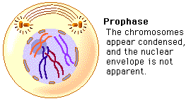

A- _____________________
- The chromatid pairs are split into two chromosomes by the __________________ _________________________ which pull the centromere apart.

- Each sister chromatids is now called a chromosome.

- The chromosome pairs then travel to opposite ___________________
of the CELL.

M - metaphase
- The tugging action of the spindle fibres pulls the X-SHAPED chromosomes
into a ____________ line across the _______________(equator) of the cell.

T - ______________________
- One complete set of chromosomes is now at each ____________ of the cell.  - The spindle fibres _________________  - A nuclear membrane reforms around each set of chromosomes | - The nucleolus ____________  - Now there are ______ nuclei  in one cell with identical DNA  - the cell is ready for _________________ (division of the cell cytoplasm)
Sketch Stage:

Do This: Mitosis Worksheets

