Notes Ohm’s Law Relationships and Problem Solving
How is voltage related to current?
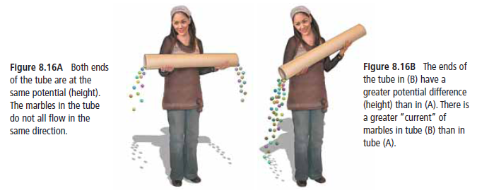
The amount of current that flows through a wire depends on the voltage. The greater the voltage the faster the charges flow.
V = IR
If ↑ V then ↑ I
If ↓ V then ↓ I

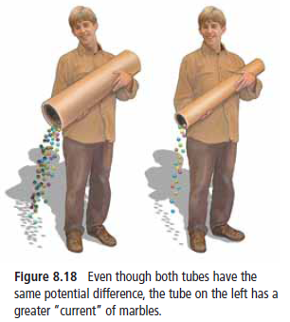
How is current related to resistance?
Amount of current also depends on
how the wire resists the flow of the charge.
V = IR
If ↓ R then ↑ I
If ↑ R then ↓ I

Ohm’s Law
Unit for Resistance is called the ___________ ( )
Ohm’s Law shows the relationship between Voltage (V), Current (I), and Resistance (R):

)

*If the units in the problem DO NOT match the standard units above, you must convert them to the standard units above!!!

To use Ohm’s Law, units must be in the standard volts (V), amperes (A), and ohms (Ω).
Mega = 1 000 000 times, kilo = 1000 times, milli = 1/1000 times (times the base unit)
Current Conversion | Conversion Factors | Conversion | Conversion Factor
1 kA = 1000 A | $\frac{1 kA}{1000 A}$ or $\frac{1000 A}{1 kA}$ | 1 A = 1000 mA | $\frac{1 A}{1000 mA}$ or $\frac{1000 mA}{1 A}$

Solving for Voltage (V) in Volts (V) V=IR

- What is the Voltage (V) across a battery in a circuit if the Current (I) is 30 A and the Resistance (R) is 10 Ω? V = ?, I = ______ and R =_______

Don’t forget to write the unit!
V =
- What is the Voltage (V) across a battery in a circuit if the Current (I) is 3000 mA and the Resistance (R) is 10 Ω?

$$I=\frac{V}{R}$$
Solving for Current (I) in Amps (A)
*Again, always double-check to make sure the units in the question are the standard units (Volts, Amps, and Ohms) otherwise you must convert them to the standard units!!!

- A circuit has a battery providing a Voltage (V) of 12V. What is the Current (I) going through the circuit if it has a resistor with a Resistance (R) of 10 Ω? I =?, V=_______, R=________

$I=\frac{V}{R}$

I =

Don’t forget to write the unit!
Always BOX your answer
I =

- A circuit has a battery providing a Voltage (V) of $1 ×{10}^{2}$ V. What is the Current (I) going through the circuit if it has a resistor with a Resistance (R) of 20 Ω?

- A circuit has a battery providing a Voltage (V) of 125V. What is the Current (I) going through the circuit if it has a resistor with a Resistance (R) of $1 ×{10}^{-1}$kΩ? I = ?, V =_____, R = _____

Solving for Resistance (I) in Ohms (Ω)
*Again, always double-check to make sure the units in the question are the standard units (Volts - V, Amps- A, and Ohms-Ω) otherwise you must convert them to the standard units!!!

- A circuit has a battery providing a Voltage (V) of 100 V. What is the total Resistance (R) in the circuit if the Current (I) is found to be 30 A? Round to the nearest tenth.
R = ?, V=_______, I=________

V = I R – Rearrange formula to solve for R!

- A vacuum cleaner is plugged into a 120 V outlet. The vacuum cleaner is rated at 12000 mA. What is the resistance of the motor and circuitry of the vacuum? (V=IR)

Now using the three forms of the Ohm’s Law formula practiced above, see if you can decide which form to use in the following mixed problems! Show all steps and work!
V = I R $I=\frac{V}{R}$ $R=\frac{V}{I}$
Practice Questions – SHOW ALL WORK and UNITS!
*Again, always double-check to make sure the units in the question are the standard units (Volts - V, Amps- A, and Ohms-Ω) otherwise you must convert them to the standard units!!!
- How much electrical potential (voltage) would there be if a hairdryer has a current of 2A and a resistance of 25Ω?

- If a washer has an electrical potential of $5×{10}^{2}$V and a current of 50A, what is the resistance?

- What is the voltage of a computer if the current is 20 amperes and the resistance is 10 ohms?

- Find the total current by using the following information measured in a circuit if V= 200V and R = 5Ω

- If an Xbox has a current of 20 amps and a voltage of 600 volts, what is the resistance?

- If a stove has a voltage drop of 900V and a total resistance of $3×{10}^{4}$ mΩ. What would be the current running through the stove?

Key: 1) 50V 2) 10Ω 3) 200V 4) 40A 5) 30Ω 6) R = 30 Ω and I = 30A
Additional Practice: Textbook pgs 293, #1-3 and 294 #1-3.
Textbook pgs. 301 #8-13 (Omit 11) and 303, #26 – 31 (omit 30);

