Types of Observations: Name:____________________________Blk_____ #____

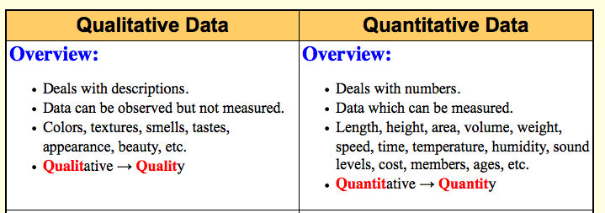

Name and then describe three objects using only Qualitative Observations:
Object 1:____________ | Object 2: _______________ | Object 3:_____________
Quantitative Observations:

Use the following equipment to make quantitative observations and then calculate densities for the metal cube and cylinder. Ensure objects are made of different metals! Record metal type in table.
Materials: Electronic Balance, ruler, calculator, cylinder and cube, pencil
Complete the table: Use the measurement of diameter to calculate radius and then plug into the formula to calculate volume of cylinder. Use measured mass of cylinder and calculated volume to calculate density of cylinder. Use measured side length of cube to calculate volume and then measured mass of cube and volume cube to calculate density of cube.
CC2-data collection CC3- data analysis CC3- data analysis
Object | Electronic Balance  Mass (g) | Use Ruler  Measure in cm to one decimal place ie 3.4 cm | Calculate Volume  $(cm^{3})$ | Calculate Density  ($g/cm^{3})$
Cylinder  Metal Type: | Mass: | Diameter – d =_________  $Radius- r=\frac{d}{2}=$_____  Height (h) of _______cm  Cylinder | $$Volume Cylinder \\ = π∙r^{2}∙h$$  $$V=π×{\left( _________\right)}^{2}×_______$$  $=$ ___________ $cm^{3}$ | $$Density of cylinder \\ =Mass÷Volume$$  $=$ $__________÷__________$  = _________________ $g/cm^{3}$
Cube  Metal Type: | Mass: | Side length (s):  $___________________ cm$ | $$Volume of Cube=s^{3} \\ ={\left( \right)}^{3}$$  $=$ ____________ $cm^{3}$ | $$Density of Cube=$$$Mass÷Volume=$  $=$ $__________÷__________$  = _________________ $g/cm^{3}$

Presenting Data and Analysis
Record results/measurements in a table below. Then create a line graph!
- Use the electric balance to measure the mass of 3, 8, 12 and 15 pennies!
Number of Pennies (n) IV | Mass (m) in grams DV | Coordinates to plot  ( n, m)
3. Make a graph to show the relationship between the number of pennies and mass in the 10 X10 grid below.
Graphing Tips!
- Put the independent variable on the horizontal axis and the dependent variable on the vertical axis!
- Label graph axes and provide appropriate scales, spacing and a title for the graph. You need to have additional values on axes so you can extrapolate
- Plot the points! Use a ruler to connect points to create line of best fit. Then do #2,3 below!

Competencies 2 - I can conduct a scientific experiment obtaining appropriate qualitative and quantitative observations
and present this data in an organized manner using tables, charts and/or graphs.
Emerging | Developing | Proficient | Extending

- Describe the patterns shown in the graph? Is the relationship between pennies and mass static, cyclic, negatively correlated or positively correlated? Explain.

Show work on graph to estimate the following! Use a ruler!
- Use the graph to estimate the mass of 10 pennies? ____________________________(interpolate between points)

- Use the graph to estimate the mass of 18 pennies?____________________________(extrapolate beyond points)

Emerging | Developing | Proficient | Extending
Competencies 3- I can process, analyze, and evaluate results to write a conclusion and critique results/experiment design.

