Warm-up: Review parallel vs series circuits
A circuit contains two lamps, each with a measured potential difference of 4.0 V.
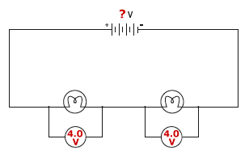
What is the voltage of the battery in the circuit?
  - 16.0 V
  - 8.0 V
  - 1.0 V
  - 4.0 V

A circuit contains two lamps, a battery, and three ammeters.
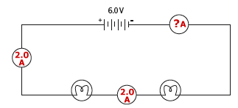
Based on the readings on two of the ammeters, what is the reading on the third ammeter?
  - 2.0 A
  - 4.0 A
  - 1.0 A
  - 3.0 A

Three lamps are connected in a circuit in parallel with a 9.0 V battery.
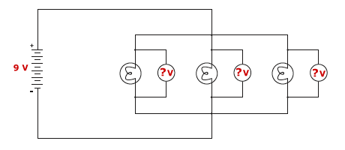
What will be the measured potential difference across each of the three bulbs?
  - 9.0 V
  - 3.0 V
  - 1.0 V
  - 4.5 V

Which of the following statements regarding current in circuits is true?
  - The total current in a parallel circuit must always equal the voltage in the circuit
  - The current in a series circuit varies from component to component
  - The current at all points in a series circuit is the same
  - The current at all points in a parallel circuit is the same

Which of the following circuits containing three equal value resistors would result in the greatest total circuit resistance?
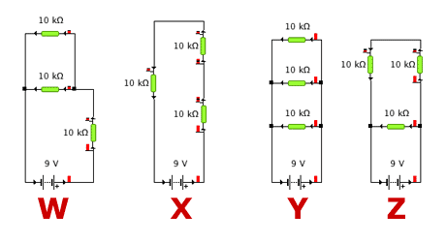
  - Circuit W
  - Circuit X
  - Circuit Z
  - Circuit Y

