Wild Fire Photograph

[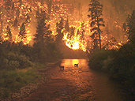](javascript:popup_scroll('es0103page05_popup2.cfm','400','550'))

Tornado Photograph

