Typical Relationships between Variables which can be determined from Graphs
-Organize the sentence strips into categories based on whether they describe a positive correlation, negative correlation, static, or cyclic relationship between variables.
-Paste two examples of each type of relationship into your handout.

GRAPH: | 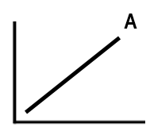 |  | 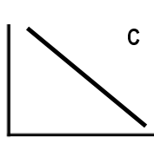 | 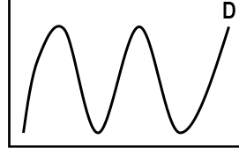
VARIABLE RELATIONSHIP: | Positive Correlation | STATIC | Negative Correlation | CYCLIC
EXAMPLES:

Review of how to construct a Line Graph:

Draw a graph representing the data below. Use the grid provided. Be sure to label axis, with name of variables and units, and provide a title.
Changes in Heart Rate with Exercise

Exercise (min) - Independent Variable – x axis | Heart Rate (#beats/min) – Dependent Variable – y axis
0 | 65
1 | 75
3 | 95
4 | 105
5 | 125
6 | 135
7 | 145
8 | 155
10 | 155

Determine scale by dividing the highest number in each column of table of values by number of grid lines on
x – axis or y – axis. Adjust interval chosen to make data fit in given grid and easier to plot.

The independent variable: Time (min) labelled on x – axis

$_____÷_____=$ so count by _______ starting at zero on x axis! Even spacing and intervals!

The dependent variable: Heart Rate labelled on y – axis
$_____÷_____=$ so count by _______ starting at zero on y axis!
Title:___________________________

To Do
1. Label axes names & Title
2.Write in numbered
scale!
-start at zero
-Even spacing!
-Equal intervals!
3. Plot points
4. Create line of best fit

5. Interpret data: Describe the relationship between the variables that is shown in this graph?

Steps:

- Cut out the following descriptions of relationships between two variables.
- What would the data look like if it was presented in a graph?
- Sort into appropriate categories. Check sort with teacher!
- Paste/glue two examples for each category into the table for your notes.

- The higher the temperature of the air in the oven, the faster a cake will bake.  - As the time I spend at the mall increases, the money in my wallet decreases.  - The more time people spend using social media, the less able they are to express themselves in conversation.  - As more water pours from the tap, the volume in the bath increases. | - As a climber increases his/her altitude, the temperature decreases.  - As the size of a post-it note increases, density of the post-it remains the same.  - As time in a day increases, ocean water levels rise and fall in a predictable pattern.  - As the time Ms. Harnik spends watching “The Voice” increases, her singing ability remains the same.  - As date of the month increases, phases of the moon repeat in a pattern. | - As distance from the equator increases, temperature decreases.  - As the time of year changes from September 2018 to September 2019, the temperature in Delta begins to decrease, then increase, and then decrease again.  - As volume of a piece of quartz increases, its density remains the same.  - As the time Mr. Turpin spends in the car increases, his distance remains the same. Why would this be?

