Reproduction

Asexual Reproduction vs Sexual Reproduction
Requires ____________________ | Requires two parents
Produces offspring_____________to the parent. | Produces offspring _____________ from the parents.
Can produce_________ offspring very ______ | Requires _________ time and ____________to produce offspring
Results in limited ____________within a species | Results in lots of ________________ within a species
Mitosis is one form of asexual reproduction and results in offspring that are _____________ to parent | Meiosis is used to produce specialized sex cells called __________________: ___________(from males) and ___________ (from females), which combine to produce a new individual.

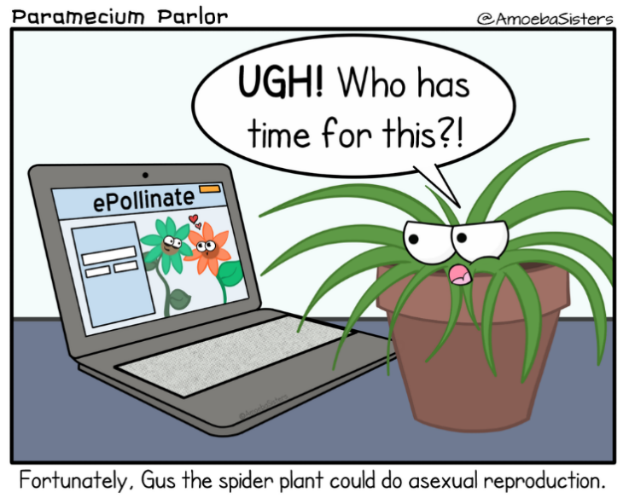

How SEXUAL REPRODUCTION Works: Requires Two Parents
DNA from each parent combines Genetically unique offspring
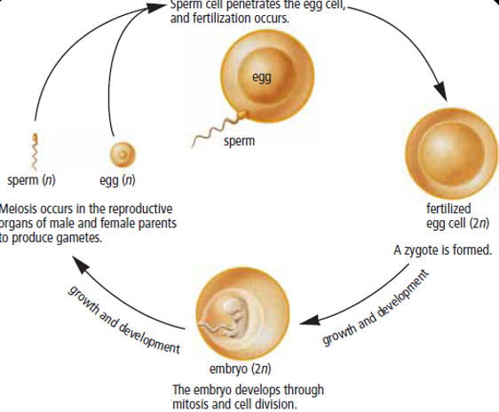

In Humans the Process of Fertilization:
  - A single sperm penetrates the outer covering of the ______________ (egg)
  - Nuclei of sperm and ovum fuse = single __________________cell is forme.
  - The fertilized cell is called an ____________________.
  - The zygote begins to divide by _________________ producing more cells.
  - Once a zygote becomes two cells, it is called an _________________. The embryo increases in size by further cell division (mitosis) and eventually develops specialized cells which make up various body structures in an organism.

What’s Essential to Sexual Reproduction?
  - _______________________________ in the same _______________ at the same________________ so that genetic information can be combined.

Internal Fertilization External Fertilization
-Sperm meet egg ____________ female body  -Embryo/offspring develop _____________ by parents  -Few offspring | -Sperm meet egg ______________________  -Lots offspring produced quickly  -__________________ to outside world  -Many offspring don’t survive
Eg. Eg.

Success after fertilization requires:
  - enough ________________________________________ and appropriate temperature
  - protection from ____________________________________
Pollen /Seed Transport
Purpose: Increase ________________Diversity and ________________________ of Offspring
- Move pollen or seeds ______________ from parent (as far as possible)
- Genes _______________________________ rather than remaining near parent
- Pollen (containing_____________) released and carried by wind to female parts by insects and some birds by______________________.
Some Common Pollinators are:

Seed Dispersal: How?
________________________________________________________________

Purpose of Fruit

- Fruit contain seeds which hold the zygote (______________________________)
- Eaten by animals and ______________________________________ to form new plants.
- New plants grow _____________ from parent plants so ________________competition for food and other resources which __________________survival of offspring.
- Fruit also _____________ seeds from environment.
Complete Assignment on Sexual vs Asexual Reproduction
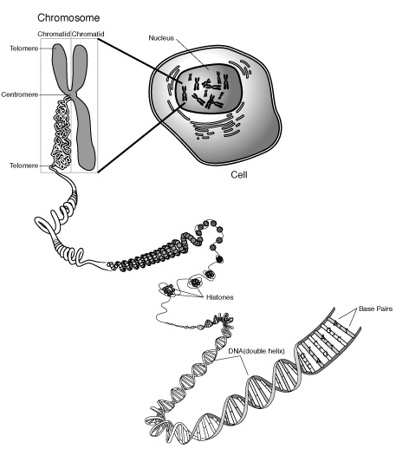
Diploid vs Haploid Cells and Meiosis
Chromosomes are compacted DNA!
- Chromosomes contain ________________information
- _________________ ensures all cells in the body (except sex cells) have the same DNA and the same number and kind of chromosomes
- Mitosis occurs in somatic or ______________ cells

Ex:

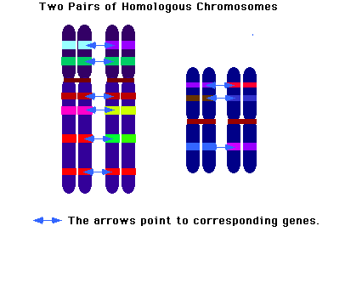
Diploid Cells
- Every organism has its own unique number of chromosomes. Humans have _______________.
This is called its diploid number or the total number of chromosomes in a body cell.
Diploid means “2 ____________” and is written as “2n”.
$n+n =2n$
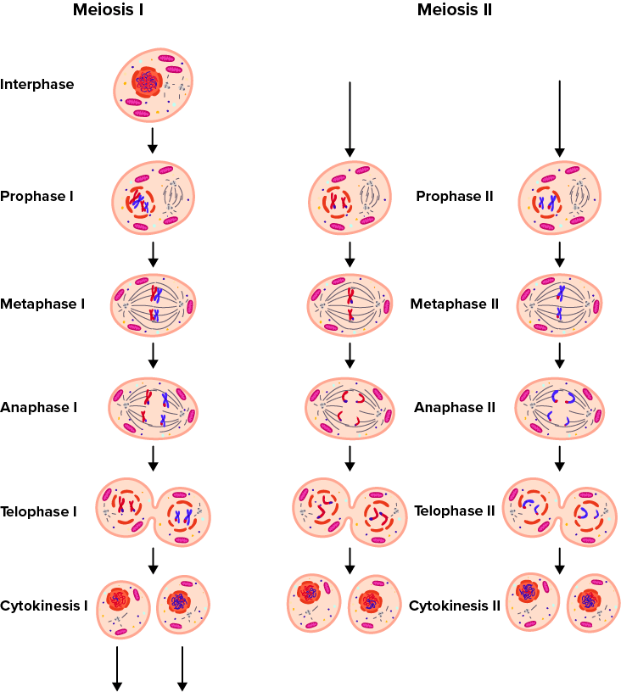
- Body cells of adult organisms have 2 sets of
(matching) chromosomes –
______________________ chromosomes
1 set from female parent gamete and
1 set from male parent gamete

Haploid Cells
- Gametes are specialized ________________ produced
during ___________________. A similar process to mitosis
which involves ________________________________.
- Gametes are haploid cells (n) because each sperm or
egg cell only has ____________ of each chromosome.
Meiosis – Formation of Gametes
Two Parts: Meiosis I- PMAT I and Meiosis II-PMAT II
Prophase I, Metaphase I, Anaphase I, Telophase I Interkinesis
Prophase II, Metaphase II, Anaphase II, Telophase II and Cytokinesis

Meiosis – the process in which the number of chromosomes in the original cell is _______________ by_______________ through the separation of homologous chromosomes
- Meiosis occurs in sex organs only
- Males (XY) – sex organs are the_____________ in humans
- Females (XX) – sex organs are the ______________ in humans
- Meiosis also occurs in the sex organs of other animals, plants, fungi, etc…
- When does meiosis occur in humans?
- Males beginning at_______________________
- Females before __________________ – all eggs are produced before birth and at puberty eggs mature
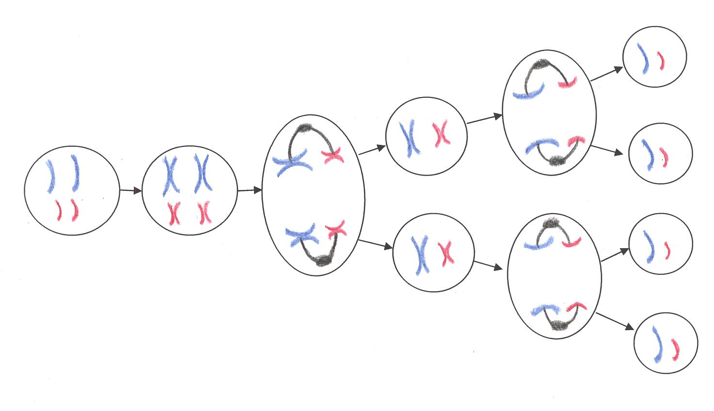
Parent cell
Chromosomes duplicate
Division 1
Division 2
Daughter cells (gametes) have _______ as many chromosomes as parent cell

Sex Cells

- Meiosis produces sex cells called _______________– cells with ½ the number of chromosomes as the original parent cell
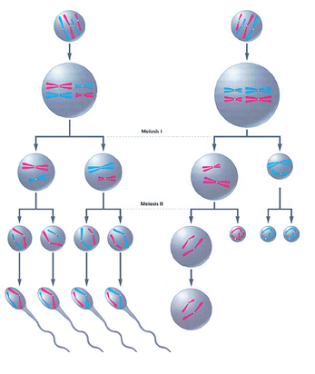
- Males – meiosis produces_____ sperm
- Females – meiosis produces
1 (viable) egg
-The other 3 cells are called polar bodies – they give up their cytoplasm to nourish the 1 healthy egg.

Unique events in Meiosis
- Homologous (matching) chromosomes ____________________ before 1st cell division
Homologous chromosomes:
-look alike
-code for same traits
-receive one from each parent
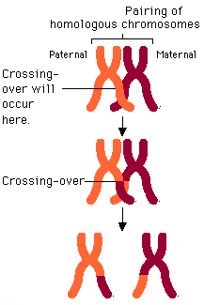
- During 1st division, homologous chromosomes __________________genes during process called “___________________________________”

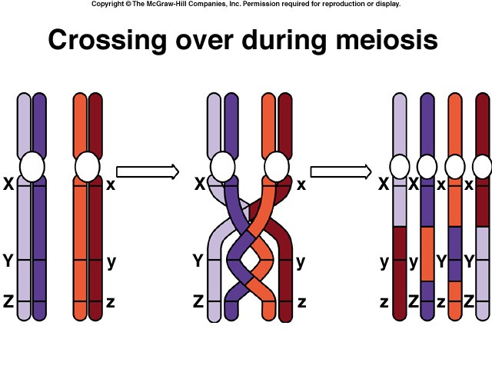

- These homologous chromosomes separate during______ division of meiosis – so chromosomes in gametes are _________________from each other due to crossing over

- Crossing over increases ________________ variation and is the reason why siblings look ______________

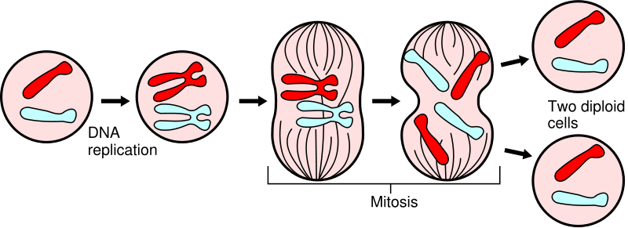

No crossing over – daughter cells are identical to parent cells
Mitosis

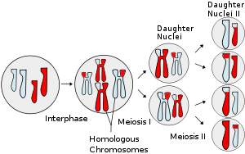

Meiosis
Crossing over occurs –causes genetic variation
(Daughter cells are NOT identical to parent cell)

VIDEO AND SNURFLE MEIOSIS ACTIVITY

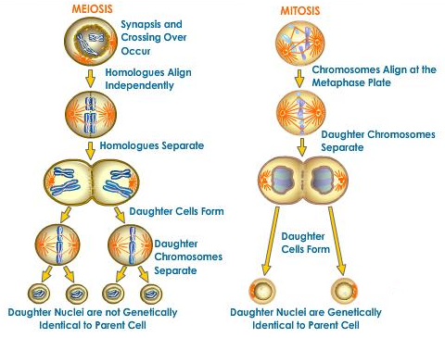

Comparing Mitosis and Meiosis

 | Meiosis | Mitosis
Where does this process occur? | Male (XY) = in_____________  Female (XX) = in____________ | in __________________________
What kind of cells are produced?
When does this occur? | Male (XY) = puberty  Female (XX) = _________________ | Any time
# of Divisions  (Draw picture) | ____ | ____
# of Daughter cells produced | Male (XY) = _____ sperm  Female (XX) = ____ viable egg(s) | _____
# of Chromosomes in daughter cells | ________ as many as parent cell  haploid or N  In humans ___chromosomes/gamete | Same as parent cell  diploid or 2N  In humans _____chromosomes/cell
Type of Reproduction
Genetic Composition | Daughter cells are  identical / not identical  to parent cell  Genetic variation | Daughter cells are  identical / not identical  to parent cell
Pairing of Homologous Chromosomes | YES / NO  Crossing over of genes occurs during ________phase ___ of meiosis | YES / NO
Function/Importance | To produce haploid cells called:  ___________________ | Growth, repair; development of adult from zygote

Exit Reflection Questions:

What is an advantage of sexual reproduction and a disadvantage? Use a specific example to explain.

What is the difference between an ovum, embryo and a zygote?

Why do humans have two copies of each chromosome in each body cell instead of only one?

What process is responsible for combining the two sets of chromosomes? ________________________

What two processes only occur during meiosis and not during mitosis?

A dog has a diploid chromosome number of 78 in each body cell. How many chromosomes would be in each gamete cell?

