Topic IV: Solar Radiation’s Impact on the Earth System
Earth- I can explain how solar radiation impacts the Earth System.
Without heat and light from the Sun, life on Earth would not exist. The sun emits huge amounts of electromagnetic radiation which travels in waves of energy through space to Earth.
Electromagnetic Radiation coming from the sun is predominately:
- _____________________________ radiation that we can see
- _____________________________ radiation –heat from the Sun
- ___________________________ radiation – shorter, high frequency waves, high energy waves.
UV-C waves have enough energy to destroy all life on Earth.
The sun emits many forms of electromagnetic radiation in varying quantities.
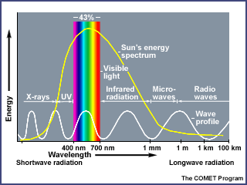
About 43% of the total incoming energy emitted from the sun is in the _________________ parts of the spectrum. ________________________ energy which we feel as heat on our skin is about 50%.
Ultraviolet radiation (UV) is only ______.
Less than 1% of solar radiation emitted by sun is dangerous, high frequency, short wavelength ________________ rays and gamma waves.
Most of the most harmful radiation from the sun is absorbed by the ionosphere or other parts of the atmosphere and does not reach the surface of Earth.
The Earth is constantly “blanketed” in solar radiation from the sun. About 30% of this energy is reflected back to space by ____________________________ in the atmosphere and the
different surfaces on the planet while 70% of incoming radiation is absorbed either in the atmosphere or by water or land warming these surfaces.
Fortunately for Earth, incoming radiation is balanced by _____________________radiation otherwise the planet would heat up and become uninhabitable.
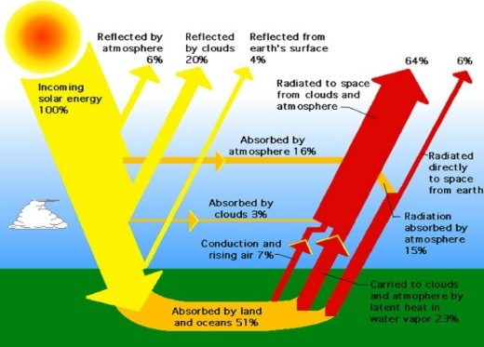
Distribution of the Sun’s Energy

The albedo of a surface impacts how much energy is reflected by surface or absorbed. Albedo refers to the amount of energy ___________________ by a surface.
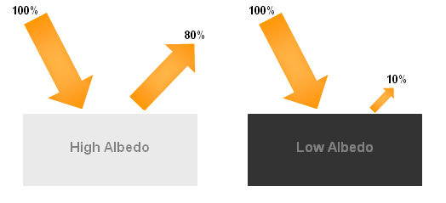 | Light-coloured surfaces (snow, sand) have a  _________ albedo and reflect energy.  Dark-coloured surfaces (soil, water) have a  _________ albedo and absorb energy.
Some surfaces heat up and cool down faster than others.
In the following list, which substances do you feel will heat up the fastest and cool down the fastest? Which will heat slower and retain heat longer?
White sand Dark soil Water
Complete the following:
I think that _________________________________ will heat the slowest and retain heat the longest.
I think that _________________________________ will heat the fastest and lose heat quickly.
Explain your choices! How does the albedo of a surface affect heat retention?

Why does the equator receive more solar radiation than the poles causing higher temperatures and greater exposure to harmful UV radiation?
The angle of the Sun’s rays reaching the equator are at ______degrees so not only are they more ___________________ so incoming radiation is spread over a _______________area but also the thickness of the atmosphere is __________________ at the equator, so less radiation is absorbed by the atmosphere before reaching the biosphere.
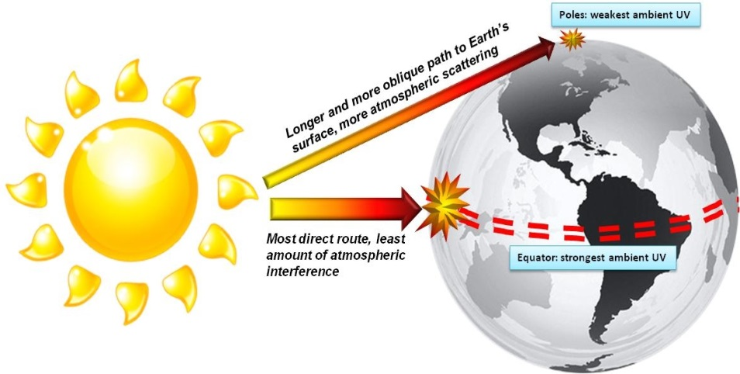
Formation of Wind
- The uneven ______________________of the Earth Surface results in air over land being heated
differently than air over water and the poles being colder than equatorial regions.
- _________________ transfers heat absorbed by the ground to the particles in the air which heat up, rise and then __________________ currents transfer this energy throughout the atmosphere.

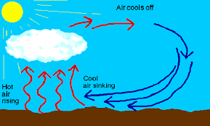
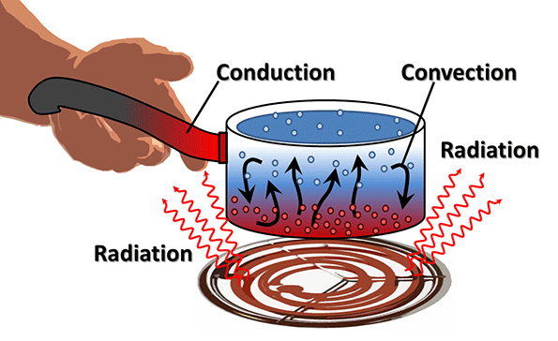
Convection Air Current

- Warm air rises and cools and then drops creating differences in _____________________________.
- Air will flow from areas with _______________ air pressure and cooler more dense air to areas with _________air pressure containing less dense, warmer air. This movement of air is called ________.
View wind Video
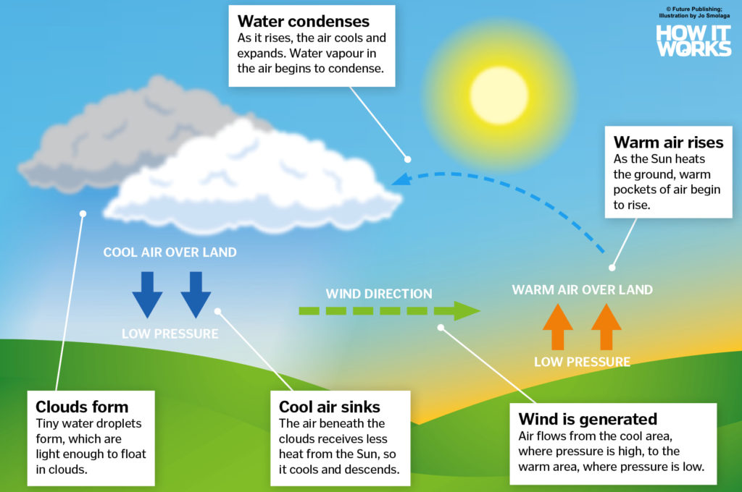
Wind Formation

Ocean Currents
Uneven heating of the earth surfaces and the ________________ of the planet global wind patterns
Which impacts downwelling and upwelling of ocean waters between cooler nutrient rich waters and warmer surface waters Global movement of ocean water.
This circuit of the ocean waters is called the global ________________________________________.
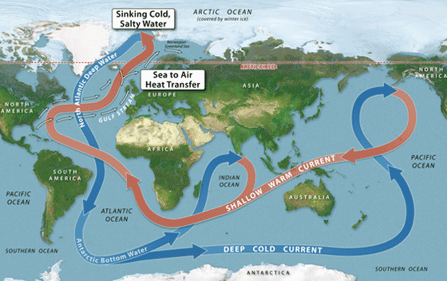
It can take water in the ocean _______ years to
complete one circuit.
Cold surface currents ________coastal areas
Warm surface currents_______ coastal areas

Other factors such as ___________________________________________________________________ will impact flow of ocean currents.
** Take notes on these factors as you watch the video on ocean currents.

Earth- I can explain how solar radiation impacts the Earth System.
Total: /16 Emg Dev Prf Ext
<9 9-11.5 12-14 >14
Respond to the following questions on solar radiation interactions with the biosphere/atmosphere/hydrosphere and it’s role in creating Wind and Ocean Currents
Some websites for Reference:
https://derm.net/2019/01/is-infrared-good-or-bad-for-your-skin/; https://science.nasa.gov/ems/07_infraredwaves; https://spaceplace.nasa.gov/sunburn/en/
http://www.skincancer.org/prevention/uva-and-uvb
http://www.cancerresearchuk.org/about-cancer/causes-of-cancer/sun-uv-and-cancer/how-the-sun-and-uv-cause-cancer; https://www.cancerresearchuk.org/about-cancer/causes-of-cancer/sun-uv-and-cancer/the-uv-index-and-sunburn-risk
https://www.betterhealth.vic.gov.au/health/conditionsandtreatments/sunburn
- What effect does infrared radiation exposure from the sun have on human skin? /1

- Which type of UV radiation is most harmful to life and why? /2

- How does ozone protect the biosphere from this deadly UV radiation? /1

- What is sunburn and what type(s) of radiation cause(s) sunburn? /2

- Describe some factors which reduce/increase the amount of UV-A and B you are exposed to?
/3

- How does the high Albedo of objects like white sand and snow increase the severity of a sunburn? /1

- What processes, forces and/or factors affect the size, shape, speed, and direction of ocean currents? /3

- What is wind? How does the wind form? Why are some winds stronger and some winds weaker? /3

