Earth - I can communicate an understanding of interactions between Earth’s spheres and the interconnectedness of everything within the Earth System.
There are _________major parts in the Earth system. Each part has its own collection of materials and processes. However, the parts of the Earth system do not operate on their own. They all interact with other parts in many ways as nutrients cycle and energy moves through the spheres.
The four spheres are ____________________________________________________________
- The atmosphere - extends up from the Earth surface for several hundred _________
The most important layers of the atmosphere to life on Earth are the _____________________________ _______________________________.
-Troposphere - This is the lowest part of the atmosphere - the part we _____________.
It contains most of ____________________ i.e. ____________________________
________________________.
It contains about _____________ of all the air in the atmosphere and water in the form of ___________________________________
Water vapour in the air helps ______________ _____________ from the ___________, _______________ our planet. The tropopause is the boundary of this layer.
-Stratosphere - extends upwards from the tropopause to about ______km.
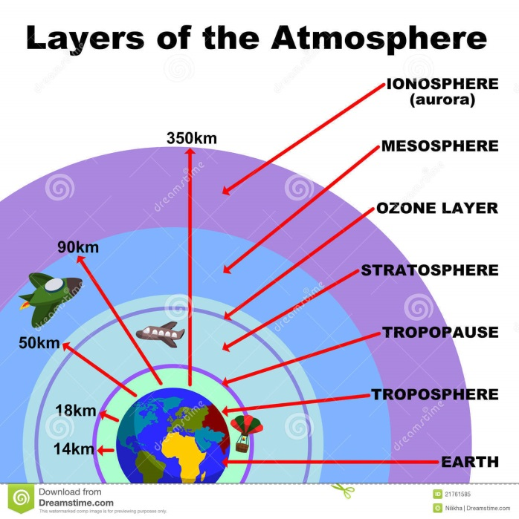
It contains much of the __________________ in the atmosphere. This layer is essential to life on earth as it _____________________harmful ___________________ from the sun.

- The biosphere is all __________________ things, from single-celled bacteria to plants and animals.

- The geosphere = _____________ - includes all minerals, ___________, molten rock,
sediments, and __________________. The Earth’s core, crust and mantle.
- The hydrosphere = __________________ - includes the ______________________,
rivers, lakes, streams, ___________________, water vapor, and even puddles.
- The cryosphere is the_________________ part of the hydrosphere and includes snow, ____________________, and polar ice caps (sea ice).

The Sun’s Importance to the Earth System
- The Sun has a large impact on the Earth and so it is also considered a part of the Earth system. Almost all the __________________ on Earth comes from the Sun.
- The sun provides the primary source of _____________ for all living _______________.
- Plants and other _______________________ use the sun’s energy to create high energy molecules for ________________ and ______________________.
- This process is called __________________________.
- Biogeochemical cycles that provide essential ___________________ for living things are driven by the sun’s energy as well.
- Water is cycled through the different spheres with the _______________________ being the driving force maintaining the cycle.
- Gases and materials in the atmosphere interact, ______, __________ and absorb the sun’s radiation which influences global _________________________.
- _______________is impacted by ____________ and _____________currents which in turn are driven by the Sun’s energy.

Interactions in the Earth System
- The Earth System is dynamic and always _______________________.
- Materials in the system move from one sphere to the next in different ways.
- Such as through _________________ and _________________
- Mountains grow out of the geosphere as ______________________ collide. Volcanos erupt releasing materials into the __________________.
- Water moves in different states ( ) through the _______________ cycle.
- Elements important to life, cycle between the living and nonliving parts of the Earth system through biogeochemical cycles such as the _____________, __________________and __________________cycles.
- Ocean currents and wind patterns in the atmosphere play a major role in _____________nutrients as well as ___________________________from the sun throughout the Earth System.

Complete Prezi interactive and questions! Then view Video on Bennett Dam Impact and reflection questions!

