NOTES: Compounds,Molecules, Formulas and Bonding

Important to know!

- Elements are made up of only one type of atom
such as Hydrogen = H₂ or Copper = Cu
- Molecules are made up of two or more atoms
such as Cl₂ or CO₂
- The a compound is made up of 2 or more atoms from different elements.
such as K₂S

What is a compound?
- _____________________________________________ joined together by chemical bonds
- The substance has ________________________ properties than the elements that make it up.
- The elements making up the compound exist in specific ratios

Ex. Water = H₂O Contains:_____________________________________________________________________________

Chemical formulas of Compounds /Molecules show:
- The proportion of each element present in the substance
- The elements present in a substance
- Number of atoms of each element in the substance
- Parentheses may be used to show groups of atoms that stay together and behave as a unit

E.g. CO ₂ =

E.g. Ca(NO₃)₂ =

How many atoms are in the following compound: Ca₃N₂ ?

Try the Following:

1) How many different elements are in the following compound? Al (OH)₃ ____________________

How many atoms are in this compound? __________________________________________

2) How many elements different are in the following compound? (NH₄)₃ PO₄ ____________________

How many atoms are in this compound? ___________________________________________

2 Types of Compounds

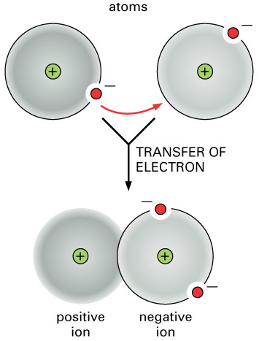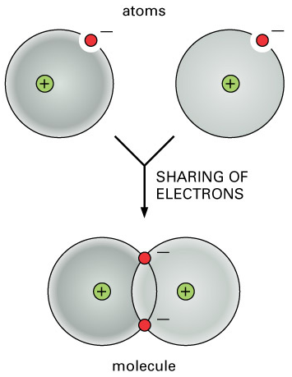
Covalent
Ionic

- Electrons _____________ between two or more __________________ atoms  - Form “molecules” a neutral particle made up of atoms joined by covalent bonds  - Bonding due to electron sharing | - Electrons ____________________from  metal to non-metal to create oppositely charged ions  - Form “ionic lattice”  - Bonding due to attraction between oppositely charged ions (+/-attraction)

Covalent Compounds
_______________________ atoms share electrons to form ______________________
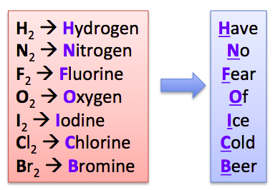
Example 1 H₂O  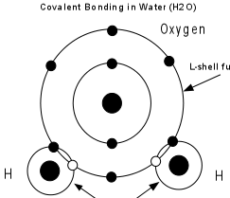 | 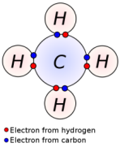  Example 2 CH₄

Diatomic molecules: Non-metal elements that always exist as two atoms
___________________________________covalently bonded together.

Ionic Compounds

__________________ transfer electrons to ____________________ to create a bond.
Example NaCl
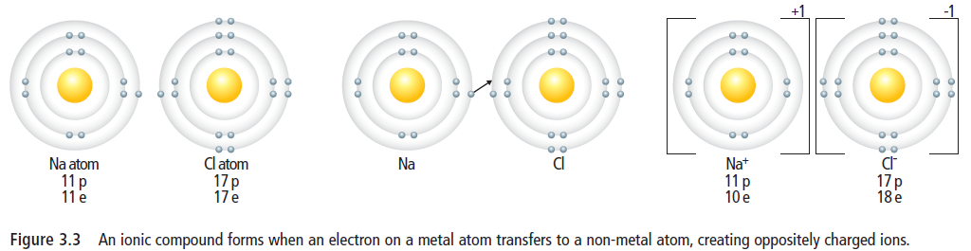

________________ charged Sodium ions are attracted to ___________________ charged Chloride ions
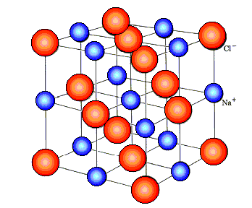
Ions come together to form an ___________ ______________.

All __________ ions attract all __________ ions to form a ____________________ (eg. grains of salt).

Polyatomic Ions -.A group of ________________________ bonded chemically to each other that has a ___________________

Some examples of polyatomic ions are:

Do This: Refer to text pages 76-80;
Complete: Ions vs Atoms vs Compounds and Comparison Sheets (Mark with keys on Website)

