Topic II: Understanding the Biosphere and Energy Flow
Earth- I can explain how energy flows through the biosphere and how abiotic and biotic factors influence biodiversity and organisms at different trophic levels.
Ecology is the study of the interactions between living organisms, including humans, and their environment; it seeks to understand the ______________________ between plants and animals and the world around them.
In an Ecosystem View – Ecology Intro Video (by teacher’s pet)
Living things are affected by interactions between with other living organisms and non-living things co-existing in a specific area.
Biotic (living parts of the environment) –
Abiotic- (non-living parts of an environment) –
Energy Flow through Ecosystems
Every organism needs to obtain energy to live. For example, plants get energy from the _______________, some animals eat plants, and some animals eat other animals.
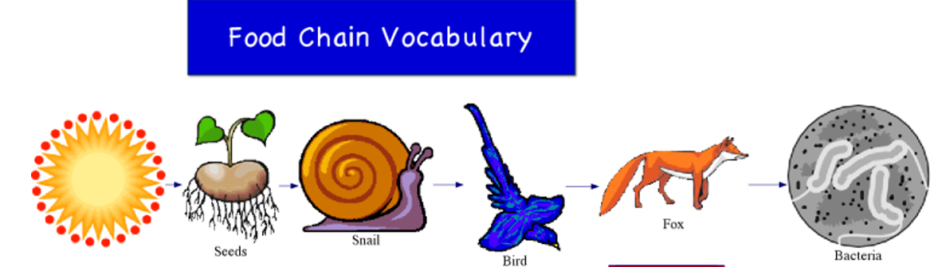
A food chain is a series of steps where organisms _______________ _________________ by eating and being eaten.

Energy  __________ | P_____________ | Herbivore  Primary  ______________ | Predator and/or_______  Om____________  _______________  Consumer | Predator  C______________  Tertiary  Consumer | D________________
Direction ________________Moves

Energy flow in a Food Chain
The food chain starts with the primary energy source, usually the ____________.
The next step in the chain is an organism that makes its own food from an energy source. These kinds of organisms are called _______________________ or autotrophs. In most ecosystems green plants and some kinds of single-celled living things make their own food (sugar) from sunlight through ___________________________________.
Organisms that cannot make their own food and must eat producers or other living things are called
___________________________ or heterotrophs.
When any organism dies, it is eventually eaten by detritivores or scavengers (such as ________________
___________________________________________) and /or broken down by decomposers
(mostly _________________________________________________). These organisms break down
dead organic material to get the energy they need to grow and reproduce.
Trophic Levels: The trophic level of an organism is the position it holds in a food chain.
- Primary producers -organisms that make their own food from sunlight are the base of every food chain
- Primary consumers are animals that eat primary producers; they are also called
herbivores (___________________________________________).
- Secondary consumers eat primary consumers.
They are carnivores (____________________) and ___________________ (consumers that eat both animals and plants).
- Tertiary consumers eat secondary consumers.
- Quaternary consumers eat tertiary consumers. Like an ________________________________
- Food chains "end" with top predators, animals that have little or no natural enemies.
Like a ____________________________________________________________
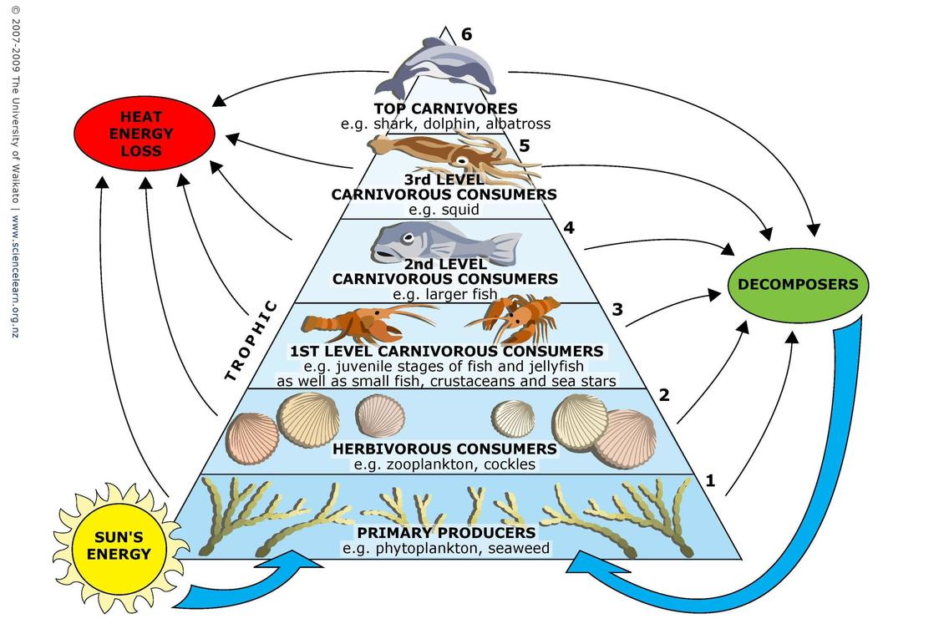
Decomposers and Detritivores feed on all dead organisms at each trophic level.
The arrows in a food chain show the flow of energy, from the sun to a top predator. As the energy flows from organism to organism, energy is ___________at each step.
Do card sort by trophic level!

View: How the Wolves Change Rivers: Video link
A ______________________ weaves together two or more food chains within any given ecosystem. All organisms are connected to each other through their feeding relationships. So, if the population of one species is adversely affected this will affect the survival of other populations in that ecosystem.

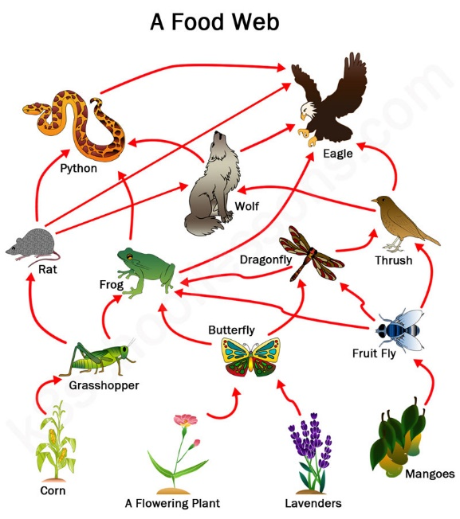
Ecosystem Diversity:
In any food web, energy is lost each time one organism ________another. Because of this, there must be many more __________ than there are plant-eaters.
There are more producers than consumers, and more plant-eaters than meat-eaters.
Although there is intense competition between animals, there is also an interdependence. When _______ ______________ goes extinct, it can affect an entire food chain of other species and have unpredictable consequences.

- Complete worksheets to review lesson concepts and terms!

