Name: Understanding Circuits and Electron Flow

Questions: Which materials will allow current to flow in a circuit? What factors impact current flow in a circuit?
Background:
Conductivity is the ability to conduct or transmit heat, electricity, or sound. Conductors are materials that allow electricity to easily pass through. Insulators are materials that resist the flow of electricity, so electricity does not easily pass through. Current will not flow if a circuit is open or incomplete. All components must be placed in circuit correctly for current to flow through all devices. The greater the resistance the slower the current. The greater the voltage the faster the current.

Hypothesis:
IF we place a conducting material into a complete circuit, THEN electrons will able to flow through it.

Procedure:
- Type in the following URL: https://phet.colorado.edu/en/simulation/circuit-construction-kit-dc
- Click the play button to begin the simulation.
- Click and use the ‘Intro’ simulation.
- Create the following circuit:
*The lightbulb looks like:
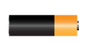
*The electrochemical cell (looks like a battery) looks like:
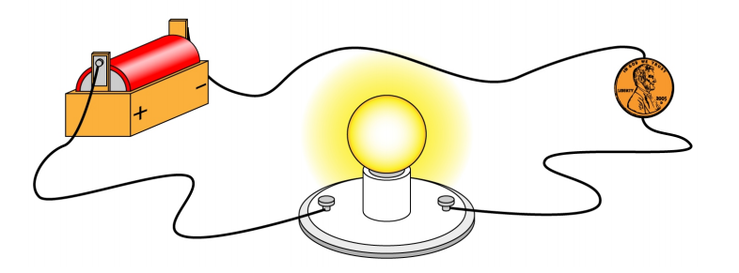
- Click the value button in top right box to see resistance of devices and objects in circuit.
- What is the resistance through the coin? _____Ω
- Do the electrons move in the circuit containing the coin? Yes or No.
- Is the coin a conductor or an insulator? _________________ How do you know?

- In which direction do the electrons move in the circuit? Be sure to refer to the positive and negative terminals of the cell in your response.

- Replace the coin with the different objects provided on the side of the screen.
Complete the following table: Click value button on top right box to record resistance of object

Object | Conductor or Insulator? | Resistance Value  In Ohms (Ω)
Dollar Bill
Paper Clip
Pencil
Eraser
Wire

Which materials stop the flow of electrons?____________________________ Why?

- Another device in your circuit is the light bulb.
  - What is the amount of resistance that is provided by the lightbulb? ______________
  - Is the light bulb considered a source, conductor, load or switch in a circuit? How do you know?

- Put the coin back into the circuit and click on the following button.
The diagram shown is called a circuit diagram.

- Add a switch to the circuit.
- What happens to the electron flow when the switch is closed? (Closed Circuit)___________________
- What happens when the switch is opened? (Open Circuit)____________________________________
- What is the purpose of a switch in a circuit? ______________________________________________

- Draw out the circuit diagram using the symbols that you see:

- From the circuit diagram and/or side panel what is the symbol that represents:
- An electrochemical cell: b. the object: c. A lightbulb:
- A wire: e. An open switch:
- Reset the simulation and then create the following circuit. Draw a circuit diagram using above symbols.
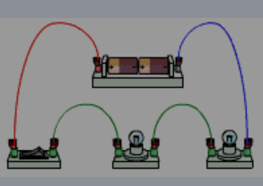

1
2

- Ammeters are used to measure the amount of current flowing through a closed circuit. Close the switch you created #12. You should see the electrons moving! Use the ammeter to measure the current between the negative terminal of the cell and the first light bulb.
  - How much current is flowing through the circuit? _______Amperes
  - If you place the ammeter in other positions within the circuit, what do you notice about the amount of current?
  - Remove one cell from the circuit. Reconnect and close the circuit. Measure the current ______A
  - Replace the cell and remove one light bulb from the circuit. Reconnect and close the circuit.
Measure the current with only one light bulb: ______A

How was current changed by removing a cell? Increased or decreased
How was current changed by removing a light bulb? Increased or decreased

Follow-up Questions/Conclusion:
- What are some characteristics that make an object an insulator? Name at least 2.

- What are some characteristics that make an object a conductor? Name at least 2.

- In the simulation, compare the resistance provided by each of the objects tested. What do you notice about the resistance of the conductors compared to the resistance of the insulators?

- Does current flow through conductors or insulators? ____________________Why?

- What components must be present in a circuit in order for the current to flow?

- During your investigation what stopped the flow of electrons?

- What did you do that made the current increase? Why do you think this happened?

- What did you do that made the current decrease? Why do you think this happened?

- While you were creating your circuits you may have seen the circuit burn. This probably indicates a short in the circuit. What causes this?

Voltage in a Circuit How does voltage behave in a simple series circuit?

Use the Phet DC Simulation lab to investigate changes in voltage in circuits.
https://phet.colorado.edu/en/simulation/circuit-construction-kit-dc

Create the following circuit using the lab simulation: 1. Draw a circuit diagram including a voltmeter in parallel around the two cells and another around the two light bulbs. 2. Then redraw the circuit diagram but this time include a voltmeter to measure voltage around each individual light bulb.

Diagram 1 Diagram 2

1
2
Check Diagrams are correct before proceeding!

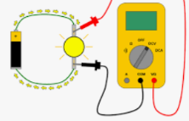
Voltmeters measure the voltage change across devices in a circuit. The wires must be placed on either side of device so that the reading is positive and voltmeter connected as shown in diagram.

Refer to your circuit diagram when placing voltmeters in circuit.
- Voltage measurements with two cells. Close the switch so current flows.
  - Measure the voltage supplied by both cells. Connect the voltmeter to the positive terminal of the first cell and the negative terminal of the second cell. The voltage drop around the two cells is_____ Volts
  - Measure the voltage drop around both light bulbs together. The voltage drop is ______ V

  - Measure the voltage drop around each individual light bulb. bulb 1: ________V bulb 2: _________ V

  - Measure the voltage drop around the switch. The switch voltage is _______ V

Why is there no voltage lost across the switch?

- Remove one cell from the circuit. Make sure the current is flowing.
Then repeat measurements of cell, bulbs and individual bulb voltages.
  - The voltage drop around the one cell is_____ Volts
  - Measure the voltage drop around both light bulbs together. The voltage drop is ______ V

  - Measure the voltage drop around each individual light bulb. bulb 1: ________V bulb 2: _________ V
How did removing one cell change the voltage measurements? What happened to the current?

How does the total voltage provided by the battery compare to the total voltage lost by the light bulbs?

