# 

# Unit 3

## **Right Angle Trigonometry**

Learning Targets:

#1: I can determine a missing side length in a right triangle using the appropriate ratio (sine, cosine or tangent)

#2: I can determine a missing angle in a triangle using trigonometry

#3: I can solve right triangles to find the missing side lengths and/or angles using a combination of trigonometry and the Pythagorean Theorem

#4: I can solve word problems using trigonometr to find either the missing side length or angle and be able to draw and label a diagram.

**Lesson 1 – Introduction to Trigonometry**

Trigonometry is the branch of mathematics that studies the relationships between angles and the lines that form them in triangles. It was first developed for use in astronomy and geography. Today, trigonometry is used in surveying, navigation, engineering, construction, and the sciences to explore the relationships between the side lengths and angles of triangles.

Fact 1: Every triangle contains 3 sides and 3 angles or vertices (plural of vertex).

Fact 2: The measurements of these angles always total 180°.

Fact 3: To identify the side or vertex in a triangle, label the triangle following a standard routine. Each vertex of a triangle is labeled with a capital case letter and each side is labeled with the lower case letter that matches the opposite vertex.

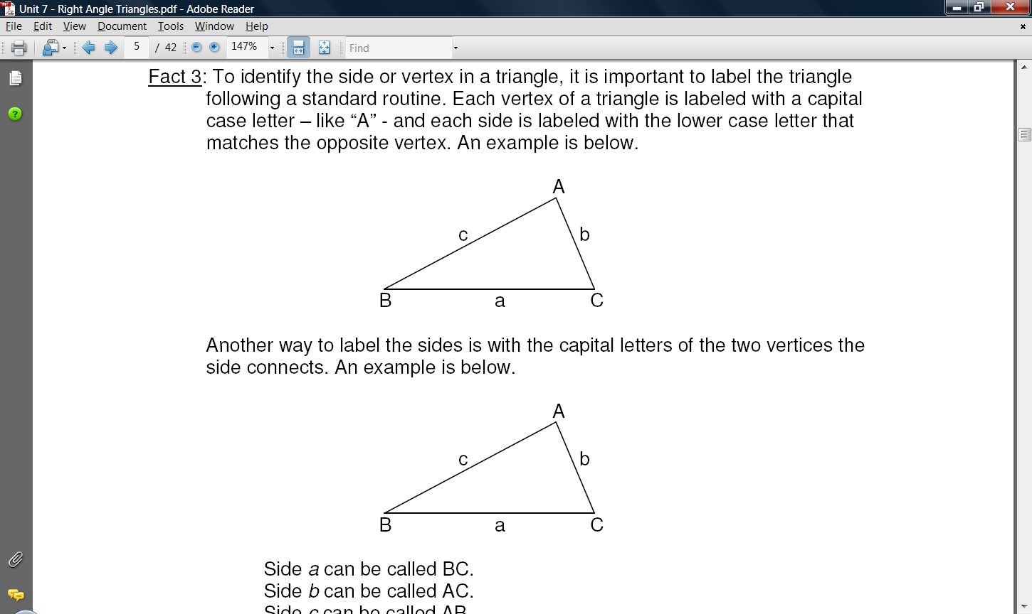

Example:

Another way to label the sides is with the capital letters of the two vertices the side connects.

Side *a* can be called BC.

Side *b* can be called AC.

Side *c* can be called AB.

An angle is identified using the three letters that create the angle or using a Greek letter such as $θ$ or $ϕ$. This is especially useful when there are more than one angle such as the triangle below

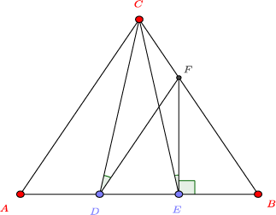

In this triangle, while we can understand what $∠A$ would mean, $∠D$ is more difficult to understand. The angle labelled as $θ$ could also be called

1. Label each side of the triangles below using a single lower case letter matching the opposite vertex.

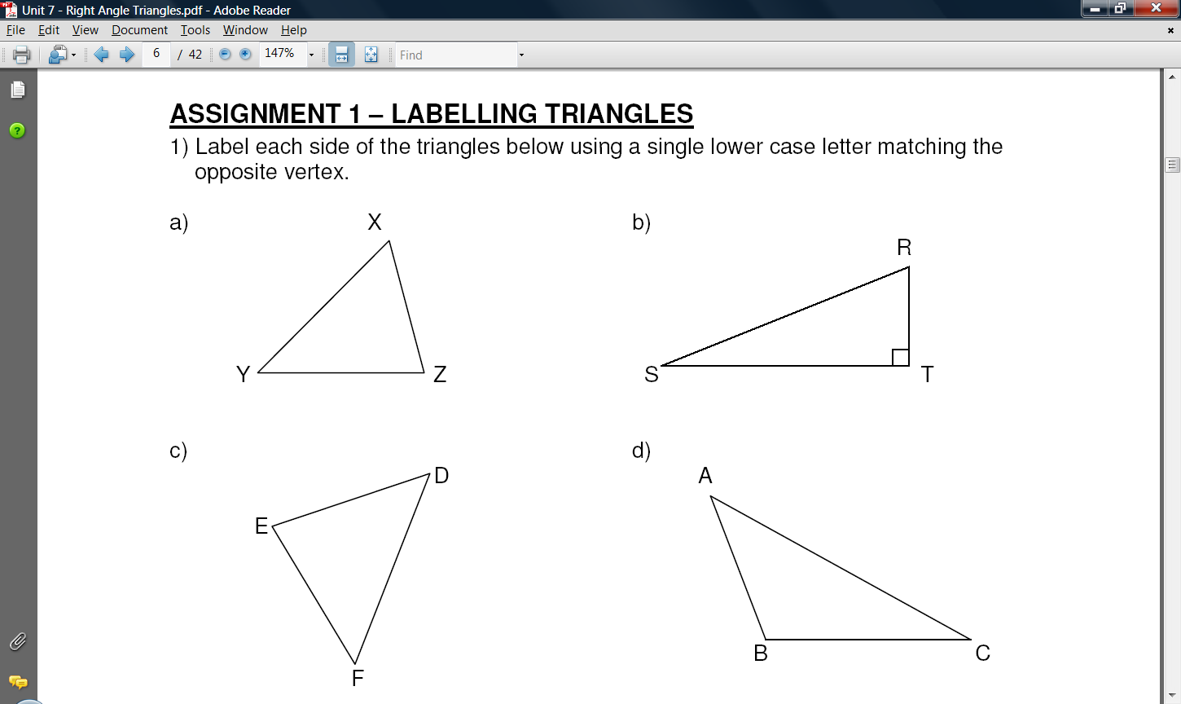 a) b)



2. Label each vertex of the triangles below using a single capital letter matching the opposite side. Identify each angle using the three letters that create the angle.

a) b)

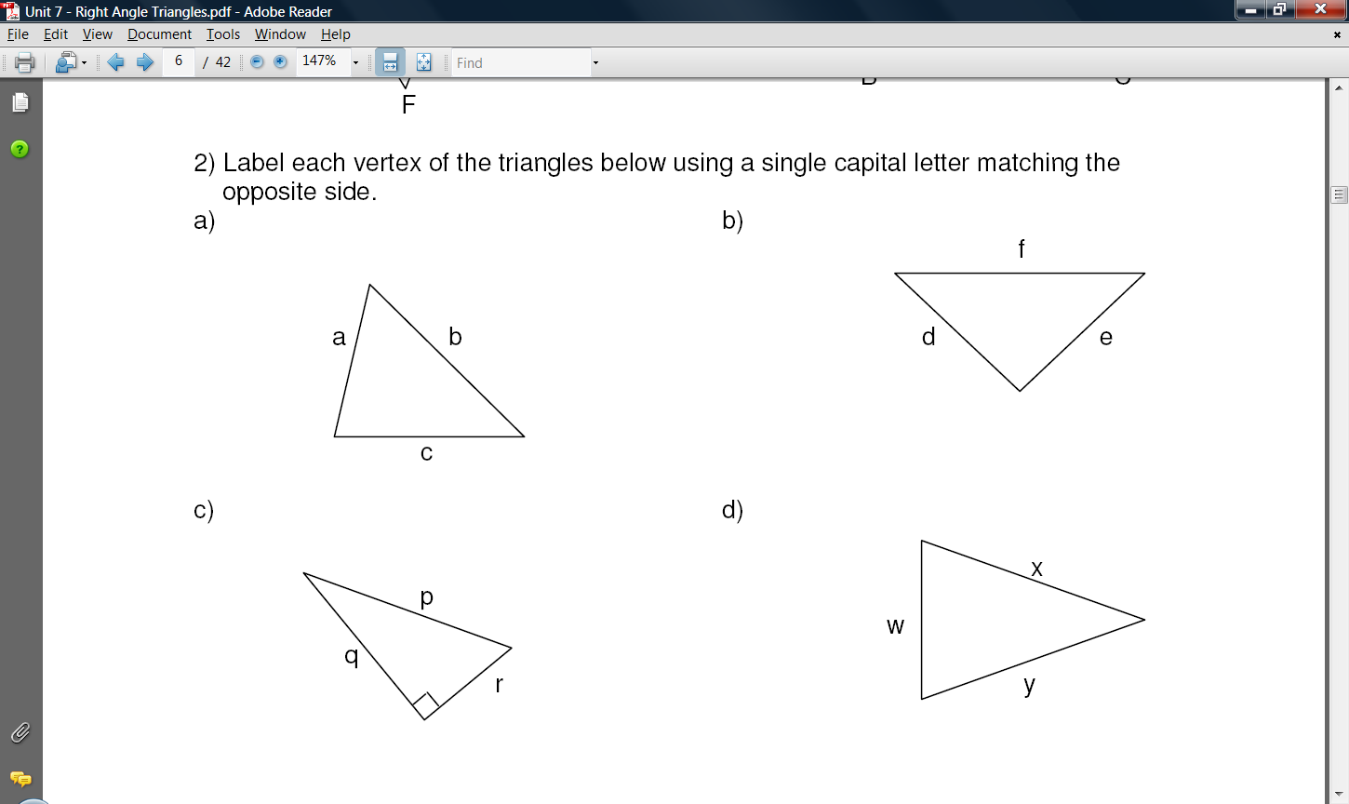

3. Draw ΔABC where ∠C = 90°, AB = 8, *b* = 3. Label all the sides and angles appropriately.

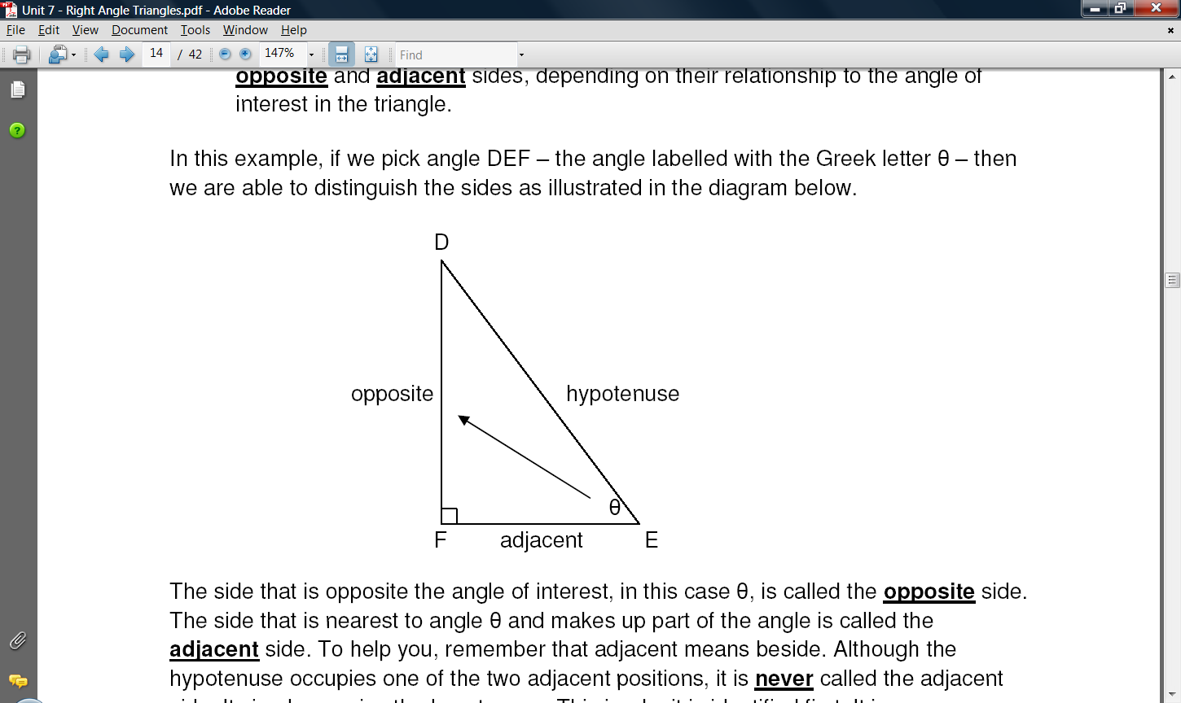Fact 5: The side of the triangle that is opposite the 90° is always called the **hypotenuse**. It is labelled in the triangle below. The other two sides of the triangle are called legs.

Fact 6: The hypotenuse is always the longest side in the triangle. It is always opposite the largest angle which is the 90° or right angle.

Fact 7: In trigonometry, the other two sides (or legs of the triangle are referred to as the **opposite** and **adjacent** sides, depending on their relationship to the angle of interest in the triangle.

The side that is opposite the angle of interest, in this case θ, is called the **opposite** side. The side that is nearest to angle θ and makes up part of the angle is called the **adjacent** side.

4. Write down the name of each side (adj, opp, hyp) according to the angle.

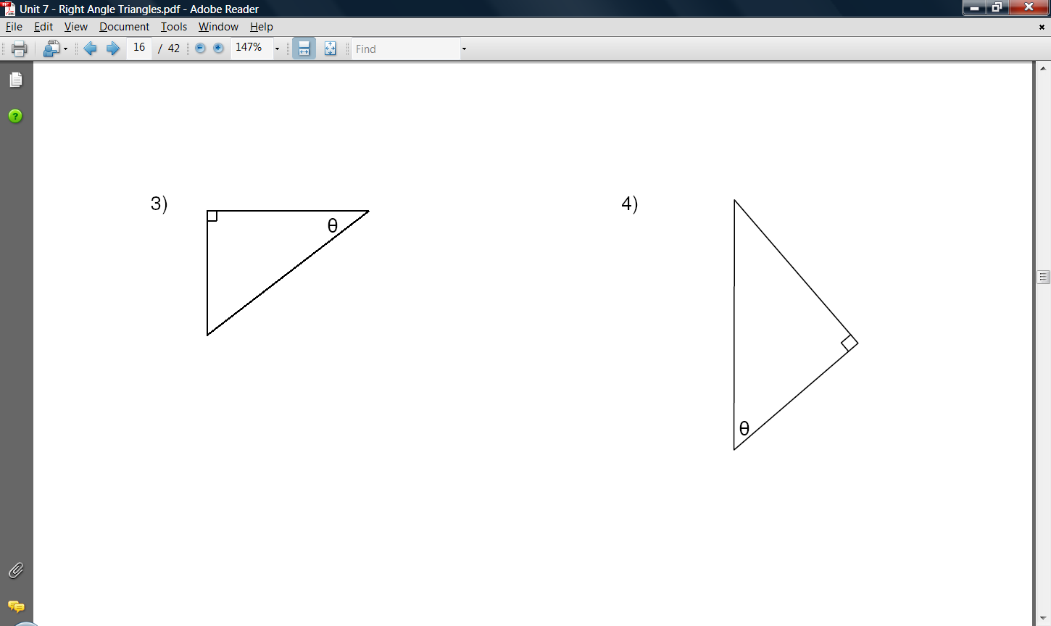

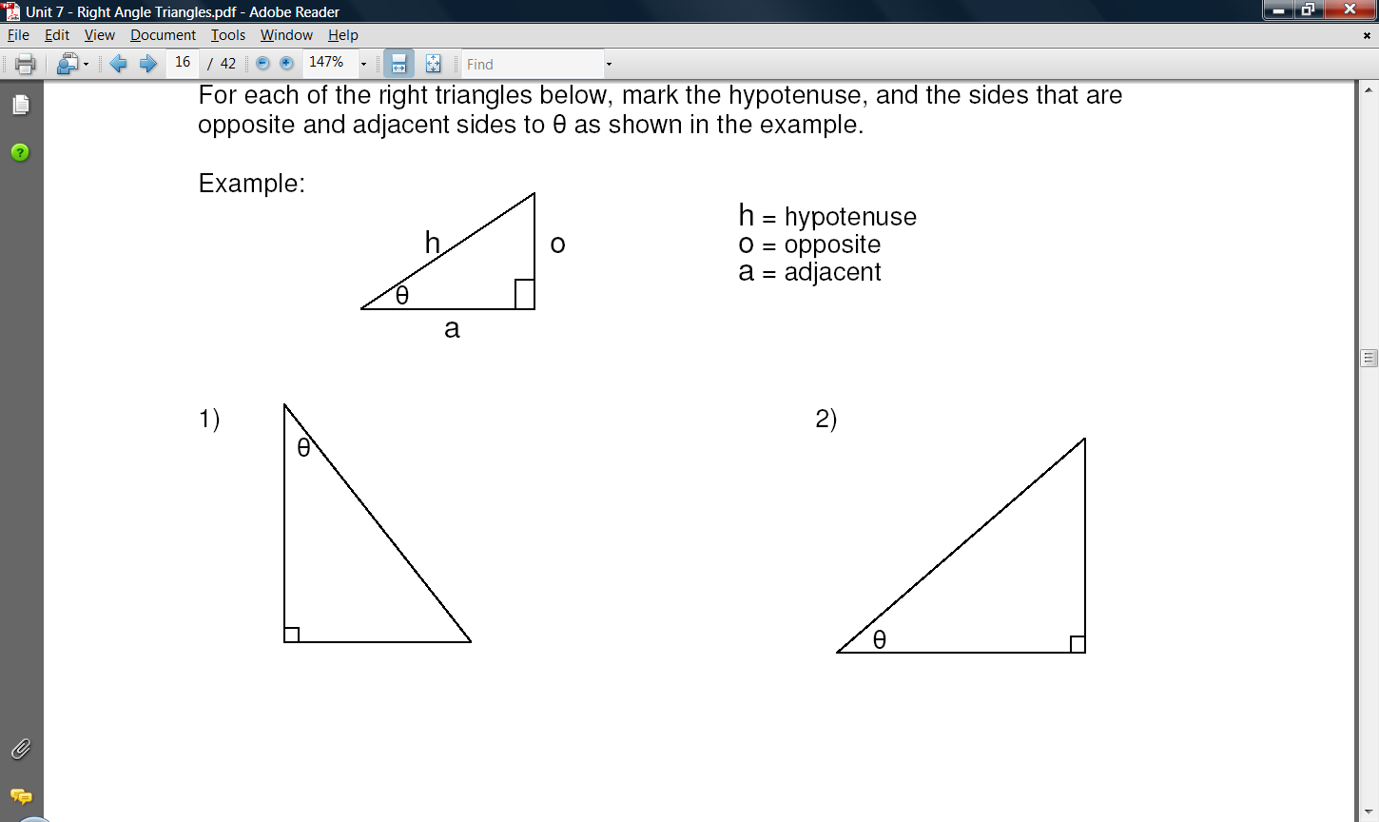 a) b) c)



Fact 8: For any right-angled triangles, we can use the Pythagorean Theorem to help us find the lengths of the sides.

*a*

*b*

*c*

*b*

*a*

*c*

The ***Pythagorean Theorem*** states that:

***a*2 + *b*2 = *c*2**  only if this is a right-angled triangle.

5. Find each missing length to the nearest tenth.

a) b)



**Sine**, **cosine**, and **tangent** are trigonometric ratios for right angled triangles.

SOH CAH TOA

The short forms are **sin**, **cos**, and **tan** that you see on your scientific calculator.

sin θ =  or sin θ = 

cos θ =  or cos θ = 

tan θ =  or tan θ = 

*A way to remember the different trigonometric ratios is by the acronym* SOH•CAH•TOA

*What do the trig ratios mean on a diagram?*

It does not matter the sizes of the 2 triangles. If they are scaled, all angles are still the same. Then the ratio of the lengths of the sides would be equal.

6. Find the following trig ratios.

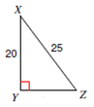 a) b)

 sin X =

cos X =

tan X =

sin C =

cos C =

tan C =

7. Using your calculator, find the following to 3 decimal places (if necessary).

a) sin 30° b) sin 48° c) cos 30°

d) cos 48° e) tan 30° f) tan 48°

Assignment: Trig Ratios Assignment in notes

**TRIGONOMETRIC RATIOS ASSIGNMENT**

1) Calculate the value of **sin θ** to four decimal places.

θ 5.2 in 8.1 in

θ

6.9 m 9.6 in

4.3 m

2) Use your calculator to determine the value of each of the following sine ratios to four decimal places.

a) sin 100 = ______________ b) sin 480 = ______________

c) sin 770 = ______________ d) sin 850 = ______________

3) Calculate the value of **cos θ** to four decimal places.

θ 5.2 in 8.1 in

θ

12.4 cm 7.9 cm 9.6 in

4) Use your calculator to determine the value of each of the following cosine ratios to four decimal places.

e) cos 100 = ______________ f) cos 480 = ______________

g) cos 770 = ______________ h) cos 850 = ______________

5) Calculate the value of **tan θ** to four decimal places.

θ

5.2 in 8.1 in

6.5 m

θ

9.6 in

5.1 m

6) Use your calculator to determine the value of each of the following tangent ratios to four decimal places.

i) tan 100 = ______________ j) tan 480 = ______________

k) tan 770 = ______________ l) tan 850 = ______________

7) There are two special sine ratios. Calculate the following.

a) sin 00 = ______________ b) sin 900 = ______________

8) There are two special cosine ratios. Calculate the following.

a) cos 00 = ______________ b) cos 900 = ______________

9) There are some special tangent ratios. Calculate the following.

a) tan 00 = ______________ b) tan 450 = ______________

c) tan 890 = ______________ d) tan 900 = ______________

**Lesson 2 – Using Trig Ratios to Solve for Lengths**

Whenever two pieces of information are known about a right triangle, all other pieces of information can be found. How you will find the other information depends on what information is initially given.

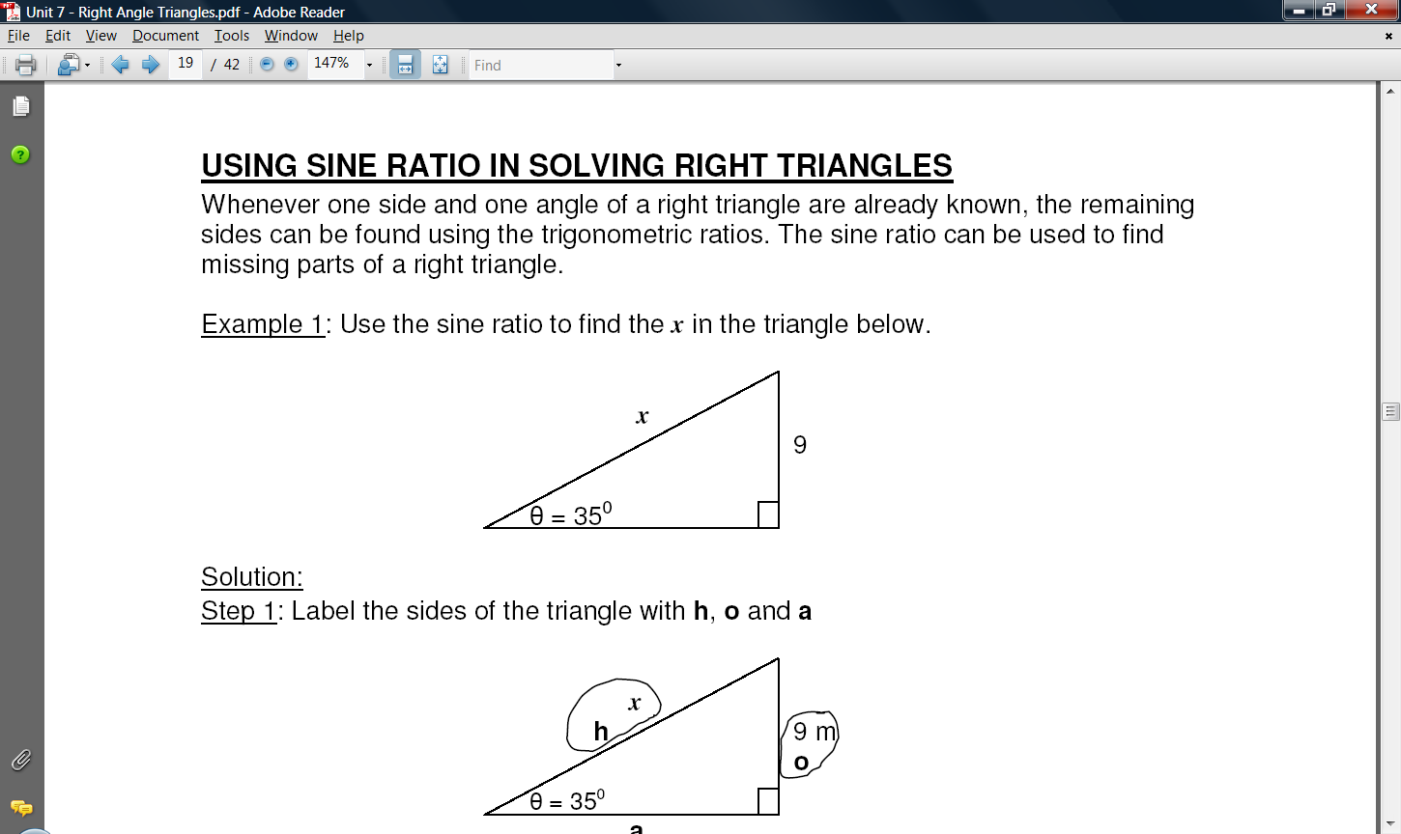Example 1 Compute side *x*.

*Step 1*: Label the sides of the triangle with **hyp**, **opp** and **adj**.

*Step 2*: Identify the ratio required to solve for *x*.

*Step 3*: Substitute the correct values into the correct ratio. Solve using the process cross multiply and divide.

Example 2: Find the missing side for each triangle below

1. 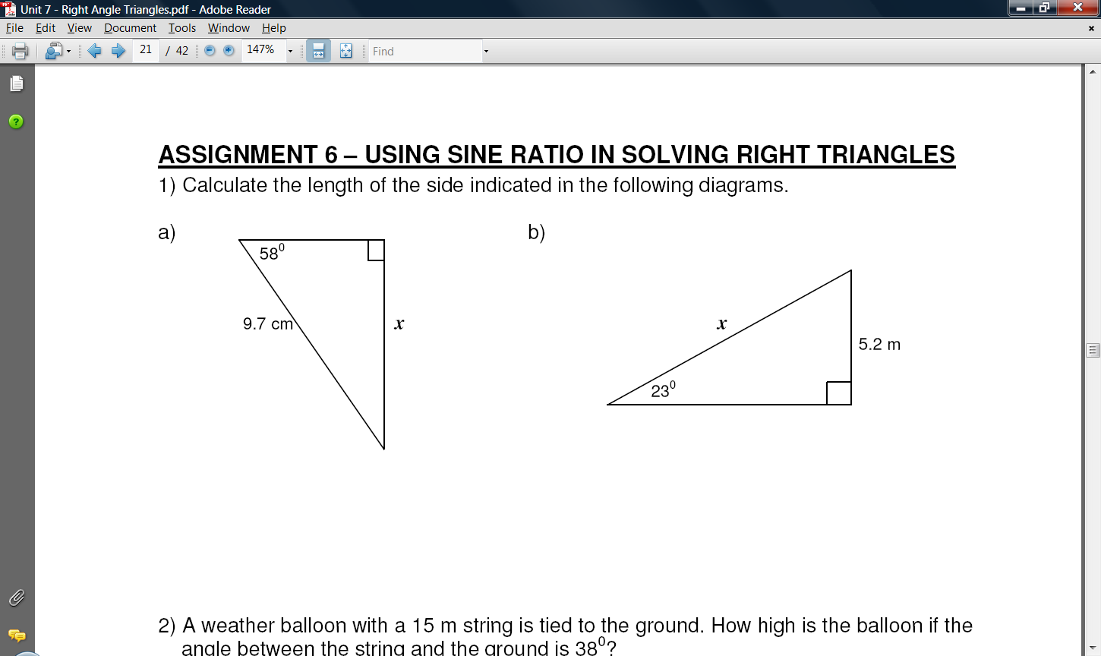

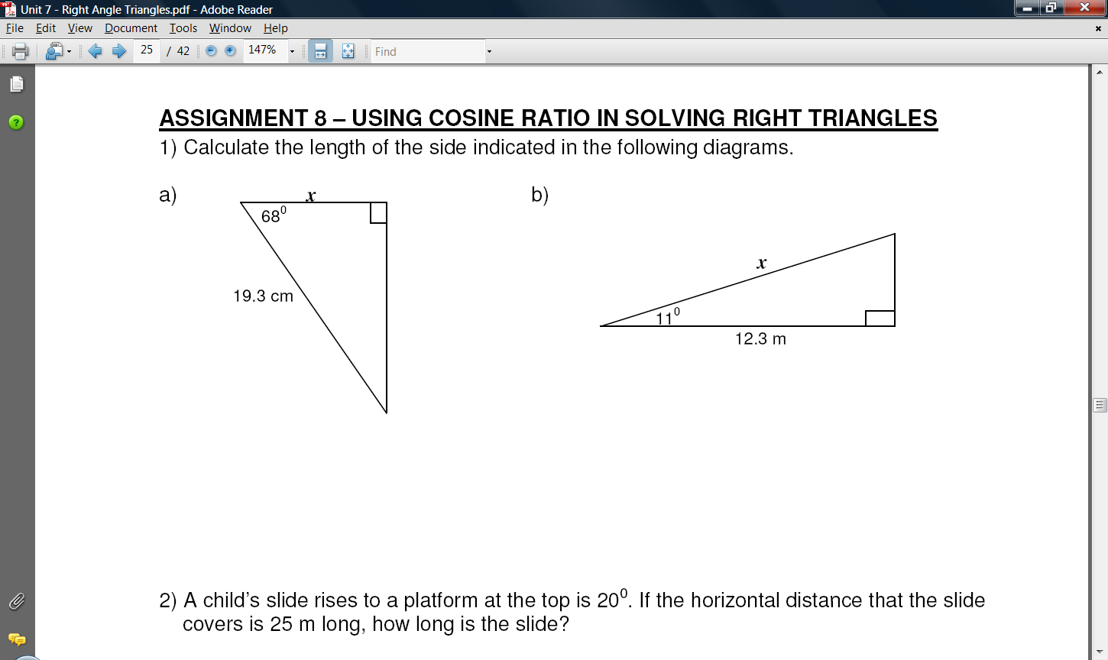

1. 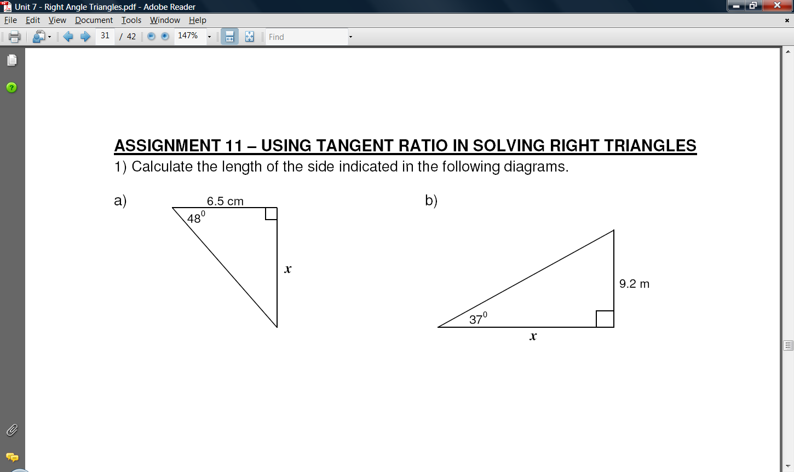

Example 3: Find x.



x

12 m

Example 4: In ΔPQR, ∠R = 90°, ∠P = 27°, and QR = 5 cm. Calculate the length of PR to the nearest tenth of a centimeter.

Example 5: A 6.1 m ladder leans against a wall. The angle formed by the ladder and the ground is 71°.

* 1. How far is the base of the ladder from the wall?
  2. How far up the wall does the ladder reach?

Example 6: Wes is flying a kite and holding it. 1 m above ground. The kite string makes at an angle of 57° with the horizontal. The kite’s shadow is 8.5 m away from Wes when the shadow is directly below the kite..

* 1. At what height from the ground is the kite the flying?
  2. How long of a string is being pulled?

Assignment:

6.3- “Right Triangles and the Tangent Ratio” worksheet #1-6, 21-24

6.4- “Right Triangles and the Sine Ratio” worksheet #1-6, 21-26

6.5- “Right Triangles and the Tangent Ratio” worksheet #1-6, 21-24

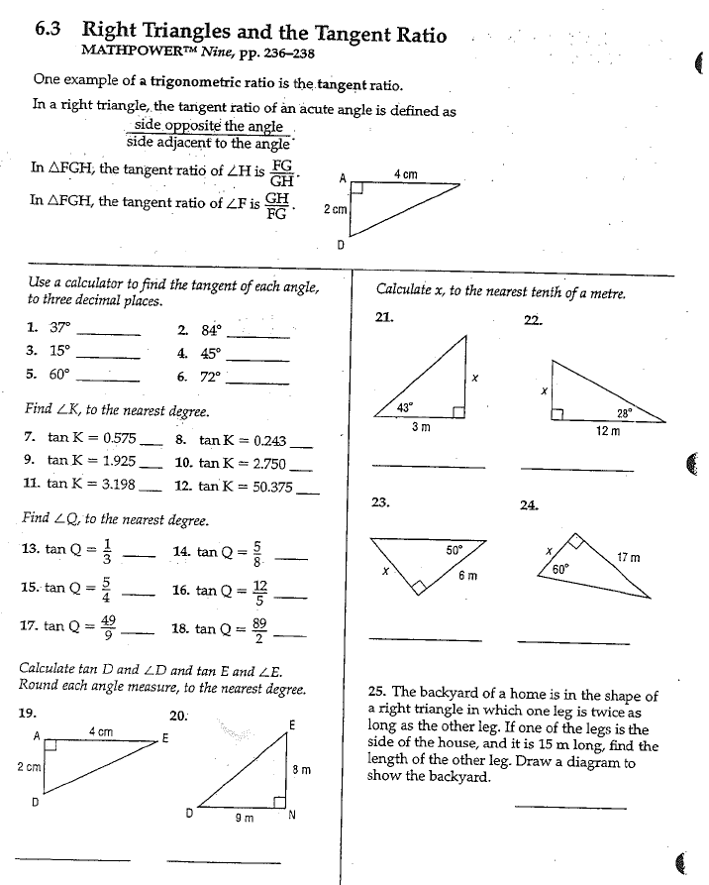

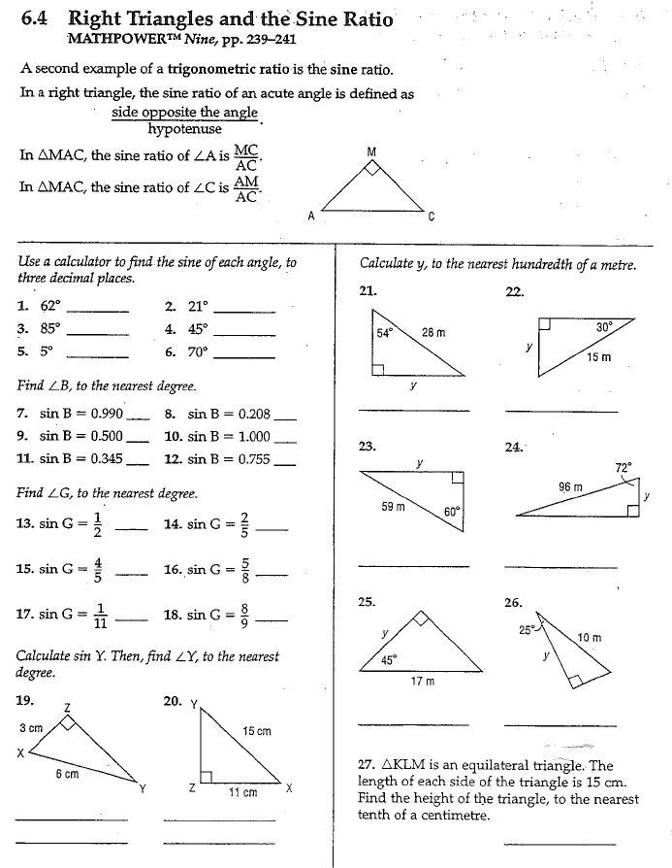

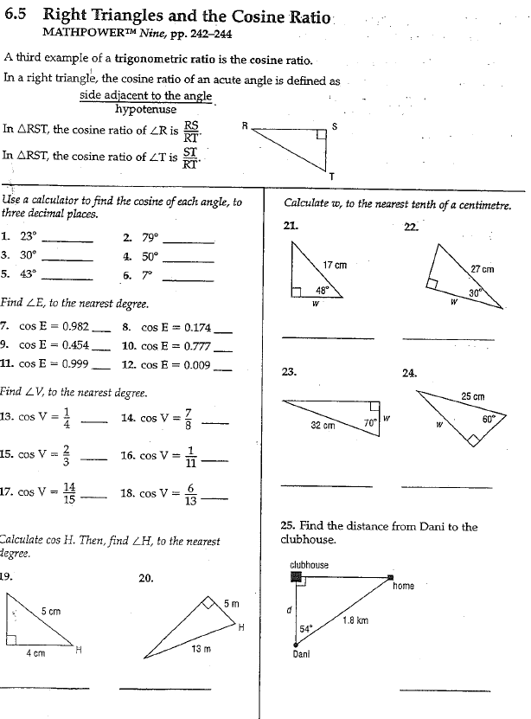

WARM-UP:

1. If what is to 4 decimal places?

2. Determine the length of x and y. Answer to one decimal if necessary.

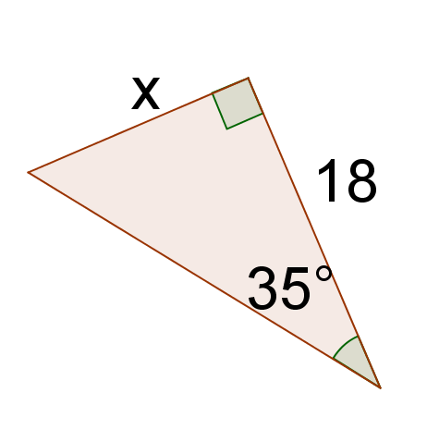

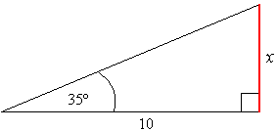a) b)

y

**y**

3. Determine the measure of $<A$.

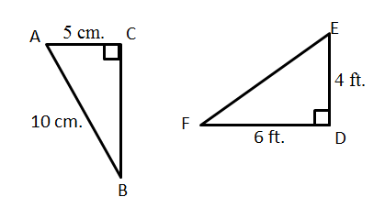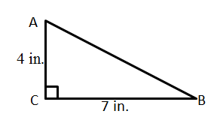

a) b)

**Lesson 3 – Using Trig Ratios to Solve for Angles**

If you know the trigonometric ratio, you can calculate the size of the angle. This requires an “inverse” operation.

To calculate the inverse, you usually use a 2nd function and the sin/cos/tan buttons on your calculator in sequence. If you look at your calculator just above the sin/cos/tan buttons, you should see the following: sin−1, cos−1, tan−1. These are the inverse functions. If you use these buttons, you will be able to turn a ratio into an angle.

Note: sin(ANGLE) = RATIO

sin−1(RATIO) = ANGLE

*Example:*

If sin A =  or sin A = 0.8, then sin−1(0.8) = 53.1°.

i.e. Inverse sine of 0.8 equals angle A.

1. Compute the following to the nearest tenth of a degree.

a) sin−1(0.187)

b) cos−1

c) tan−1(2.84)

2. Solve for ∠A to the nearest degree.

a) sin A = 0.312

b) cos A = 0.889

c) tan A = 0.585

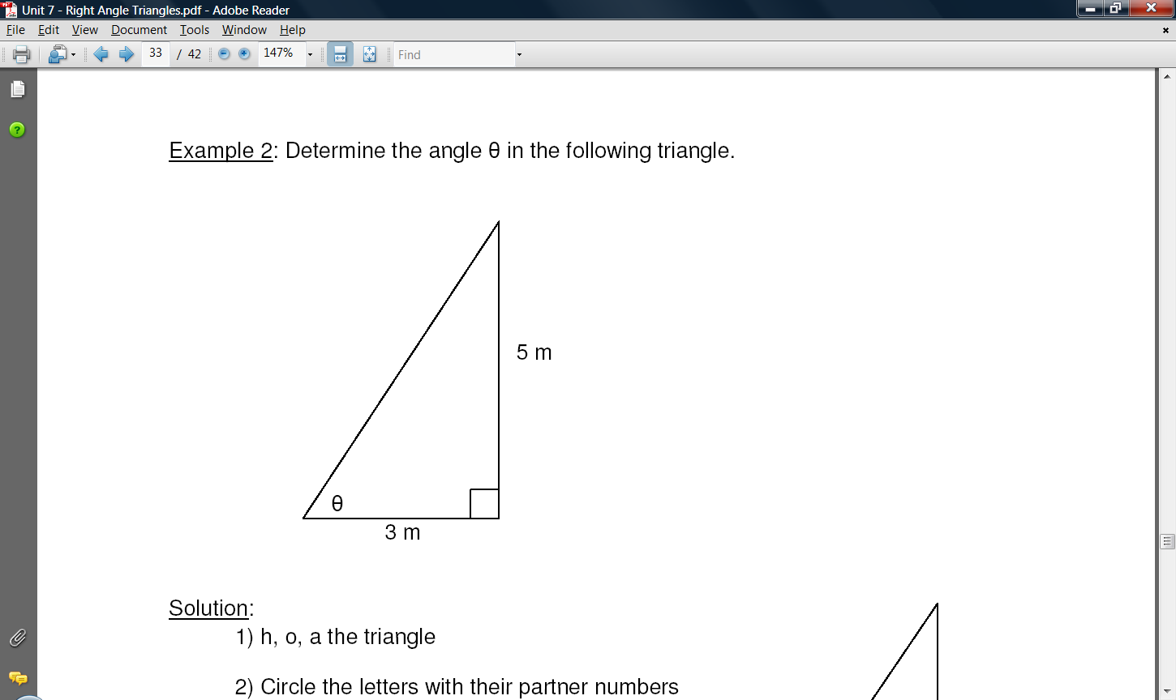3. Determine the angle θ in the following triangle.

Step 1: Label the triangle with hyp, opp, adj.

Step 2: Choose the appropriate trig ratio.

Step 3: Write down the ratio and fill it in.

Step 4: Use the inverse function to solve for θ.

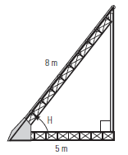4. At what angle to the ground is an 8 m long conveyor belt if it is fastened 5 m from the base of the loading ramp?

**Angle of Elevation and Depression**

When you look up at an airplane flying overhead for example, the angle between the horizontal and your line of sight is called the **angle of elevation** (or **angle of inclination**).

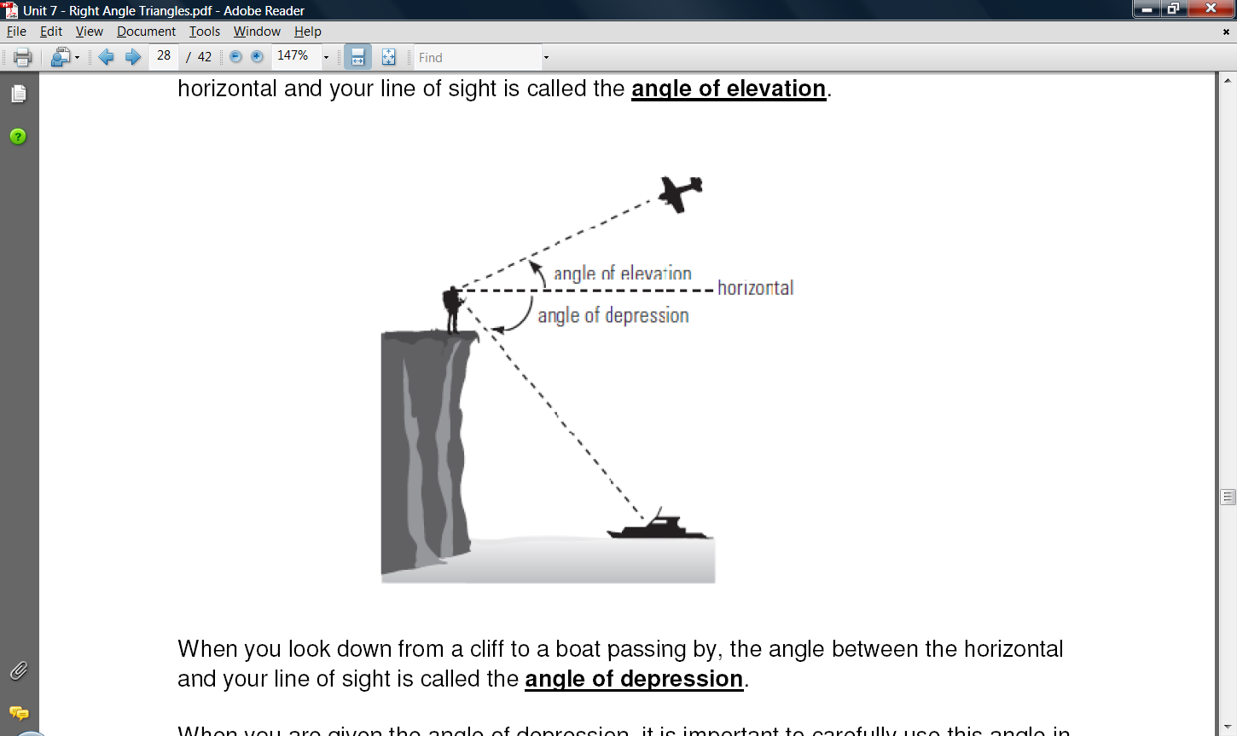

When you look down from a cliff to a boat passing by, the angle between the horizontal and your line of sight is called the **angle of depression**.

When you are given the angle of depression, it is important to carefully use this angle in your triangle.

*Example*: You are standing at the top of a cliff. You spot a boat 200 m away at an angle of depression of 55° to the horizon. Draw a diagram to illustrate this situation.

*Solution*: Draw a diagram, label it with the information.

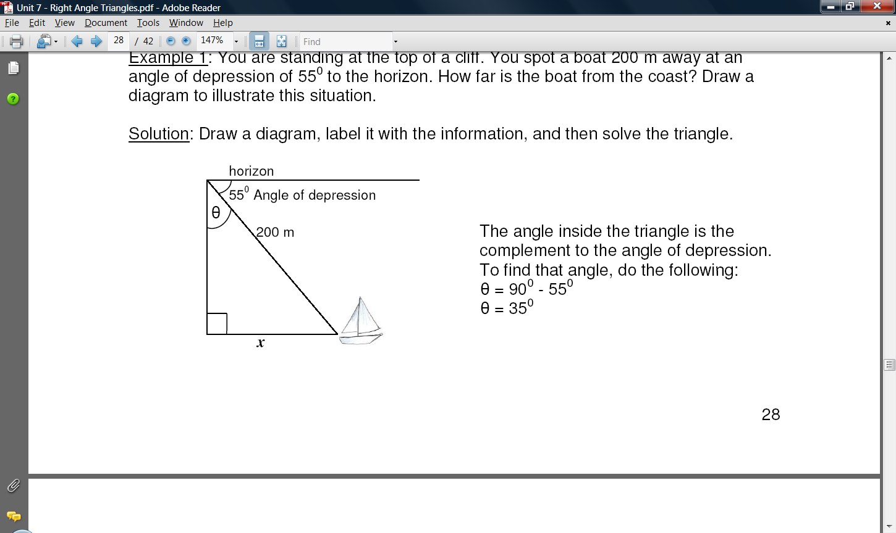

The angle inside the triangle is the complement to the angle of depression.

To find that angle, do the following:

θ = 90° − 55°

θ = 35°

* 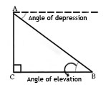How do you think the angle of elevation and the angle of depression are related in the following diagram?

5. A man stands 12 m from the base of a tree. He views the top of the tree at an angle of elevation of 58°. Draw a diagram and label the triangle.

6. A man stands on top of a 65 m cliff and sees an object at an angle of depression of 30°. Draw a diagram and label the triangle.

7. If a boat is 150 m from the base of a 90 m cliff, what is the angle of elevation from the boat to the top of the cliff?

Assignment:

6.3- “Right Triangles and the Tangent Ratio” worksheet #7-20

6.4- “Right Triangles and the Sine Ratio” worksheet #7-20

6.5- “Right Triangles and the Tangent Ratio” worksheet #7-20

Quiz on ____________________

**Lesson 4 – Solving Right Triangle**

Solving a right triangle means you find out all missing angles and missing sides.

There are 3 angles and 3 sides in a triangle. One angle is 90°, which is always given. If you are given 1 angle and 1 side, you can find out the other angle and 2 other sides. If you are given 2 sides, you can find out the other side and 2 other angles.

Tools/Methods:

a) Use sine, cosine, or tangent ratios to determine an angle or a side.

b) The sum of the 2 acute angles is 90°. If you know one acute angle, subtract from 90° will give you the other angle.

c) Use Pythagorean Theorem to determine the third side.

d) Whenever possible, avoid using calculated values. This means to that if you are given an angle, use trig to find the missing side and subtract from 90°. If you are given two side, solve for the last side using the Pythagorean theorem and solve for the angles using trig.

Example 1: Solve the triangles shown. Express each measurement to the nearest whole unit.

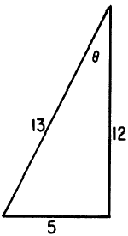

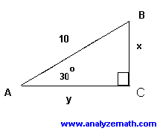

Example 2: Given ΔABC has ∠C = 90°, *b* = 7, and *c* = 25. Solve the triangle.

Step 1: Draw and label the triangle.

Step 2: Find one of the acute angles using trig.

Step 3: Find the other angle by subtraction.

Step 4: Find the third side by using the Pythagorean Theorem.

Example 3: Given ΔABC has ∠C = 90°, ∠B = 30°, and AC = 6. Solve the triangle.

Step 1: Draw and label the triangle.

Step 2: Find one side using trig ratios.

Step 3: Find the other side using a different trig ratio.

Step 4: Find the other angle by subtraction.

Example 4: An airplane is flying at a [height](javascript:def('/Glossary/glossaryterm.aspx?word=Height',%20500,%20500);) of 2 miles above the ground. The distance along the ground from the airplane to the airport is 5 miles. What is the [angle of depression](javascript:def('/Glossary/glossaryterm.aspx?word=Angle%20of%20Depression',%20500,%20500);) from the airplane to the airport?

Example 5: A bird sits on top of a lamppost. The [angle of depression](javascript:def('/Glossary/glossaryterm.aspx?word=Angle%20of%20Depression',%20500,%20500);) from the bird to the feet of an observer standing away from the lamppost is 35˚. The distance from the bird to the feet of the observer is 25 meters. How tall is the lamppost?

Example 6: Two poles on horizontal ground are 60 m apart. The shorter pole is 3 m high. The angle of depression of the top of the shorter pole from the top of the longer pole is 20˚. How tall is the longer pole?

Solving Problems with more than one Triangle

When there is more than one triangle, remember that you must know 2 pieces of information or more in order to solve for it. Look for those triangles that have 2 or more pieces of information. Working with them first will give more clues to the other triangles. Also look for common sides. You will need to solve for these. Remember that while you should avoid using calculated values as much as possible, you will need to use at least one calculated value in these situations.

Example 7 Find ∠ADB and side BC.

25°

30°

3.1 m

A

B

C

D

Example 8 Find ∠DAB, ∠ACD, and side AD.

3 m

4 m

10 m

A

B

C

D

Example 9: Solve for b.

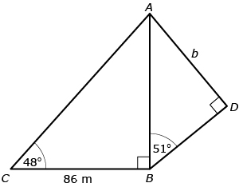

Example 10: Solve for x.

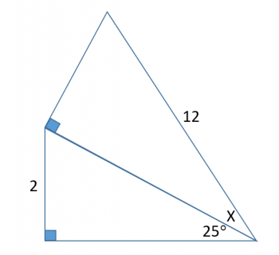

Assignment:

6.6- “Solving Right Triangles” worksheet;

Quiz next class

Review Assignment due __________________

Practice Test on __________________

Test on _______________________

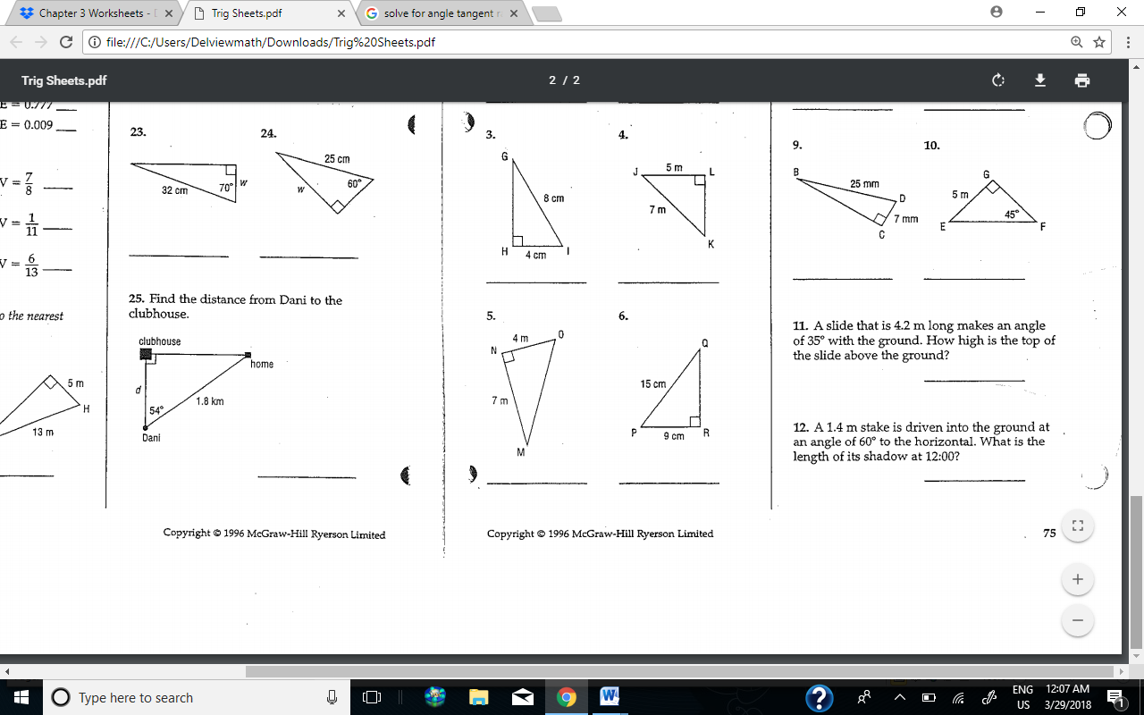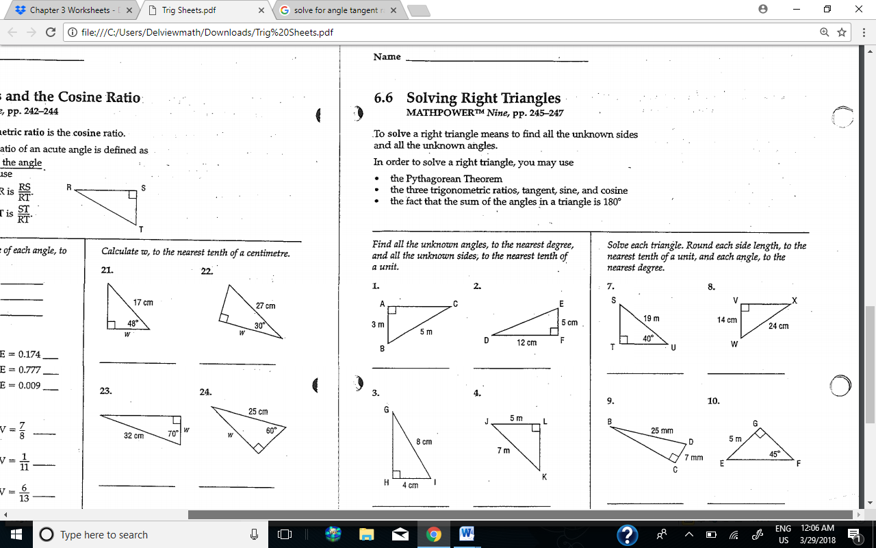

**Trigonometry Review Worksheet**

1) Determine the value of tan 23°, to four decimal places.

2) What is the measure of $<A,$ if cos A = 0.9203?

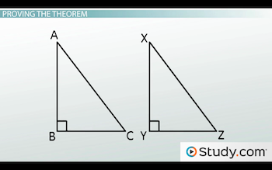3) Write the sine ratio of .

4) In ∆DEF, °, DF = 11.5 cm and DE = 2.7 cm.

(a) Determine sine ratio of $<F$ to the nearest thousandths.

(b) Determine cosine ratio of $<D$ to the nearest thousandths.

(c) Determine the measure of $<D$, to the nearest degree.

5) In ∆QRS, °, °, and QR = 42.1 cm.

(a) Determine the measure of $<Q$, to the nearest degree.

(b) How long is QS to the nearest centimetre?

6) Solve for x.

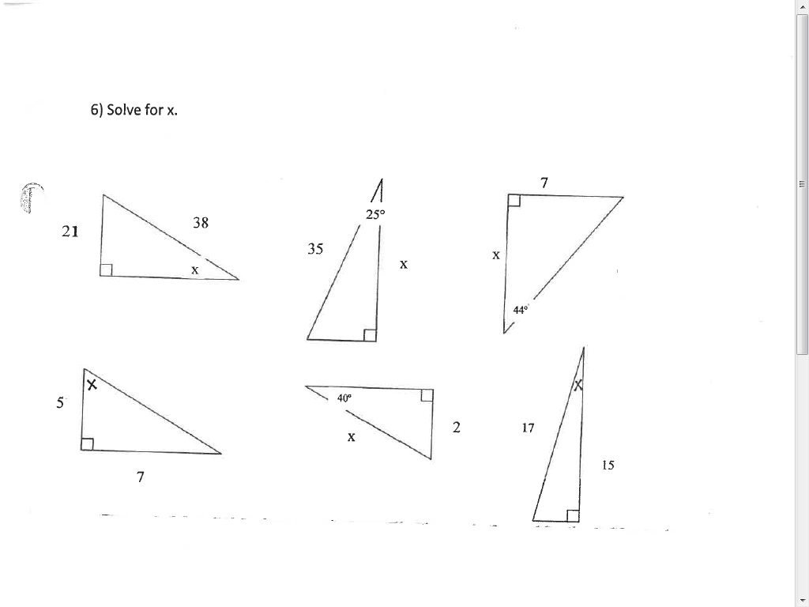

7) A skateboard ramp has a ratio of vertical distance to horizontal distance of 4 to 9. What angle does the skateboard ramp make with the ground, to the nearest degree?

8) A 6.1 m ladder leans against a wall. The angle formed by the ladder and the ground is 71°.

(a) How far is the base of the ladder from the wall?

(b) How far up the wall does the ladder reach?

9) Laura is flying a kite at a local park. She lets out 60 m of her kite string, which makes an angle of 68° with the ground. Determine the height of the kite above the ground, to the nearest tenth of a metre.

10) The string on Yuri’s kite is 45 m long and makes an angle of 55° with the ground. Yuri’s friend, Abdul, is standing directly below the kite.

(a) How far apart are Abdul and Yuri now, to the nearest tenth of a metre?

(b) Abdul runs away from Yuri, so that the angle of elevation between Abdul and the kite is 15°. How far apart are Abdul and Yuri, to the nearest tenth of a metre?

13) The two buildings are 200 m apart. Determine the heights of both buildings.

