Voltage in a Circuit How does voltage behave in a simple series circuit?

Use the Phet DC Simulation lab to investigate changes in voltage in circuits.
https://phet.colorado.edu/en/simulation/circuit-construction-kit-dc

Create the following circuit using the lab simulation: 1. Draw a circuit diagram including a voltmeter in parallel around the two cells and another around the two light bulbs. 2. Then redraw the circuit diagram but this time include a voltmeter to measure voltage around each individual light bulb.
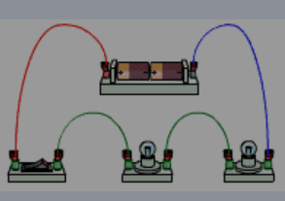
Diagram 1 Diagram 2

1
2
Check that diagrams are correct before proceeding!
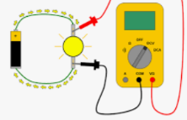
Voltmeters measure the voltage change across devices in a circuit. The wires must be placed on either side of device so that the reading is positive and voltmeter connected as shown in diagram.

Refer to your circuit diagram when placing voltmeters in circuit.
- Voltage measurements with two cells. Close the switch so current flows.
  - Measure the voltage supplied by both cells. Connect the voltmeter to the positive terminal of the first cell and the negative terminal of the second cell.
The voltage drop around the two cells is_____ Volts
  - Measure the voltage drop around both light bulbs together. The voltage drop is ______V
  - Measure the voltage drop around each individual light bulb.
bulb 1: ________V bulb 2: _________ V
  - Measure the voltage drop around the switch. The switch voltage is _______ V

*Why is there no voltage lost across the switch? ______________________________________________

- Remove one cell from the circuit. Make sure the current is flowing.
Then repeat measurements of cell, bulbs and individual bulb voltages.
  - The voltage drop around the one cell is_____ Volts
  - Measure the voltage drop around both light bulbs together. The voltage drop is _____ V

  - Measure the voltage drop around each individual light bulb.
bulb 1: ________V bulb 2: _________ V
*How did removing one cell change the voltage measurements? What happened to the current?

*How does the total voltage provided by the battery compare to the total voltage lost by the light bulbs?

