Warm-Up Series vs Parallel Circuits

1. The current through resistor 3, I3 is___________



1. 4 A
2. 6 A
3. 6.5 A
4. 10 A

Answer the next two questions using this diagram 

Resistors 3 & 4

V3 = ? V4 = ?

V2 = 5 V

V1 = 4.0 V

1. What is the **voltage drop across resistors 3 and 4** if the voltage provided by the battery is 12 V.
2. V3 = 12 V and V4 = 12 V
3. V3 = 2.5 V and V4 = 2.5 V
4. V3 = 1.5 V and V4 =1.5 V
5. V3 = 3 V and V4 = 3V
6. If the resistance of resistor 3 and 4 are equal. What is the current through each of these resistors? The current through the battery is 6 A.
7. 6 A through both resistors
8. 3 A through both resistors
9. 4 A through resistor 3 and 2 A through resistor 4
10. 2 A through resistor 3 and 4 A through resistor 4
11. Calculate the missing quantities for the circuit below. The voltage provided by the battery (Vs) is 60 V

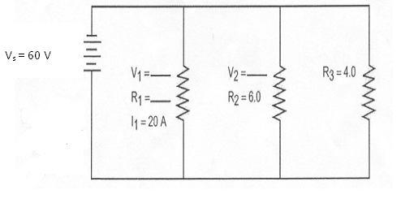

1. V1= 20 V, V2 = 20 V, R1 = 1 Ω
2. V1 = 10 V, V2 = 50 V, R1 = 10 Ω
3. V1 = 60 V, V2 = 60 V, R1 = 3 Ω
4. V1 = 60 V, V2 = 60 V, R1 = 30 Ω