Topic V: Water Cycle and Role in the Earth System *Watch Video - Sustainability: Water Cycle

Earth- I can explain how human activities impact, biosphere, nutrient cycles and the water cycle
Earth - I can describe how biogeochemical cycles (water, nitrogen, carbon, and phosphorous) work and impact the Earth System
Earth- I can explain how solar radiation impacts the biosphere, the water cycle and how it drives wind and ocean currents.
Cool Statistics about Water:
97 % of Earth’s water is found in ________________
_________% of all water is fresh water – most of which is locked in ___________ and groundwater
The atmosphere holds 0.001 % of all the water on Earth as water vapour.
- If all the water in the atmosphere fell at once the earth’s surface would be covered in only
______________ cm of water.
Water on Earth spends time in all four spheres.
On the surface water can be seen in bodies of water such as _________________________, frozen as _______________ or snow and as a gas as _______________________or fog. Water found underground is called ________________________
*Watch Interactive of Water Cycle: List all the places that the water molecule travels.
http://serc.carleton.edu/eslabs/weather/2a.html

Water continuously cycles through ecosystems by three main processes
- ___________________________: Water ______________________as the sun heats the earth becoming __________________________
- ________________________: As warm water vapour rises, it cools and _________________ into tiny water droplets and _________________ are formed.
- _________________________: As the water droplets get larger, eventually the clouds release water as rain, _______________ or hail.
On the surface water flows between bodies of water as ____________________, in rivers and streams. It infiltrates the ground finding its way to aquifers, underground streams or it may be intercepted by ____________ of plants, absorbed, carried through the plants tissues and then released as water vapour from leaf pores. This process is called ______________________________.

Answer the following questions:
- What role does sun have in driving the water cycle?

- How might water flow across the Earth’s surface impact the geosphere and the biosphere?

Water is extremely important to the Earth System: Why?
- Water vapor is a very significant _________________________ its effect is stronger than most other greenhouse gases even __________________________________.
- More moisture in the air means ________________ temperatures & more precipitation.
- More rain over shorter period leading to ______________________ _______________________
- Higher temperatures melt glaciers and ice caps leading to _______________________________
- Drives weather and climate through the transport of heat energy stored in _________________
- Heat energy is created and stored in the atmosphere when water molecules change to _________________________. The heat is released into the ____________________________ when molecules condense creating cloud droplets
- All life on Earth relies on water for survival. Photosynthesis requires water.
Our bodies are________% water.
Watch Video on Water Pollution: Complete the following while viewing the video.
What is water pollution? Results from the introduction of harmful substances like ______________________________________________________________________ into water.
Some Natural causes of water pollution are: _____________________________________________
_________________________________ _______________________________________________
Some human activities that result in water pollution are: ___________________________________
__________________________________________________________________________________
_________________________________________________________________________________
Some affects of water pollution on humans and other organisms are:________________________
_________________________________________________________________________________
_________________________________________________________________________________
What can we do to help our ecosystems and prevent water pollution?________________________
_________________________________________________________________________________
_________________________________________________________________________________

Complete the following water cycle by filling in the appropriate terms in the numbered boxes.
Some terms you may need are transportation, deposition, sublimation, precipitation, condensation, percolation, evaporation, surface flow, transpiration, plant uptake, infiltration, groundwater flow, snowmelt/run-off, transportation.

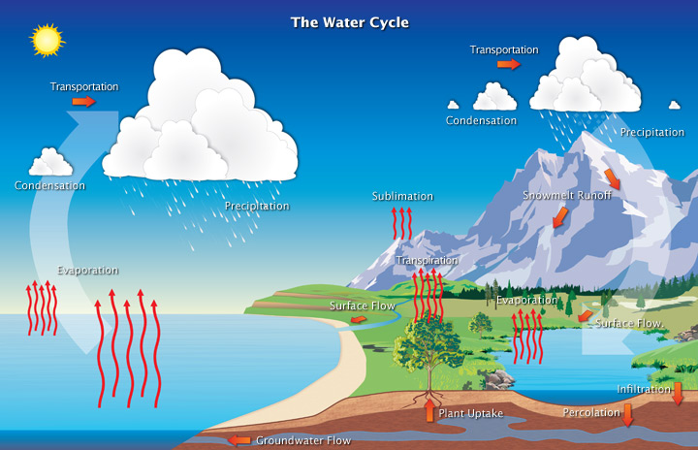
5.
3.
From ice or snow
9.
1.
2. (from plants)
8. Surface Flow
10. percolation
12.
11. (via roots)
6.
5.
4. (movement)
8.
4. Transportation
7.
7.
1.
6.

Complete the following by filling in the terms or numbers relevant to the water cycle shown on your labelled diagram of the water cycle.
The terms you will need are transportation, deposition, sublimation, precipitation, condensation, percolation, evaporation, surface flow, transpiration, plant uptake, infiltration, groundwater flow, snowmelt/run-off, transportation.
#______ -___________________ is the change of state of water (a liquid) to water vapor (a gas). On average about 120 cm of water from the ocean’s surface becomes water vapour in the atmosphere each year. | #2-_______________________ is another name for evaporation of liquid water from plants and trees into the atmosphere. Nearly all (99%) of all water that enters the roots exits through other parts of the plants such as leaves via this process into the atmosphere. | #3 - _______________________  is the process where ice and snow  (a solid) changes into water vapor  (a gas) without moving through the liquid phase.
#_______-__________________ is the movement of solid, liquid and gaseous water through the atmosphere. Without this movement, the water evaporated over the ocean would not precipitate over land. | #_____ -____________________  is when water falls to the earth as snow, sleet, drizzle or hail. On average, about 980 mm of rain, snow and sleet fall each year around the world. | #5 -________________________ is the process where water vapour (a gas) changes into water droplets (a liquid). This is when we begin to see clouds.
__________________________ is the reverse of sublimation. Water vapor (a gas) changes into ice (a solid) without going through the liquid phase This is the most often seen on clear, cold nights when frost forms on the ground. | #_____ -Infiltration is the movement of water into the ground from the surface. #_____ -Percolation is the movement of water past the soil going deep into the groundwater. | # ______ - Surface flow is the snowmelt runoff, rivers, lakes and streams that transport water to the oceans. #______- Ground water flow is the flow of water underground in aquifers. The water may return to the surface in springs or eventually seep into the oceans.
#_______ -__________________ is water taken by plant roots from the groundwater flow and soil moisture. Only 1% of water the plant draws up is used by the plant. The remaining 99% is passed back into the atmosphere.
Study these terms for your Earth System Quiz!

