Sci 9 Ions vs Atoms vs Compound Name: ________
Date: _________
These are Ions | These are Atoms or  Molecules of An Element | These are Compounds
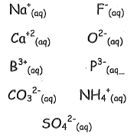 | 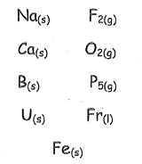 | 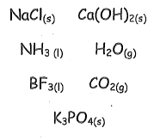
Ions have the following characteristics: | Atoms have the following characteristics: | Compounds have the following characteristics:
Give 3 more examples of ions: | Give 3 more atom examples: | Give 3 more compound examples
Circle all ions and cross out all compounds
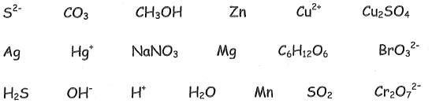
An Ion is … | An Atom is… | A Compound is…

When compounds are “ionized” they form ions (ie: NaCl becomes Na⁺ and Cl⁻)
Below, write the following compounds as the ions that they form:
KBr CuCl₂ AlF₃ LiF

