Sci 9 Ions vs Atoms vs Compound vs Molecules Name: ________
Date: _________
These are Ions (polyatomic ions  contain more than one atom  which bond together covalently) | These are Atoms or Molecules  of Elements. i.e. Cu is an  atom while H₂ is a molecule. | These are Compounds
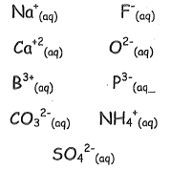 | 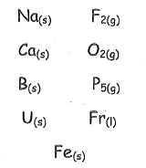 | 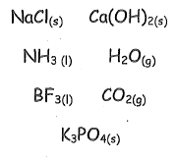
Ions have the following characteristics: | Atoms have the following characteristics: | Compounds have the following characteristics:
Give 3 more examples of ions: | Give 3 more atom examples: | Give 3 more compound examples
Circle all ions and cross out all compounds
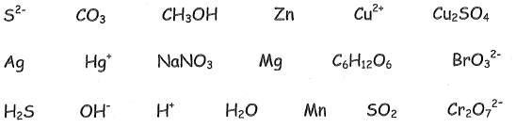
An Ion is … | An Atom is…  A molecule is… | A Compound is…

When compounds are “ionized” they form ions (ie: NaCl becomes Na⁺ and Cl⁻)
Below, write the ions that make up each compound: Use the periodic table to find ion charge!
KBr CuCl₂ AlF₃ LiF

