# 

# **Unit 5**

## Finance

Chapter 10 – Earning an Icome

In this unit you will learn:

* Types of income
* Income tax and other deductions
* Gross and net pay

**EARNING AN INCOME**

**Vocabulary:**

benefits

biweekly

bonus

commission

contract

deductions

gross pay

minimum wage

net pay

overtime

pay statement

piecework

salary

self-employment

semi-monthly

shift premium

taxable income

tip

wage

Times to Know

1 year = 365 days

1 year = 52 weeks

1 year = 12 months

weekly = 52 times/year

biweekly = 26 times/year

semi-monthly = 24 times/year

annually = yearly

**Lesson 1 - WAYS OF EARNING AN INCOME**

People who work earn their income in different ways. Their **income** is the money they receive for the work they do. The way they are paid depends on the type of job they have.

Ways of Earning an Income

|  |  |
| --- | --- |
| hourly wage | a fixed payment for each hour of work  Examples: store clerk, fast-food restaurant worker, etc |
| wage and tips | an hourly wage plus varying amounts in tips for services provided  Examples: hotel worker, taxi driver, waiter/waitress, etc. |
| salary | a regular fixed payment for work, usually expressed as an amount per year, but paid regularly (e.g. every two weeks, twice a month, or monthly  Examples: firefighter, teacher, etc. |
| commission | a payment based on a percentage of the worker’s sales  Examples: real estate agent, car salesperson |
| salary and commission | a smaller salary plus a percentage of the worker’s sales  Examples: many different salespeople |
| royalties | a payment for a piece of work that is marketed and sold  Examples: author, musician |
| piecework | a payment based on the number of items created or completed  Examples: sewing machine operator, cable TV installer, factory worker |
| contract | a payment for a fixed period of time and/or a fixed amount of money for a fixed amount of work  Examples: editor, electrical contractor, building contractor |

**ASSIGNMENT 1 – WAYS OF EARNING AN INCOME**

1) Match each job with the most likely payment method.

**Job Payment Method**

A) video store clerk ____ salary

B) police officer ____ piecework

C) screenplay writer ____ hourly wage

D) tour guide ____ hourly wage and tips

E) fruit picker ____ contract

F) furniture salesperson ____ commission

G) landscape architect ____ royalty

**GROSS PAY**

Whether you are paid a salary, a wage, or any other manner, your income is the amount of money you receive for the work you do. This income is usually paid *weekly*, *biweekly* (every two weeks), *semi-monthly* (twice a month), *monthly,* but not usually *annually* (once a year). The amount of money you make before any deductions is called your **gross pay**. Deductions – money taken off your paycheque to pay taxes, union dues, and other benefits – will be discussed later in this unit.

It is important to know how to calculate gross pay for different types of jobs.

Example 1: Maria works as an electrician and earns $24.68/h. If she worked for 15 hours on one job, how much did she earn?

Solution: Multiply the hourly wage by the number of hours she worked.

Example 2: Last year, Michelle earned $45 183.36 at a hair salon. What was her average monthly income?

Solution: Divide her gross income by the number of months in a year.

Example 3: Chi works cutting lawns. Last week, he worked 34 hours and earned $329.12. What is his hourly wage?

Solution: Divide his gross income by the number of hours he worked.

Example 4: If Sam is paid biweekly and his annual salary last year was $32 000, what was his gross pay on each paycheque?

Solution: Divide his gross income by the number of pay periods for biweekly pay in a year.

**ASSIGNMENT 2 – GROSS PAY**

1) Harpreet works as a carpenter for $20.87/h. How much will he earn in a 40-hour work week?

2) Ben works in a trucking business and is paid $35.75/h. Last week he worked the following hours:

Monday – 6 hours What was his gross pay for this week?

Tuesday – 8 hours

Wednesday – 8 hours

Thursday – 12 hours

3) Jimmy is a flag person and earned $321.10 last week for 32.5 hours work. What is his hourly wage?

4) Martha’s annual salary last year was $72 000. What was her gross pay each month?

5) Pavneet’s annual gross pay is $48 000. If she is paid biweekly, what is her gross pay on each paycheque?

**KEEPING TRACK OF TIME**

When an employee is paid an hourly wage, it is necessary to keep track of the hours they have worked in order that the gross pay is calculated correctly. For the purposes of this course, time will be calculated to the quarter hour, not to the minute.

Everyone knows that an hour has 60 minutes. Therefore, parts of hours are based on the whole being 60 minutes as follows:

15 minutes = 0.25 hours = 15 = 1 hour

60 4

30 minutes = 0.50 hours = 30 = 1 hour

60 2

45 minutes = 0.75 hours = 45 = 3 hour

60 4

Example 1: If Mike worked from 8:30 to 11:30. How many hours did he work?

Solution: **ALWAYS START WITH THE FINISHING TIME**. Then subtract the hours from hours and minutes from minutes.

Example 2: Mike worked from 8:15 to 11:30. How many hours did he work?

Solution: Subtract the hours from hours and minutes from minutes.

Example 3: If Mike worked from 8:30 to 11:15. How many hours did he work?

Solution: Subtract the hours from hours and minutes from minutes. Regroup the hours to minutes to subtract correctly

Example 4: If Mike worked from 11:15 to 3:30. How many hours did he work?

Solution: Change the afternoon time to 24 hour time. Then subtract the hours from hours and minutes from minutes. Regrouping the hours to minutes might be necessary.

If an employee worked two shifts on the same day, you will need to add those two shifts together. If the time is in hours and minutes, add the hours and add the minutes separately: hours to hours and minutes to minutes. Then, if necessary, regroup the minutes into hours. If the shift times are in decimal form, add them together using a calculator normally.

Example 5: Mike worked from 8:30 to 11:45 and 1:15 to 4:15. How many total hours did he work?

**ASSIGNMENT 3 – KEEPING TRACK OF TIME**

1) Calculate the hours worked for the following shifts. **Show your work**. Remember to start with the finishing time when subtracting.

a) 9:00 to 12:00 b) 8:30 to 12:30

Continued on the next page!

Remember to start with the finishing time when subtracting. **Show your work**.

c) 9:15 to 11:45 d) 1:15 to 3:30

e) 10:45 to 14:45 f) 9:00 to 15:00

g) 9:15 to 13:45 h) 10:30 to 3:30

i) 8:30 to 12:00 j) 8:30 to 10:15

k) 8:45 to 3:00 l) 10:15 to 2:00

m) 12:45 to 4:15 n) 6:30 to 1:15

**Lesson 3 -TIME CARDS**

Employers often keep time records for employees using time cards. The employee will enter the times they worked and submit the time card on a regular basis in order to be paid.

Example: Antonio’s time card for the last week is below.

a) How many hours did he work in this week?

|  |  |  |  |
| --- | --- | --- | --- |
| **TIME CARD – Antonio** | | | |
| DAY | IN | OUT | HOURS WORKED |
| Monday | 9:15 | 11:45 |  |
| Tuesday | 8:45 | 11:30 |  |
| Wednesday | 1:00 | 4:30 |  |
| Thursday | 9:00 | 12:45 |  |
| Friday | 9:30 | 1:00 |  |

Solution: Calculate the hours for each day worked, add them together, and regroup the minutes. (These shifts are calculated vertically as you did in the previous assignment!)

Monday Tuesday Wednesday Thursday Friday

By adding the hours to hours and minutes to minutes, the total is:

Regroup the minutes by subtracting groups of 60 min and adding 1 hour until the total is less than 60 min.

b) If he earns $14.60 per hour, how much did he earn that week?

Solution: Multiply the number of hours he worked by the his hourly wage.

**ASSIGNMENT 4 – TIME CARDS**

1) Complete the chart to show how the hours worked in this week. Show calculations below the chart.

|  |  |  |  |
| --- | --- | --- | --- |
| DAY | IN | OUT | Hours Worked |
| Monday | 8:00 | 16:00 |  |
| Tuesday | 8:15 | 15:15 |  |
| Wednesday | 8:30 | 16:30 |  |
| Thursday | 9:00 | 17:30 |  |
| Friday | 8:15 | 11:45 |  |
| TOTAL |  |  |  |

2) Monty works part time at a gas station. He earns $9.45/h. His time card for one week is shown below.

a) Complete the chart to show how many hours Monty worked in this week. Show calculations below the chart.

|  |  |  |  |
| --- | --- | --- | --- |
| DAY | IN | OUT | Hours Worked |
| Monday | 3:15 | 6:45 |  |
| Tuesday |  |  |  |
| Wednesday | 5:00 | 9:30 |  |
| Thursday | 4:45 | 9:45 |  |
| Friday | 3:30 | 7:00 |  |
| TOTAL |  |  |  |

b) How much would Monty earn for this week?

3) Complete the time card to show how the hours worked in this week. Show calculations below the chart.

|  |  |  |  |
| --- | --- | --- | --- |
| DAY | IN | OUT | Hours Worked |
| Monday | 7:45 | 2:00 |  |
| Tuesday | 10:00 | 5:15 |  |
| Wednesday | 9:30 | 6:00 |  |
| Thursday | 2:15 | 7:00 |  |
| Friday | 8:45 | 11:15 |  |
| TOTAL |  |  |  |

4) Hannah works as a part-time warehouse technician. She often works a split-shift, where her work day is split between two time blocks. She gets paid $12.76/h. Her time card is shown below.

a) Complete the chart to show how many hours Hannah worked in this week. Show ALL calculations below the chart.

|  |  |  |  |  |  |
| --- | --- | --- | --- | --- | --- |
| **TIME CARD: Hannah** | | | | | |
| **DAY** | **Morning** | | **Afternoon** | | **Total Hours** |
|  | IN | OUT | IN | OUT |  |
| Monday | 7:45 | 9:00 | 5:00 | 7:45 |  |
| Tuesday |  |  | 4:00 | 8:00 |  |
| Wednesday | 9:00 | 11:00 |  |  |  |
| Thursday | 9:00 | 11:00 | 3:00 | 5:00 |  |
| Friday |  |  | 3:00 | 6:00 |  |
| Saturday | 9:00 | 12:00 |  |  |  |
| TOTAL |  |  |  |  |  |

b) How much did she earn during this week? Show your calculation!!

Quiz next class

**Lesson 4 - OVERTIME PAY**

Many full-time jobs have a 40-hour work week, but other jobs may have different regular hours. Either way, if you work more than the regular number of hours you are scheduled for, it is classified as overtime. You should earn overtime pay for those extra hours.

Overtime is often paid at “time and a half” – that means you get 1.5 times your regular wage. Overtime could also be “double time” which means you get 2 times your regular wage, or even double time and a half – 2.5 times your regular wage. Overtime wages must be agreed upon by the employer and employee before any extra money is paid.

Example: Marcel earns $15.82/h and he works 37.5 hours each week. He is paid time and a half for any extra hours he works over 37.5 hours each week. If he works 42.25 hours during one week, how much will he earn?

**ASSIGNMENT 5 – OVERTIME PAY**

1) Denise earns $22.50 an hour. How much will Denise earn for an overtime hour if she earns time and a half for overtime work?

2) Ingrid works as a medical receptionist at a rate of $11.82/h for 35 hours per week. She is paid overtime at time and a half for **extra hours** she works each week. Last week, she worked 42 hours. What will her weekly pay be for last week?

3) Natalie works as a playground supervisor for 8 weeks during the summer at a rate of $15.27/h. She works a 40-hour week but averages 3 hours of overtime each week, paid at time and a half. How much will she earn each week, and for the whole summer?

4) Pete works in construction and earns $15.77/h. His regular work week is 40 hours, but he works a lot of overtime in the summer. For overtime from Monday to Friday, he earns time and a half. For Saturdays, he earns double time and a half. How much will Pete earn if he works 42.25 hours during the week, and 5.75 hours on Saturday.

**Lesson 5 -OTHER WAYS TO EARN AN INCOME**

As mentioned at the start of this unit, there are other ways to earn an income that are not wages or salary. These other ways include piecework, commission, salary plus commission, and contract work.

Example 1: Piecework

Greg works as a tree planter during the summer and earns $2.50 for each tree he plants. If he planted 45 trees one day, how much did he earn?

Solution: Multiply $2.50 by 45 trees

Example 2:

Marissa works as a flower arranger. She is paid $143.75 for making 25 identical flower arrangements. How much was she paid for each arrangement?

Solution: Divide $143.75 by 25 arrangements to find the unit rate.

Example 3: Commission

Ming works on commission at a rate of 6.5% of his gross sales. If he sold $9865 worth of furniture last week, how much commission did he earn?

Solution: Multiply his gross sales by his commission rate, as a decimal.

.

Example 4:

Gurpreet earned $416.03 commission on his sales of $9245. What was his rate of commission?

Solution: Find what percentage $416.03 is of $9425. Use a proportion or division.

Example 5: Contract Work

Fred is a general contractor who has been hired to fix a client’s house. The cost of the materials will be $785.96, and he will have to hire 2 workers for 8 hours each at a rate of $12.85/h. He wants to earn at least $450 for himself. What should he charge the client in the contract?

Solution: Calculate all of Fred’s costs to find the overall charge.

**ASSIGNMENT 6 – OTHER WAYS TO EARN AN INCOME**

1) Thomasina knits sweaters and sells them at a craft shop. She charges $75.50 for a large sweater. If she sells 5 large sweaters, how much will she earn?

2) Jack cleans windows for extra income. He charges $3.00 for a main floor window and $5.00 for a second-story window. How much will he earn if he cleans a house with 7 main floor windows and 6 second-story windows?

3) Karissa picked 18 quarts of strawberries and earned $67.50. How much did she earn per quart?

4) Joey is a writer who often writes articles for a local newspaper. He is paid $0.35 per word for his articles. How many words were in Joey’s last article if he was paid $192.50?

5) Sara works in a sports store and earns 12% commission on her sales. How much does she make on a bicycle that sold for $785.95?

6) A real estate agent makes 5% commission on the first $250 000 of the house’s selling price, and 2% on any amount over that. What is Sue’s commission when she sells a house worth $375 000?

7) What is the rate of commission if you make $592 on sales of $12 589?

8) Tien has three employees working for her. Each employee is paid $8.00/h for an 8-hour day. In addition, they are also paid a commission of 12% on all sales they make. If the three employees made sales of $785.96, $453.87, and $616.42, how much in total must Tien pay her employees for that day of work?

9) A sheet metal company had 5 contracts last month. The contracts were worth $5600, $2800, $7450, $1900, and $8900. Materials, salaries, and all other expenses last month totaled $23 750. What was the percentage of the profits? (Hint: calculate profit by using: profit = income – costs)

**Lesson 6 - ADDITIONAL EARNINGS**

In some jobs, an extra amount is earned for a job well done or for exceeding expectations. This **bonus payment** *is paid in addition to regular pay* and/or overtime, and could be a lump sum payment or a percentage of earnings. Other additional earnings include danger pay, isolation pay, a shift premium, and tips.

Example 1: Last summer, Jordan earned $3600 in his job. He has been promised a signing bonus of 15% if he agrees to sign up to work for his company again. If Jordan signs up, how much will he get as a signing bonus?

Solution: Find 15% of Jordan’s wages.

Example 2: Denise works at a computer repair shop. Her boss offers her a shift premium of $1.75/h if she works after 5:00 pm or on Saturday. Last week, Denise worked:

* + - Monday: 9:00 am – 5:00 pm
    - Tuesday: 2:00 pm – 8:00 pm
    - Wednesday: 2:00 pm – 7:00 pm
    - Friday: 12:00 pm – 8:00 pm
    - Saturday: 9:00 am – 3:00 pm

If Denise’s regular pay is $15.25/h, how much did she earn last week?

Solution: Determine Denise’s regular and shift premium hours for each day.

|  |  |  |
| --- | --- | --- |
| DAY | Regular Hours | Shift Premium Hours |
| Monday |  |  |
| Tuesday |  |  |
| Wednesday |  |  |
| Friday |  |  |
| Saturday |  |  |
| Total hours |  |  |

Calculate Denise’s earnings for each rate.

Regular hours –

Shift Premium hours –

Denise’s earnings =

Example 3: Sam works as a server at a local restaurant. Yesterday he earned $165.32 in tips. If this was 15% of the sales, how much were the sales yesterday?

Solution: Use a proportion to solve.

Because a percentage (15%) is always out of 100, use a proportion to find the sales.

**ASSIGNMENT 7 – ADDITIONAL EARNINGS**

1) Darren’s hourly wage is $24.80. Because his job is dangerous, Sean makes 38% more than Darren. How much would Sean make an hour?

2) Raymond receives a bonus for isolation pay. His regular pay is $2245/month. He is offered either a bonus of 12% or $275. Which will give him a higher gross pay?

3) Chen is working for 10 weeks in Northern Canada. He is paid $532/week and he gets an isolation bonus. The bonus offered is 28% of his total earnings for the 10 weeks, or $1250. Which is the better option for Chen to choose?

4) A courier driver is offered a shift premium of $7.00/h to drive **after 8:00 pm**. Mike’s schedule last week is show below. If Mike’s regular pay is $12.75/h, how much did he earn last week? Use the chart below to help you.

* + - Monday: 12:00 pm – 7:00 pm
    - Tuesday: 9:00 am – 5:00 pm
    - Wednesday: 6:00 pm – 11:00 pm
    - Thursday: 12:00 pm – 8:00 pm
    - Friday: 3:00 pm – 9:00 pm

|  |  |  |
| --- | --- | --- |
| DAY | Regular Hours | Shift Premium Hours |
| Monday |  |  |
| Tuesday |  |  |
| Wednesday |  |  |
| Thursday |  |  |
| Friday |  |  |
| Total hours |  |  |

5) Belinda is a seamstress. She charges $16.50 to hem pants, $9.90 to alter a shirt, and $33.00 for any alterations to suit jackets. How much will Belinda earn if she works on 14 pairs of pants, 6 shirts, and 3 suit jackets?

6) Rachelle earns a 12% commission on all sales she makes at a clothing store. If she makes clothing sales of $27.99, $34.99, $20.99, and $39.19 in her shift, how much does she earn for the day?

7) Mason earned $408.65 working 35 hours at $8.21/h, plus tips. How much did he make in tips?

8) Rosita had a meal at a restaurant but only left a $3.00 tip for a bill that was $24.75 due to poor service. What percentage tip did she leave?

9) Kirsten works as a waitress. She earns a base wage of $8.20/h, plus tips. One day she bills her customers $950, and her tips are 15% of that amount. What is Kirsten’s income, with tips, for this 8-hour day?

**Lesson 7 - NET PAY AND DEDUCTIONS**

When you earn an income, your paycheque is always lower than your gross pay. This is because there are deductions from your gross pay. **Deductions** are *amounts of money taken off your gross pay* for income taxes (federal and provincial/territorial), union dues, disability insurance, employment insurance (EI), Canada Pension Plan (CPP) or other pension plans, and health or other benefits.

Income taxes are only paid on your **taxable income**, which is the income after certain deductions are made but before other deductions are made. Deductions that are deducted to determine your taxable income include *union dues*, *certain company benefits like parking*, and *company pension plans*.

Your **net income** or **net pay** is *the final income after all deductions have been taken off* *your gross pay*. It is the amount that is on your paycheque. Net pay is also called **take-home pay**.

Example 1: John’s life insurance is 1.5% of his salary of $450. How much does he pay for his life insurance?

Solution: Change 1.5% to a decimal and multiply it by his salary.

.

Example 2: Jaar’s gross pay was $785. His net pay was $625.42. How much were his deductions and what percentage of his gross pay were his deductions?

Solution: Subtract to get the deductions and then calculate the percentage.

**ASSIGNMENT 8 – NET PAY AND DEDUCTIONS**

1) If the federal tax rate is 15%, how much is deducted from your $750 paycheque for federal taxes?

2) Marc has a gross income of $500 per week. He pays $1.38 in union dues and contributes $43.00 towards his company pension plan each week. What is his weekly taxable income?

3) Samara’s taxable income was $3276.54 last month. If she paid $757.24 in taxes, what percentage of her taxable income did she pay?

4) Hans paid $37.51 Employment Insurance (EI) on his monthly income of $2168.21. What was the EI rate?

**DEDUCTION TABLES**

Another way to determine deductions for federal tax, provincial/territorial tax, EI, or CPP is to use a deduction table. These are published by the Government of Canada each year for federal rates, each province/territory and EI and CPP.

To use a deduction table, find the taxable income in the left column and read the deduction from the appropriate column on the right side. Tax tables have different claim codes so read them carefully. The tables for EI and CPP, found in your Data Pages, have no claim codes.

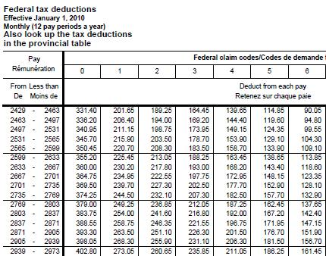Example: A hotel clerk in Whistler, BC earns $2430 each month. His Claim Code is 2. How much federal and provincial taxes will be deducted from his pay? Use the portions of the deduction tables below to answer the question.

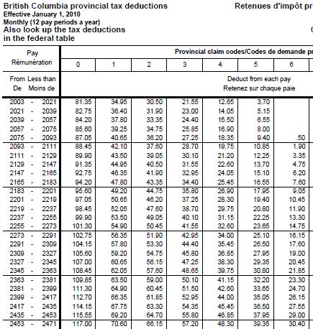

Solution: Using the tables above, find the appropriate deduction.

First, find the correct range under the “Pay” column that $2430 falls in. On the Federal chart (left), this is the first line. On the Provincial chart (right) this is the 24th line (third from the bottom).

Then move to the right to the column labeled “2” – Claim Code 2.from here, read the

deductions as follows:

Federal taxes = $189.25 Provincial taxes = $63.30

**ASSIGNMENT 9 – DEDUCTION TABLES**

1) A worker in Calgary, AB earns $1391 bi-weekly (every two weeks), and his Claim Code is 3. How much federal and provincial tax will be deducted from his paycheque? Circle your answers.

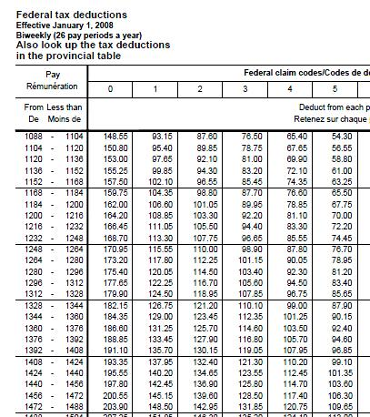

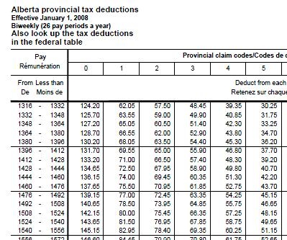

---------------------------------------------------------------------------------------------------------------------

2) Cindy earns an hourly wage of $9.75, and she works 40 hours per week. She is assigned Claim Code 1. Calculate Cindy’s gross pay. Then, using the tables from the *Data Pages*, determine her deductions for federal tax, provincial tax, EI, and CPP, and calculate her weekly net pay.

**PAY STATEMENTS**

A **pay statement** is a form that an employer gives each employee that shows gross earnings and deductions from earnings for a pay period. Pay statements can also be used to serve as a record for deduction calculations, and for determining net pay.

Example 1: Examine the simplified pay statement below and answer the following questions.



a) What is Jolie’s hourly rate of pay?

Solution:

b) How many days does the pay period cover?

Solution:

c) If Jolie’s gross earnings are $712.50, how many hours did she work?

Solution:

**ASSIGNMENT 10 – PAY STATEMENTS**

1) Using the pay statement below for Amanda, answer the following questions.

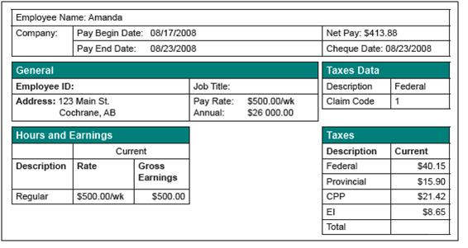

a) What is Amanda’s gross weekly income?

b) What is the total of Amanda’s weekly deductions?

c) What is Amanda’s net pay?

d) What percent of her gross pay did she pay in federal taxes?

Quiz next class  
Test:________________________