Lesson 4 – Factoring Trinomials ax²+bx+c

Recall Algebra Tiles

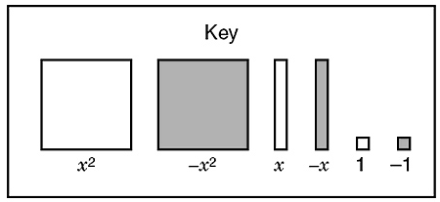

Determine the product using algebra tiles:

(a) -3x(x – 1) (b) (x + 3)(2x + 1)

Now given the product determine the dimensions:

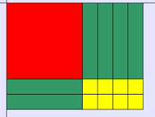
(a) (b)

THIS IS CALLED ____________________.

Example 1: Factor the following, if possible: a = 1

- x²+x-12 (b) 5x²-35x+60

c) x²+ 4x+6 (d) x⁴+11x²+24 e) (x+b)²+6(x+b)+8

Do pg. 29 notes worksheet 3.8 – see key on website.

STOP!!! For Tuesday notes Example 2: Factor the following, if possible: a> 1
a) 3x²-10x+8 (b) 10x²-22x+4

c) 3y²-11y +6 (d) 3x²+ 2x +4

e) 2x²+5xy+2y² (f) 8a²+18a-5

Example 3:
A rescue worker launches a signal flare into the air from the side of a mountain. The height of the flare can be represented by the formula h=-16t²+144t+160. In the formula, h is the height, in feet, above the ground, and t is the time, in seconds.
a) What is the factored from of the formula?
b) What is the height of the flare after 5.6s?

Assignment: 3.8, 3.9 Worksheet. Quiz on Lessons 1-4 on MARCH 2

