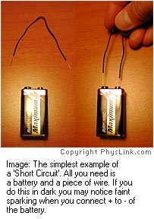**NOTES Circuits – Short, Series and Parallel**

**Short Circuit**

* A complete circuit without a ______________________
* Electricity is ___________ take the path of least resistance
* Caused by two conducting wires touching or a paper clip/wire might bypass a load
* Results in excessive _______________flow through the ‘short’
* Drains battery quickly
* Can destroy power source, creates heat, sparking and/or a fire

|  |  |
| --- | --- |
| **https://i.stack.imgur.com/7HPOK.jpg** | **Schematic Diagram** |

**Series: One Pathway**

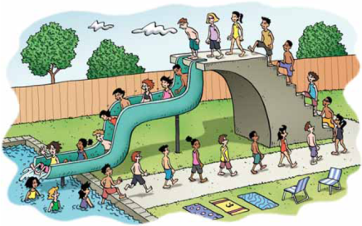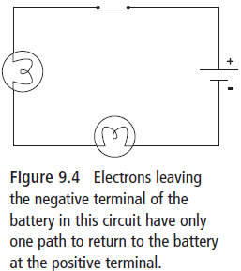

**Voltage in Series**

* Voltage is the __________________________ difference in __________________________ between two points.
* If electrons________ 12 V from the battery, they will ________all 12 V as they travel from the –ve to the +ve terminal of the battery through the circuit
* Staircase analogy –12 steps up-gain potential energy- 12 steps down lose same energy
* Along the circuit, electrical potential energy is____________________ to other types of energy as it passes through resistors and loads
* 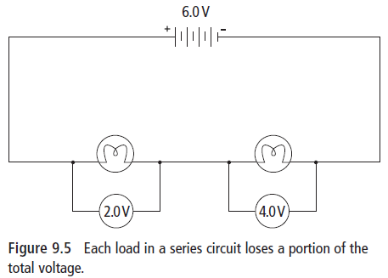In light bulbs this energy is converted to __________________________________.

**Current in Series**

Since electrons _______ each other, they remain evenly spaced out. Within the same pathway, current

______________________________________.  
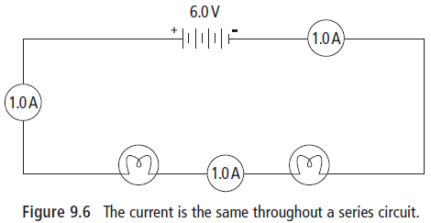

**Resistance in Series**

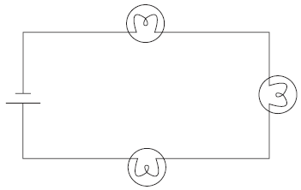There is only _____ pathway. Adding more resistance to the same pathway ______________ the total resistance and _______________ the current in that pathway.

E.g. Adding a dry and sticky portion of a slide after the last one decreases the rate of flow for ***all*** the people going down the slide.

Adding more bulbs _____________ total resistance resulting in total current _____________.

**Parallel: Many Pathways**

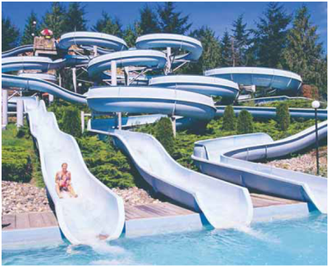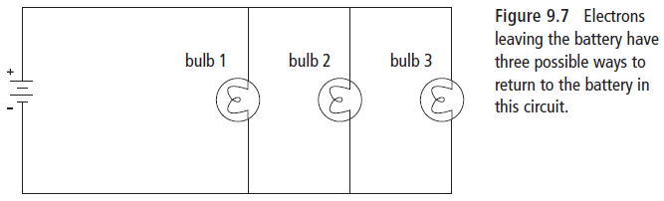

**Voltage in Parallel**

* Within each ________________, the total voltage gained by the ________________is lost

*E.g. there could be many water slides (______________) people can go down, but every person will go down the same height and end up in the same ______________ (positive terminal)*

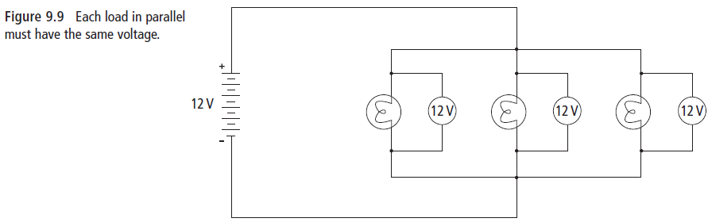

**Current in Parallel**

The total current will split up at a _________________ point and re-join where the paths meet. More current will flow through paths with ____________ resistance.

*E.g. At the top of a waterslide (junction) an attendant makes people go to the next available slide – the slides with the least resistance will have more people going down it every second.* 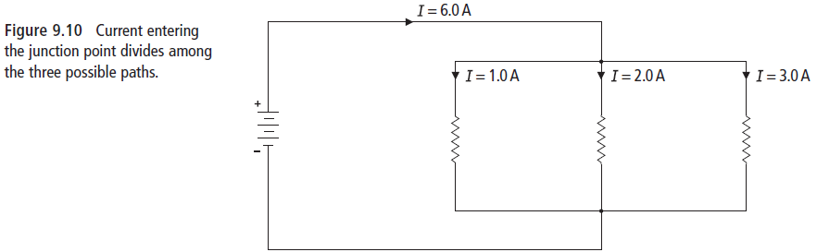

**Resistance in Parallel**

Any time you create another pathway, you _______________ the total resistance in the circuit. Even if you are adding resistors, adding them in parallel will _______________ the total resistance.

*E.g. Adding another waterslide at the water park will increase the flow of people coming down from the top of the slides.*

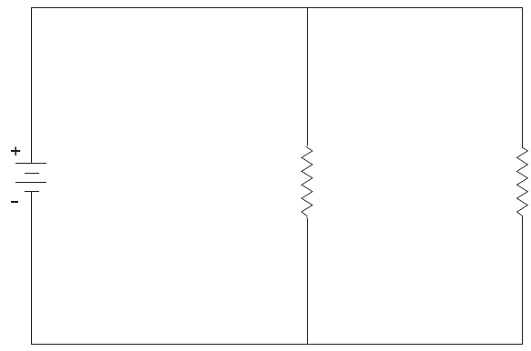

**DO THIS!**

* **Complete questions that follow from textbook p. 319.**
* **Circuit Diagrams- Current and Voltage worksheet**

**Section 9.1**



**Series and Parallel Circuits**

**Check Your Understanding**

|  |
| --- |
|  |

**Checking Concepts**

**1.** How is a parallel circuit different from a series circuit?

**2.** In a series circuit, how does the voltage supplied by the battery compare to the voltages on each load?

**3.** What happens to the total resistance of a series circuit when another resistor is added?

**4.** What happens to the total resistance of a parallel circuit when another resistor is added?

**5.** Two resistors are connected in parallel to a battery. What must be the voltage across these two resistors?

**6.** Is the current in one branch of a parallel circuit more than, less than, or equal to the total current entering the junction point of the circuit?

**Understanding Key Ideas**

**7.** For the following circuit, find:

(a) the current through resistor 2

(b) the voltage across resistor 2

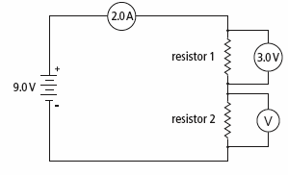

**8.** For the following circuit, find:

(a) the current through resistor 2

(b) the voltage across resistor 2

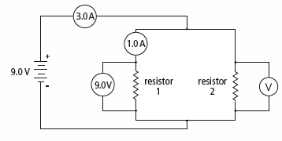

**9.** You are given the following circuit.

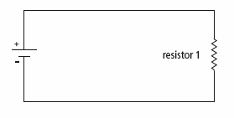

A second resistor is now added in series with resistor 1.

(a) Draw the new circuit diagram.

(b) Comparing your new circuit to the original, describe the changes in:

(i) total resistance

(ii) current leaving the cell

(iii) voltage across resistor 1

**10.** You are given the following circuit.



A second resistor is now added in parallel with resistor 1.

(a) Draw the new circuit diagram.

(b) Comparing your new circuit to the original, describe the changes in:

(i) total resistance

(ii) current leaving the cell (iii) voltage across resistor