**Graphing and Understanding Ohm’s Law: V=IR**

**Procedure:**

1. **Go to the Phet Simulation for the DC circuit –Press play and use the lab version!**[**https://phet.colorado.edu/en/simulations/circuit-construction-kit-dc**](https://phet.colorado.edu/en/simulations/circuit-construction-kit-dc)
2. **For trial 1 and 2: set up the following circuit including one resistor, cell and an open switch.**

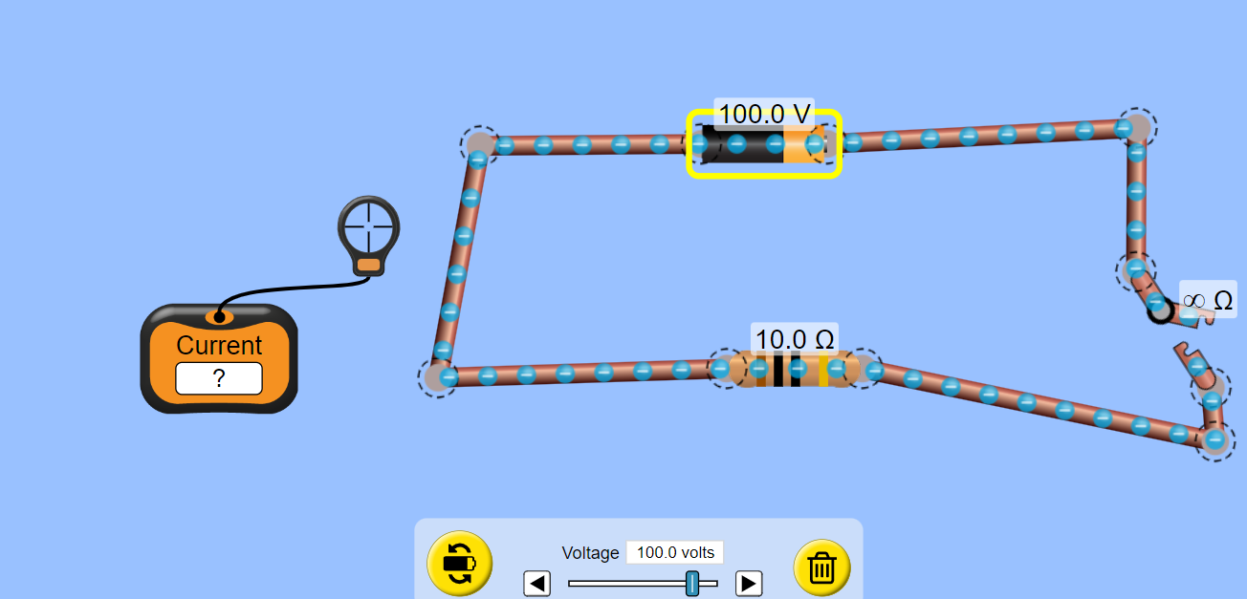

1. **Pull out the ammeter to measure current and press the value button so values of voltage and resistance are visible.**
2. Right click on the cell and set the voltage to 100 V. Keep this setting for trial 1.
3. Right click on the resistor to set the resistance to 10 Ω.
4. Close the switch and measure the current using the ammeter.
5. Record current measurement in the table for trial 1.
6. Open switch to changeresistance on resistor.
7. **Repeat steps 5-8 for the resistor settings of 20, 30, 40 and then 50 Ω.**
8. Create a graph from the **measured current** **values in the table for trial 1**to show the relationship between **Resistance and Current**. Ensure dependent variable on vertical axis! Connect points to show relationship more clearly.
9. **Answer questions beside the graph for trial 1**.
10. **To complete the table for trial 2** use the same circuit. This time set the resistor to **20 Ω** for the entire trial.
11. Right click on the cell and set the voltage to 10 V.
12. Close the switch and measure the current using the ammeter.
13. Record the current measurement in the table for trial 2.
14. Open the switch to change the voltages on the cell.
15. **Repeat steps 13- 16** **for voltage settings of 20, 40, 80 and 120 Volts.**
16. Create a graph from the **measured values in the table for trial 2** to show the relationship between **Voltage and Current**. Ensure dependent variable on vertical axis! Connect points to show relationship.
17. **Answer the questions beside trial 2 graph and complete the summary.**

|  |  |  |  |
| --- | --- | --- | --- |
| **Competencies 4- I can create, interpret, and understand models, graphs and/or diagrams.** | | | |
| Emerging | Developing | Competent | Extending |

**Trial 1: Resistance changes while Voltage remains the same**

|  |  |  |  |
| --- | --- | --- | --- |
| **Voltage (V)** | **Current (A)-Measure** | **Resistance (Ω)** | **Calculated Current (A)** |
| 100 |  | 10 | $$I=\frac{V}{R}=100 V÷10Ω = A$$ |
| 100 |  | 20 |  |
| 100 |  | 30 |  |
| 100 |  | 40 |  |
| 100 |  | 50 |  |

**Steps to Graph:** 1) Label axes with names and units (put dependent variable on y-axis)   
 2) Number axes with even spacing/intervals  
 3) Plot points and connect points to create a rounded or straight line between points

***Graph of Current vs. Resistance***

|  |  |
| --- | --- |
| 0  2  4  6  8  10  12  10  20  30  40  50  60  70  80  Dependent Variable | **Questions for Trial 1**   1. How are I and R correlated in this graph? **Circle one**!   Positive Negative No Correlation   1. According to the trend on this graph, what will happen to the current if the resistance is increased further? 2. How do the calculated values in the table compare with the measured values of current? 3. Predict what the current would be when the resistance is at 25**Ω**. Use the graph!   Independent Variable |
|  |  |

**Trial 2: Voltage changes while Resistance remains the same**

|  |  |  |  |
| --- | --- | --- | --- |
| **Voltage (V)** | **Current (A) Measure** | **Resistance (Ω)** | **Calculated Current (A)** |
| 10 |  | 20 | $$I=\frac{V}{R}=10V÷20Ω= A$$ |
| 20 |  | 20 |  |
| 40 |  | 20 |  |
| 80 |  | 20 |  |
| 120 |  | 20 |  |

Steps to Graph: 1) label axes (put dependent variable on y-axis) 2) Number axes with even spacing/intervals 2) plot points 3) connect points

***Graph of Current vs. Voltage***

|  |  |
| --- | --- |
| 1  0  20 | **Questions for Trial 2**   1. How are I and V correlated in this graph? Circle one!   Positive Negative No Correlation   1. According to the trend on this graph, what will happen to the current if the voltage is increased further? 2. How do the calculated values in the table compare with the experimental values? 3. Predict what the current will be when the voltage is at 100V. Use the graph! |

**SUMMARY**

Ohm’s Law is the relationship: V = IR

As **Resistance** in a circuit increases, **Current** _________________________________.

As **Voltage** in a circuit increases, **Current** _________________________________.