Name: ____________________

**Mitosis Review**

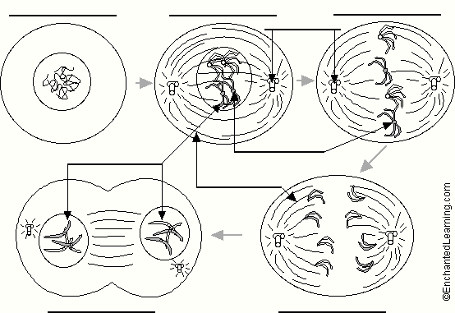

**Chromatids or Chromosomes**

**Anaphase**

**Telophase**

**Spindle fibres**

**Centromeres**

**Centrioles**

1. Label the following diagram of mitosis of an animal cell.

**Metaphase**

**Interphase**

**Prophase**

2. During which stage of a cell’s cycle do the replicated chromosomes thicken and become visible? **Prophase**

3. In animal cells, which structure is thought to produce the spindle fibers that help separate the sister chromatids during anaphase? **Centrioles**

4. Is this structure found in plant cells? **No**

5. The drawing below has been made from a photograph showing a cell undergoing mitosis. Based on the drawing, in what stage of mitosis must the cell have been in?

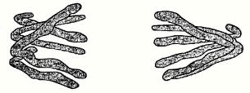

**Anaphase**

6. The drawings A-E show stages of mitosis in a plant cell.

(a) Which of the drawings A - E shows

(i) interphase **C** (**DNA** is replicated)

(ii) prophase **B** (**chromosomes** – 2  **sister chromatids** – shorten)

(iii) metaphase **E** (**sister chromatids** line up)

(iv) anaphase **A** (**sister chromatids** separate)

(v) telophase **D** (new nucleus forms at each end)

(vi) cytokinesis **D** (cell contents divided between 2 **daughter cells** )

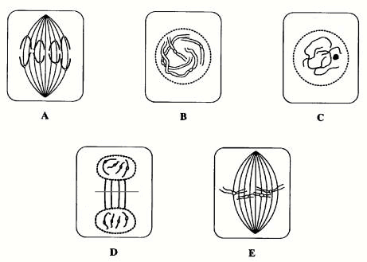

(b) Give two processes which occur during interphase and which are necessary for nuclear division to take place.

**Growth** of the cell and **replication** of the DNA

7. This drawing shows various stages of mitosis in a fast growing onion root tip.

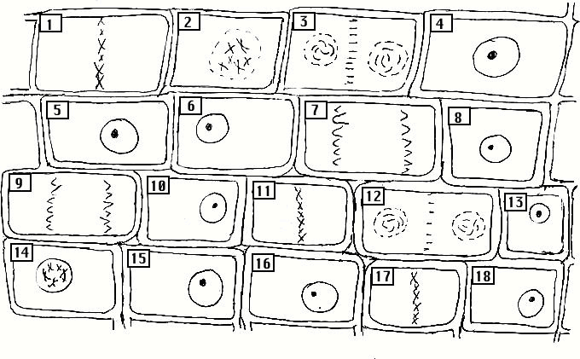

Identify the cells (by number) which are in the following stages of mitosis:

interphase **4, 5, 6, 8, 10, 13, 15, 16, 18**

prophase **2, 14**

metaphase **1, 11, 17**

anaphase **7, 9**

telophase **3, 12**

8. Using colored pens or pencils, show how 2 chromosomes are passed from mother cell to two daughter cells.

