Matter and its Properties

What is matter? Sort the following into the appropriate category

Matter Not Matter

Complete the Web by writing the terms in the appropriate box

Matter compounds homogeneous pure substances
mixtures atoms elements heterogeneous

Has volume and mass

Definite composition
Composition Varies

118 known

Building blocks of Matter

Matter is anything that takes up ____________and has ________________
-made up of smaller particles with distinct characteristics

Sketch and Label Diagram Explaining make up of Matter:

Matter can divided into two main groups
Mixtures and Pure _________________
Mixtures – two or more substances mixed together in ________________ proportions
There are two basic types of mixtures:
- In heterogeneous mixtures, you can see the __________________________ that make up the mixture and they can be separated (think of a salad).
- In a homogenous mixture, components tend to ________________________ together and you are _________ to see the different components (think about dissolving sugar in water)

Sort the following into the correct type of mixture: honey, blood, assortment of dried fruit, steel, soil, medicine, chicken noodle soup, milk, oil and vinegar dressing, granola
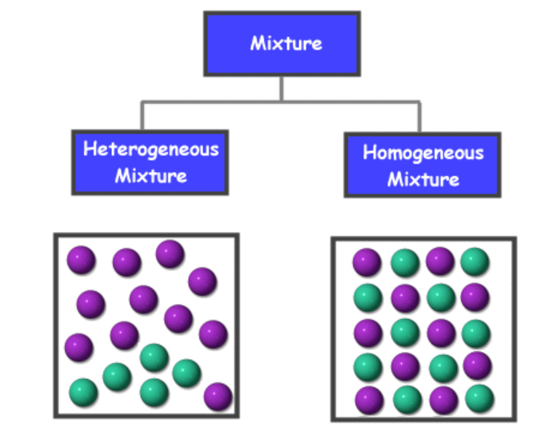

Pure Substances –a substance made up of only _____________________________________ with the same properties throughout.

Element – An element is a substance that consists entirely of ___________________________ atom. An atom is the smallest amount of an element that retains the ____________________ of the element.
Name 2 elements

Compound – Is a substance composed of at _______________________________ elements chemically
combined in specific ___________________________________.
Name 2 compounds

Try This: Identify substance as either a pure substance (pure) or a mixture (Mix – Hetero/Homo). If you know type of pure substance indicate this as well!

a. table salt b. baking soda c. copper
d. soup e. gasoline f. water
g. nitrogen gas h. whipped cream i. fluorine

Describing Matter – elements that make up matter have both chemical and physical properties

- Chemical Property- the ability of a substance to ________________with another ________________to form one or more new substances with ________________properties.
- _______________________and flammability are two chemical properties.
For example:

Physical Properties – characteristics of matter that can be ____________________ or ____________________. For Example: ______________________________
What are the four physical states of matter?

What causes substances to change Physical State?

What two things happen to particles in a substance when the substance changes state?
1)__________________________________________
2)__________________________________________

Draw a diagram of the particle appearance and behaviour in each of the four states of matter:

Some other physical properties of matter are density, colour, malleability, ductility, crystallinity, magnetism, solubility, conductivity, viscosity, melting/freezing point and boiling/condensing point.

Match these terms with the appropriate description and complete the table!
Physical Property | Description
 | Appearance of reflected light
 | Ability to dissolve in water
 | Resistance to flow of a liquid
 | Temperature of melting/freezing
 | Ability to be beaten into sheets
 | Ratio of a material’s mass to its volume
 | Tendency to be attracted to a magnet
 | Ability to be drawn into wires
 | Temperature of boiling/condensing
 | Ability to conduct electricity
 | Shape or appearance of crystals

Use the internet to learn about the reactivity and some physical properties of the following substances.
Complete the table below.

Properties to Research | Silver | Iron | Sodium | Bromine
How Reactive am I? (very, mildly, rarely) –Name two compounds formed with element listed.
Are compounds easily formed with Oxygen?
Yes, No or Sometimes – Give an example!
Electrical conductivity
Poor, Good, Excellent
Density (units)
Melting point/Freezing point (°C)
State at room temperature (25°C)
Solid, Liquid or Gas

