Name____________________

Parts of the Atom
https://www.youtube.com/watch?v=ooWfzpUIoNM

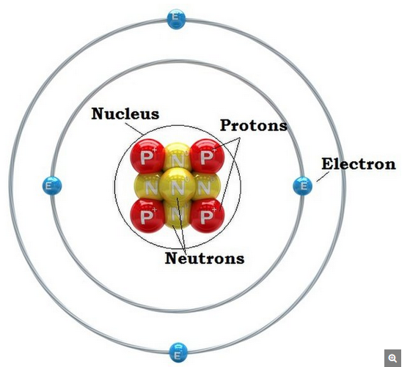
Electron Shells (orbitals or energy levels)

Read the Background about Atoms and fill in the chart.
Atoms are the basic units of matter and the defining structure of elements. The term "atom" comes from the Greek word for indivisible, because it was once thought that atoms were the smallest things in the universe and could not be divided. We now know that atoms are made up of three particles: protons, neutrons and electrons — which are composed of even smaller particles such as quarks.
Atoms were created after the Big Bang 13.7 billion years ago. As the hot, dense new universe cooled, conditions became suitable for quarks and electrons to form. Quarks came together to form protons and neutrons, and these particles combined into nuclei. This all took place within the first few minutes of the universe's existence, according to CERN.
It took 380,000 years for the universe to cool down enough to slow down the electrons so that the nuclei could capture them to form the first atoms. The earliest atoms were primarily hydrogen and helium, which are still the most abundant elements in the universe. Gravity eventually caused clouds of gas to coalesce and form stars, and heavier atoms were (and still are) created within the stars and sent throughout the universe when the star exploded (supernova).

Atomic particles
Protons and neutrons are heavier than electrons and reside in the nucleus at the center of the atom. Electrons are extremely lightweight and exist in a cloud orbiting the nucleus. The electron cloud has a radius 10,000 times greater than the nucleus.
Protons and neutrons have approximately the same mass. However, one proton weighs more than 1,800 times that of an electron. Atoms always have an equal number of protons and electrons, and the number of protons and neutrons is often the same as well. Adding a proton to an atom makes a new element, while adding a neutron makes an isotope, or heavier version, of that atom that contains an extra neutron.

Nucleus
Virtually all the mass of the atom resides in the nucleus. The protons and neutrons that make up the nucleus are approximately the same mass (the proton is slightly less).
Protons - Protons are positively charged particles found within atomic nuclei.
Neutrons - Neutrons are uncharged particles found within all atomic nuclei (except for hydrogen).
*Here’s how to predict the structure of any element on the periodic table. For example, look at carbon:
6
C
carbon
12.011
ﬂatomic number: This is the number of protons (also the number of electrons)
ﬂchemical symbol: This is an abbreviation for the element.
ﬂelement name: This is the name of the element.
ﬂatomic mass: This number tells you the number of protons plus the number of
neutrons. (It is an average of all the isotopes of that element)

Orbitals or Electron Shells

3. Electrons
Electrons are tiny compared to protons and neutrons. Originally known as "corpuscles," electrons have a negative charge and are electrically attracted to the positively charged protons. Electrons surround the atomic nucleus in pathways called orbitals or electron shells or energy levels.

*Here’s how to draw a Bohr model of a calcium atom that has 20 protons:

Protons and neutrons go in the nucleus (center). Example:
P =
N =
Electrons go in energy levels of the electron cloud.
The first shell only holds up to 2 electrons.
The second shell holds up to 8 electrons.
The third shell holds up to 8 electrons.
The fourth shell can hold up to 18 electrons.
Here there are only two electrons in outer shell.
The outermost shell (valence shell can hold up to 8 electrons)

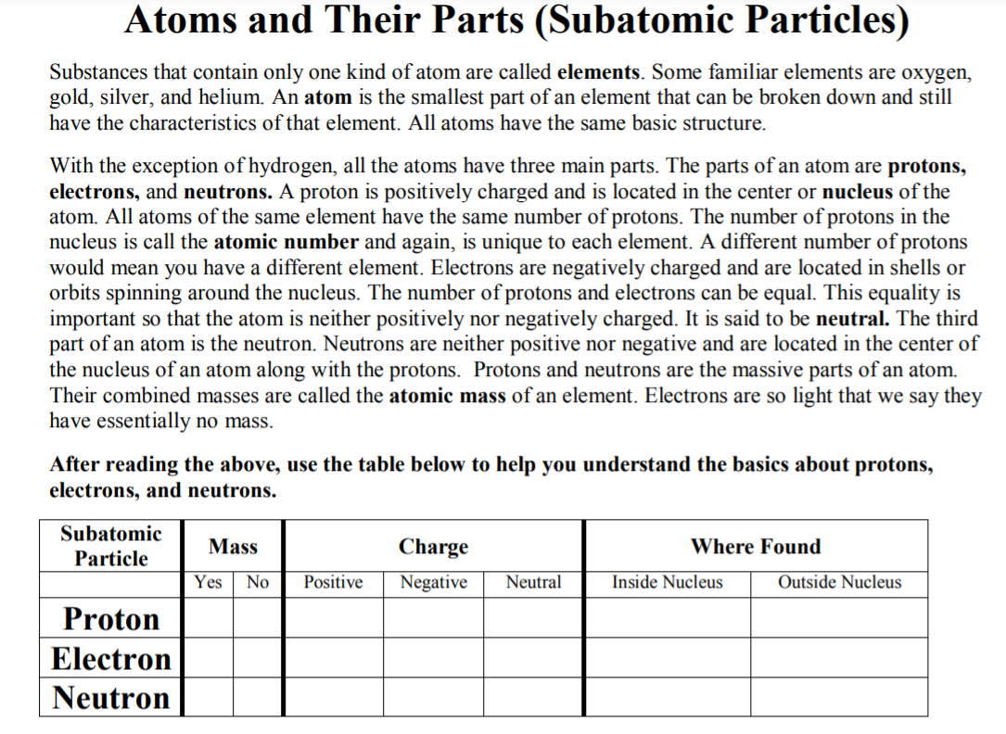
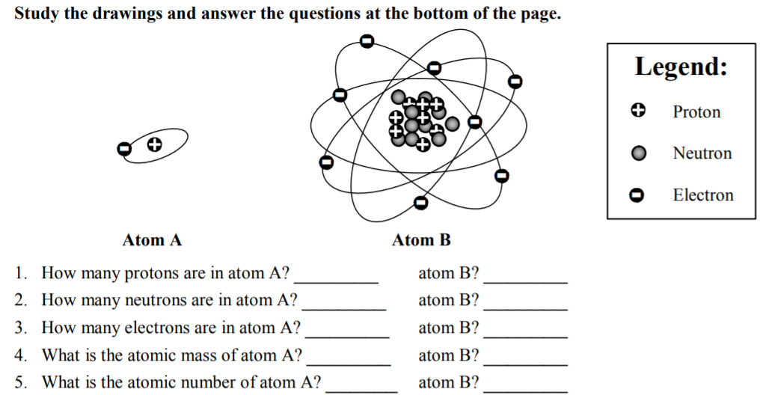

PAIR SHARE: With a partner discuss this question and respond.

What is an Atom ?

What is an atom made of? What are some particles that make up an atom?

While viewing video: https://www.youtube.com/watch?v=ooWfzpUIoNM
Draw a labelled Bohr diagram of the nitrogen atom.

What are two or three new things you learned about atoms from the video?

What is one question you have about atoms and/or matter?

Part IV: Use the internet to research and respond to the following questions regarding Atoms.
Do not use Wikipedia or chat responses! Go directly to cites listed!

- What role/importance do neutrons, protons and electrons play in atoms and chemical reactions? Give two points for each particle!

Electron /2 | Neutrons /2 | Protons /2

- Neutral atoms have no overall electric charge even though protons and electrons have an electric charge. Explain why atoms are neutral? /1

- If an atom losses or gains, electrons it will become charged. What do you call an atom that has a charge?__________________________. If the charge is negative, it is called an_________________
if the charge is positive, it is called a_________________________ /3
- Who confirmed the existence of neutrons in 1932?______________________________
This scientist was a student of the famous physicist Ernest Rutherford who showed protons were responsible for the nucleus’ positive charge. /1

- More recently, particle accelerators at CERN were used to prove that smaller particles make up
protons and neutrons. What are these particles called? _____________________. /1
- Electrons are a different type of particle know as _______________________. /1

- Give the name of two websites you used to find the information listed above! Be sure cites are from reliable scientific sources (not Wikipedia or chats, but educational sources with authors, date of publication etc.) /2

Skills – I can use a variety of valid sources to research scientific topics, verify information, and cite these sources. /15

Emerging | Developing | Proficient | Extending

