Notes: The Periodic Table of Elements Name:_________________
Learning Target: I can interpret and use a periodic table
Origin of Today’s Periodic table of Elements

In 1867, Dimitri Mendeleev found __________ in the elements and organized them into a ___________
    - Organized elements according to: _______________________
    - grouped elements with similar _______________ into families
  - The resulting table had ______________ for elements not yet __________________

How is the periodic table of elements organized?

- By Element

Atomic Mass:
Atomic Number:
Ion Charge:

- Elements are listed in squares containing the element symbol, name, atomic number, ion charge (s), atomic mass.

- By Class

______________________, non-metals and ________________________________________

- By rows
- Each horizontal row is called a period.
- As you move across a period (row) each element has _________________________
than the element before which means the atomic number increases _______________.
- The atomic mass also increases from ________ to _________.

- By Groups/Families
- __________________columns – are called groups or families
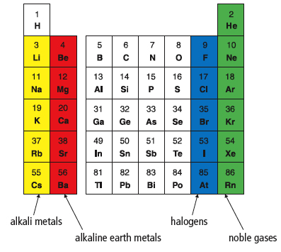
- Elements in the same column have ____________________________________

____________________ ______________________ _____________ _______________

What are some repeating patterns that can be observed when looking at the periodic table?
1) ______________________ 2)________________________

- Atom size increases as we move down the groups and from right to left on the periodic table.
- The greater the # of ________________________ the larger the atom

- The greater the mass of the nucleus in the same row the ________________ the atom
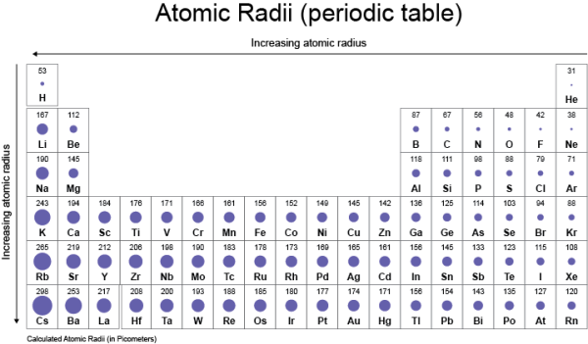
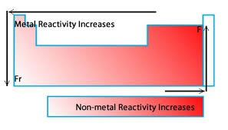

- Metal reactivity increases from right to left and down each column
- Non-metal reactivity increases left to right and up each column
- Reactivity depends on ____________________ the atom gains or looses electrons.

- Metals want to _____________electrons to form a full outer shell and non-metals want to ___________electrons to form a full outer shell.

On the blank periodic table complete the following when instructed to do so! Use the completed periodic table, textbook and internet.

- Write in the chemical symbols of each metalloid (semi-metal)
- Use a highlighter to outline around the periphery of the metalloids on your blank periodic table.
The metals are located to the ___________________________of the staircase. The non-metals are located to the ___________________________ of the staircase.

3) Describe important distinguishing characteristics for each type of element below!

Metals:

Non-metals:

Semi-metals (Metalloids):

4) On your periodic table and write down the following above/near the appropriate category:
Metal: An element whose atoms LOSE electrons when forming an ion.
Non-metal: An element whose atoms GAIN electrons when forming an ion.
Semi-metal: Elements that have both metal and non-metal characteristics.

5) What is meant by periods on the periodic table?

6) Highlight the period numbers down the left side of your periodic table and label above as Period.

7) Go across period 3 and list the atomic numbers (number of protons) and element symbols for sodium until Argon. Write the symbol and atomic number in the same position as in your complete periodic table.

For each group/family of elements use a different colour to shade in the elements included in the group.

8) Colour and label the group 1 - Alkali metals - on your periodic table
List 3 properties of the alkali metals.
1)
2)
3)

9) Colour and label the group 2 - Alkaline earth metals - on your periodic table
List 3 properties of the alkaline earth metals
1)
2)
3)

10) Colour and label the group 18 - Noble gases - on your periodic table
List 3 properties of the Noble gases
1)
2)
3)

11) Colour and label the group 17 - Halogens - on your periodic table
List 2 properties of the Halogens
1)
2)

12) Hydrogen – Is essentially its own special group, but it is located above the alkali metals on the periodic table.

List 5 properties of hydrogen (use the internet)
1)
2)
3)
4)
5)

13) You can use the Periodic Table to determine the charge of non-transition metal elements.

Positive Ions (called = cations) Metals always LOSE electrons to form ions.
- Put a +1 above the alkali metals
- Put a +2 above the alkaline earth metals
- Put a +3 above group 13

Negative Ions (called = anions) Non-metals always GAIN electrons to form ions.
- Put a 0 above the noble gas family because they do not form ions and are stable.
- Put a -1 above the halogens
- Put a -2 above group 16
- Put a -3 above group 15

14) Important to know: Most transition metals - have more than one possible ion charge and are called multivalent elements.

- Colour and label: The transition metals - groups 3-12

15) Important to know: The diatomic elements. Diatomic means that the element is always found as two atoms chemically bonded together.

- Label each diatomic element on the table: F₂, Cl₂, Br₂, I₂, O₂, N₂, H₂

What type of elements are these? Metals, non-metals or semi-metals.

Using & Understanding the Periodic Table Name:________________

Use the internet, the periodic table of elements and your notes to answer the following questions.

- List three pieces of information besides the element’s name and symbol that you can find recorded on a typical periodic table for a given element. /1.5 marks

____________________________________,__________________________________

________________________________________________________
- State how many protons are present in each of the following atoms: /1.5 marks

- Silicon b) chromium c) iodine

- List the following elements using their names by atomic mass from lightest to heaviest.
Zn, Ca, Co, Ni, C /1 mark

_________________________________________________________________

- Use your periodic table to find the atomic number for each of the following elements. /3

helium | gold | oxygen
iron | uranium | mendelevium

- Which has more protons, an atom of sodium or an atom of potassium? Give proton # of each and response. /2 marks

- What does atomic mass measure? /1 mark

- Describe the pattern in atomic masses going across and down the periodic table? /1 mark

- In the periodic table what are the atomic masses of each of the following elements. /3

lithium | copper | silicon
mercury | iron | magnesium

- Which has more mass, an atom of gold or an atom of lead? Give masses of each and state response. / 2 marks

10 . The elements in the periodic table are classified into three main sections. /2 marks
List these sections: _____________________,______________________
_____________________

- How does an atom become an ion? /1 mark

- Which subatomic particle has to be removed so that an atom becomes a positively charged ion? __________________________________ /1 mark

- Elements on the left side of the stair case aways form _________________ions whereas elements on the right side form ___________________ions. /1 mark
- Oxygen is a ________________ it’s ion charge value is _________. /1 mark

- Lithium is a _________________ its ion charge value is ________. /1 mark

- Metals that have more than one ion charge shown, can form different ions. What are these elements called?___________________________________________ /1 mark
- Some elements have a common ion charge of zero. What does this tell you about the element? /1 mark

- Manganese can form three different ions. What are the ion charges?_________ /1
What is the most common ion charge? (the top charge listed) _____________ /1

- What are the horizontal rows in the periodic table called? /1 mark _______________________________

- What are the vertical columns in the periodic table called? /1 mark
______________________________

- List two properties of elements in the noble gas family. /2 marks

- Which chemical family of metals is used in fireworks? /1 mark
_________________________________
- Which chemical family contains elements at room temperature that are solids, liquids and gases at room temperature? ____________________________________ / 1 mark
- Which chemical family contains the most reactive metals that react readily with both oxygen and water. These elements can be cut with a knife because these elements are very soft. _______________________________________ /1 mark

- Why does hydrogen have a unique position on the periodic table? /2 marks

- What are two characteristics or properties of Hydrogen that make the element unique?
/2 marks

- Diatomic elements like oxygen contain two atoms chemically bonded together. Are these substances compounds or molecules? Explain. /2 marks

Total: /40 marks = %

